**AZURE 201**

**Creating Microsoft Azure Account with Free Subscription.**

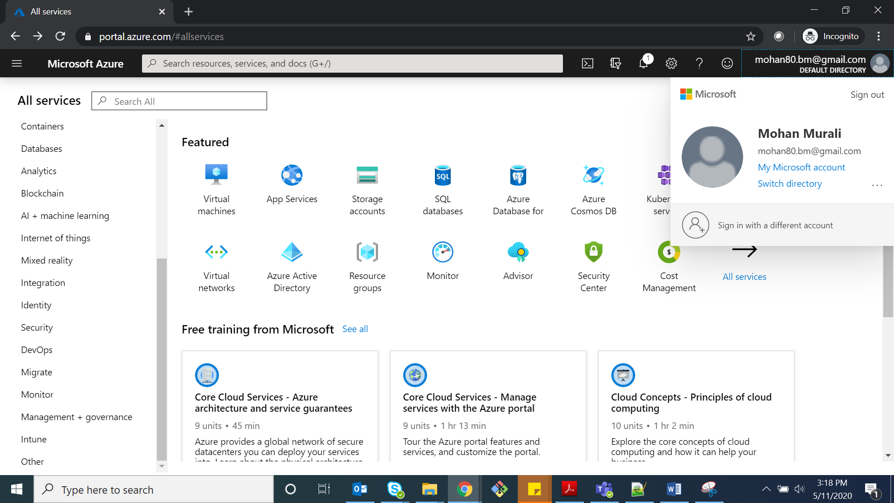

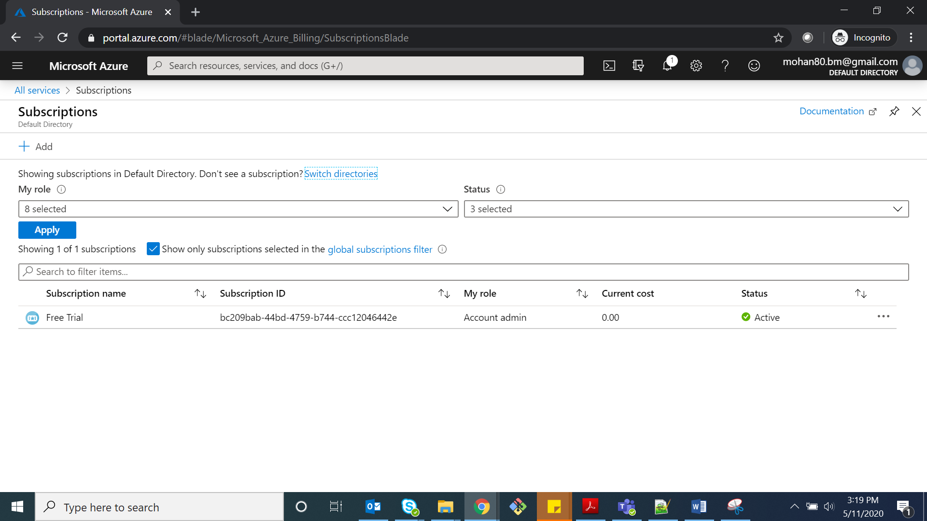

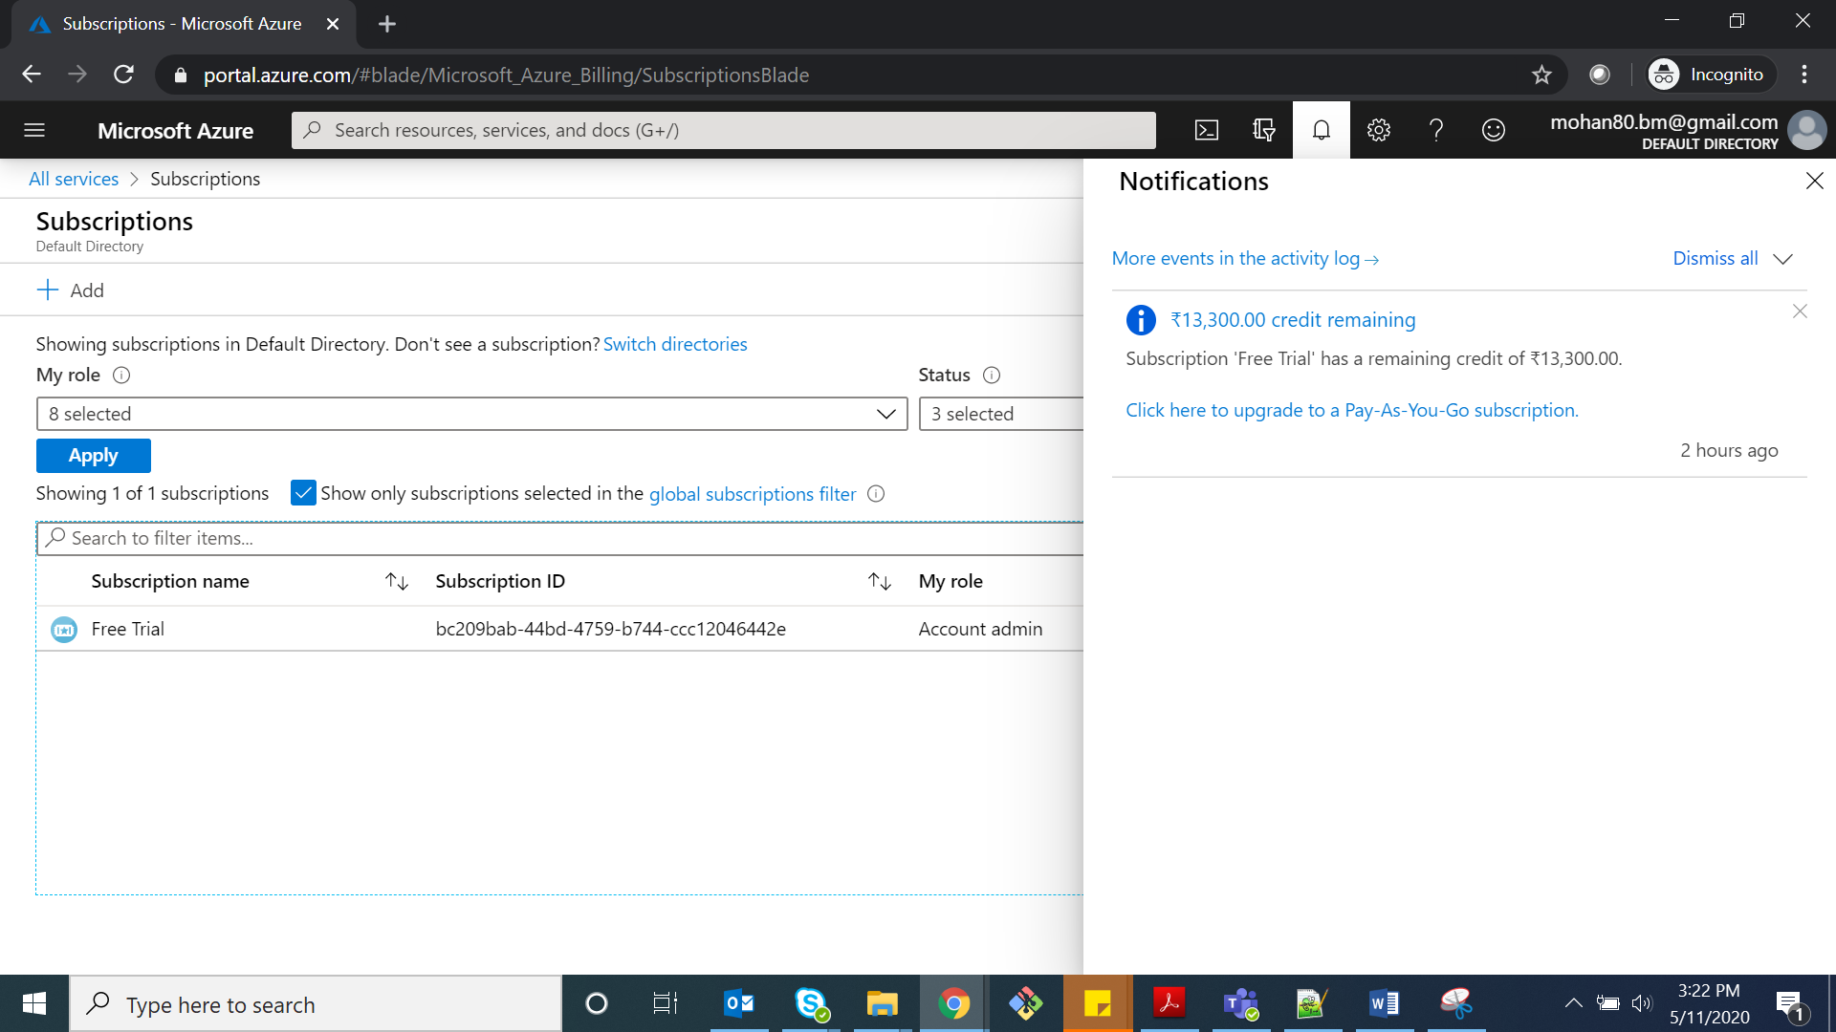

**Configuring Azure with PowerShell:**

**Checking Power Shell Version by using** **$PSVersionTable**

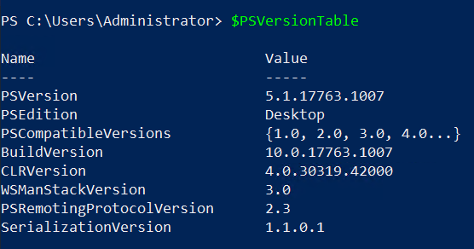

**Install Azure Model using the below command.**

**Install-Module Azurerm –Force –Verbose**

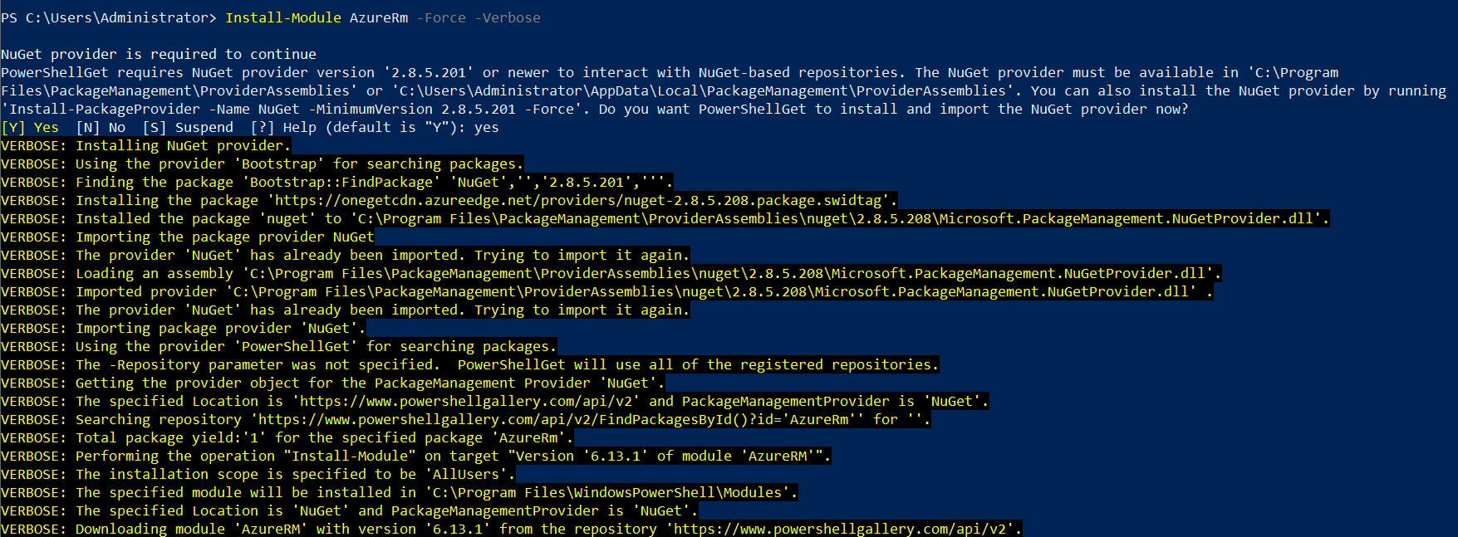

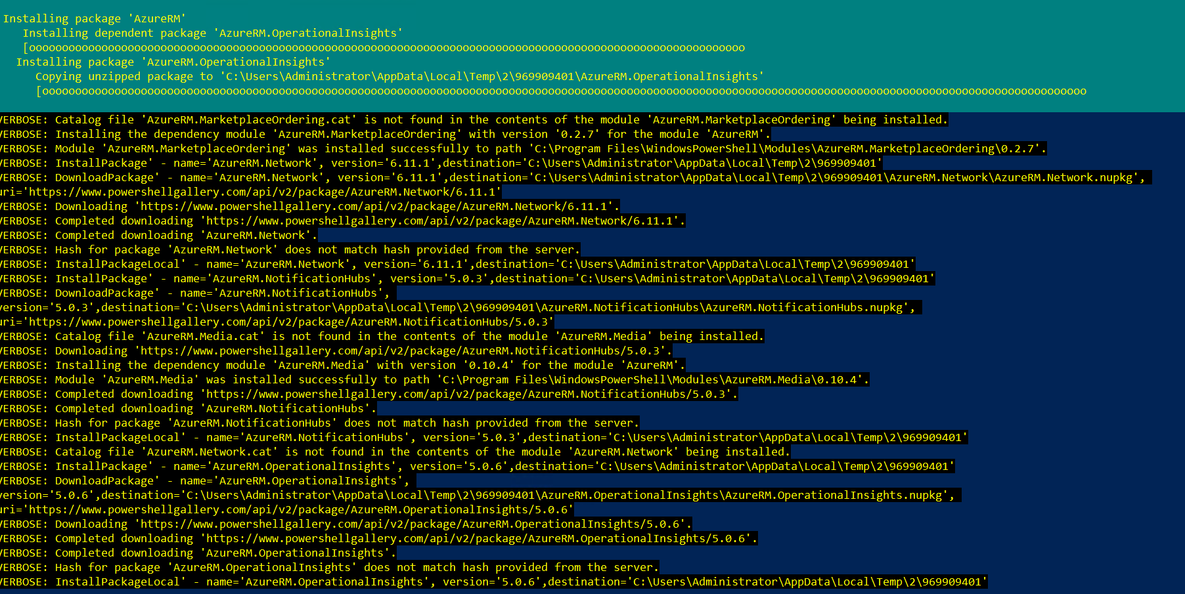

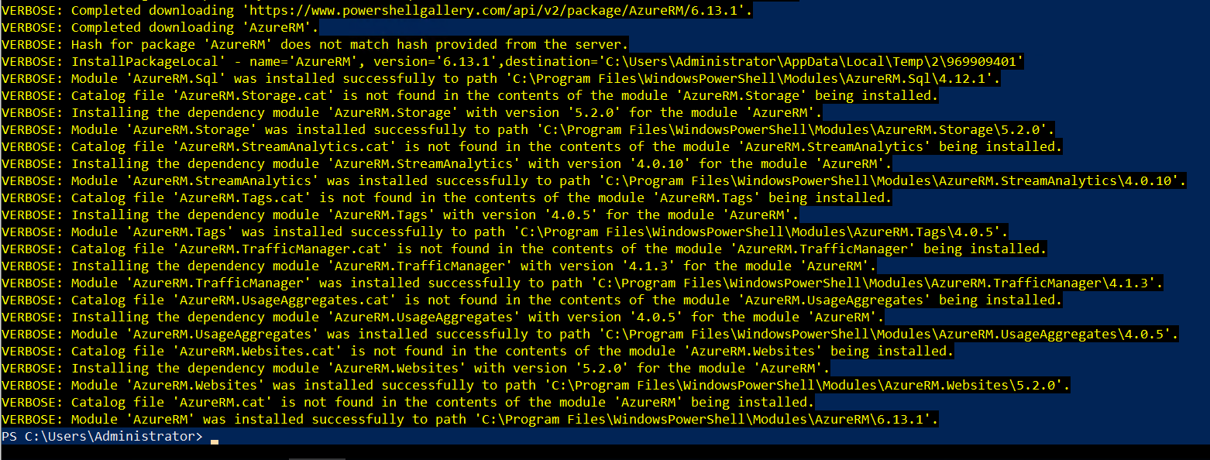

**Azure module successfully installed.**

**Configuring Azure Account with PowerShell**

**By using Add-AzureRmAccount module, we can configure azure with PowerShell. After hitting the enter button it will prompt for Microsoft azure account sign in, provide azure credentials.**

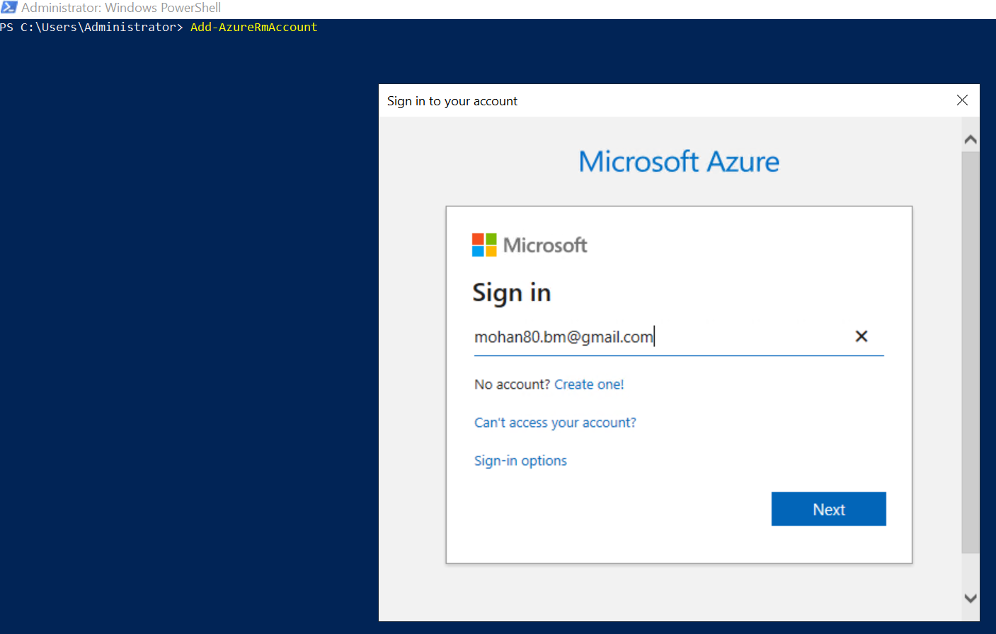

**It will ask for mail verification.**

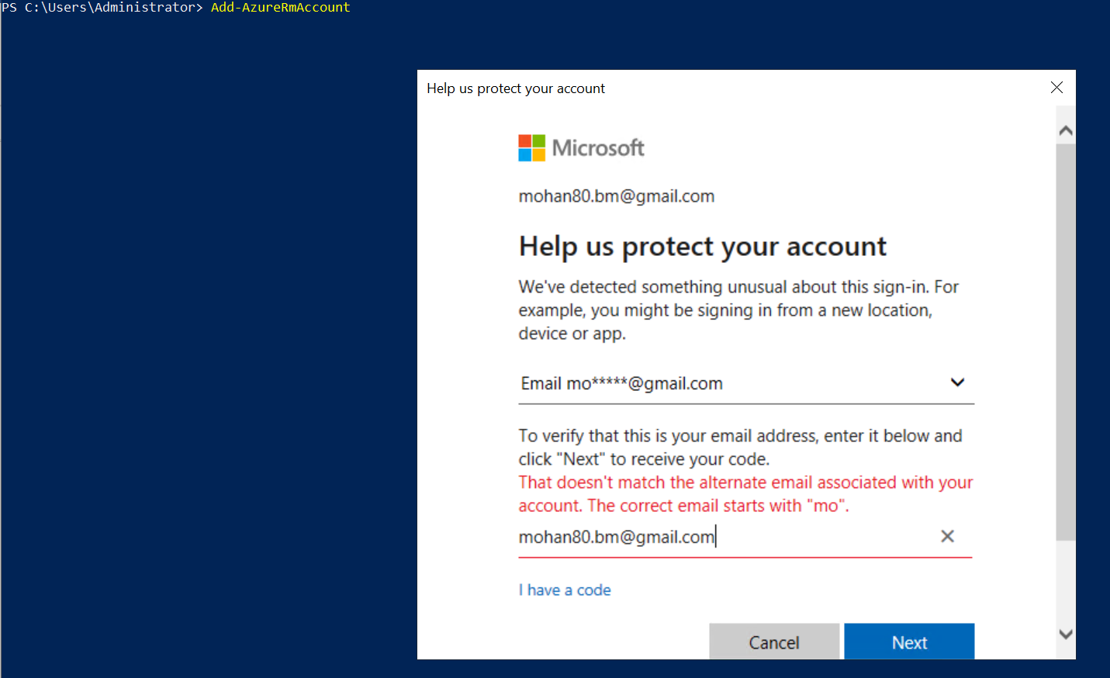

**Once provide mail it send security code to the given email. Copy paste that code and click on Next to configure azure account with PowerShell.**

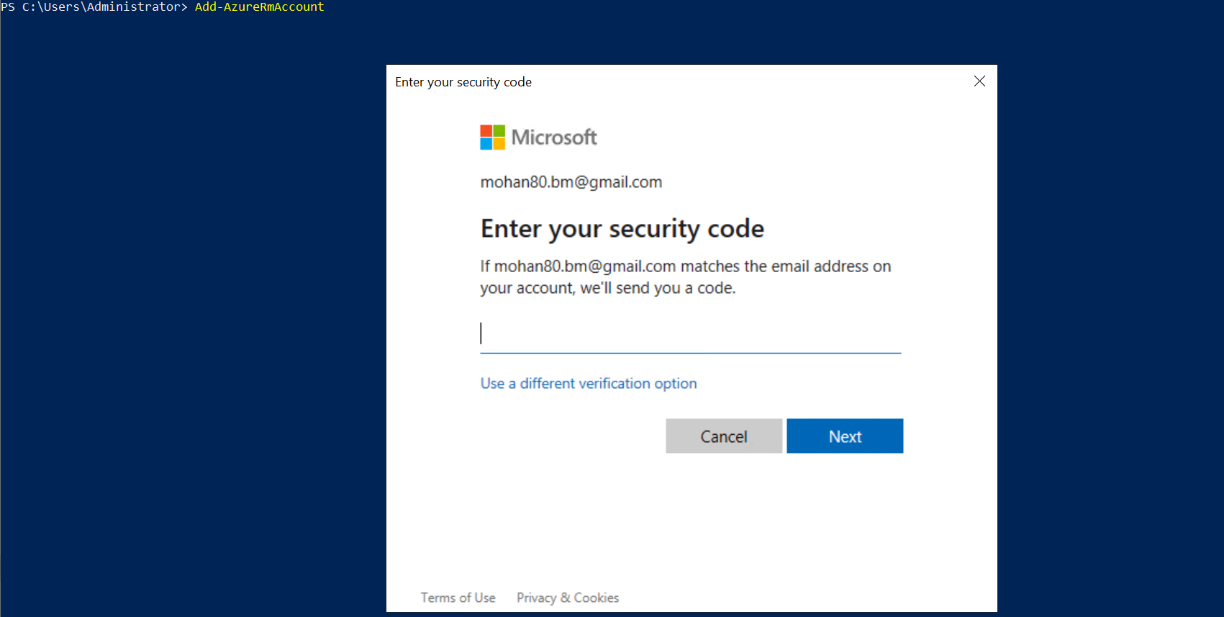

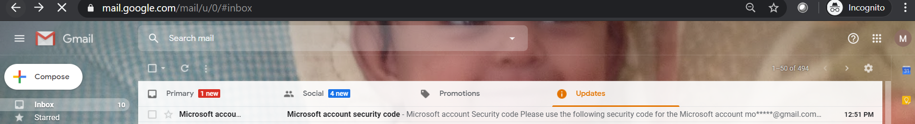

**After all the configuration and verification, it will give subscription details as shown below.**

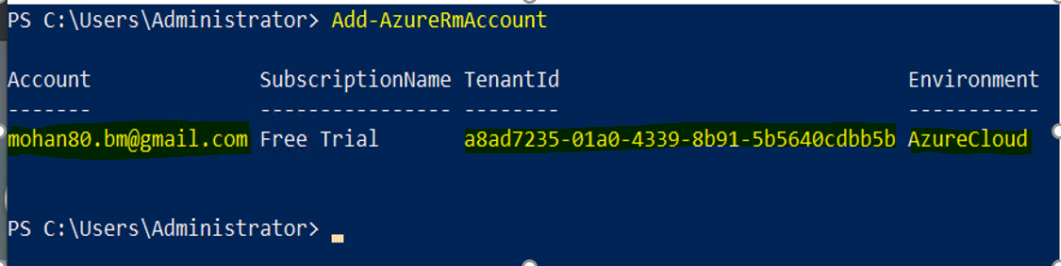

**Azure Storage:**

**Contents of template.json file which will create Azure Storage.**

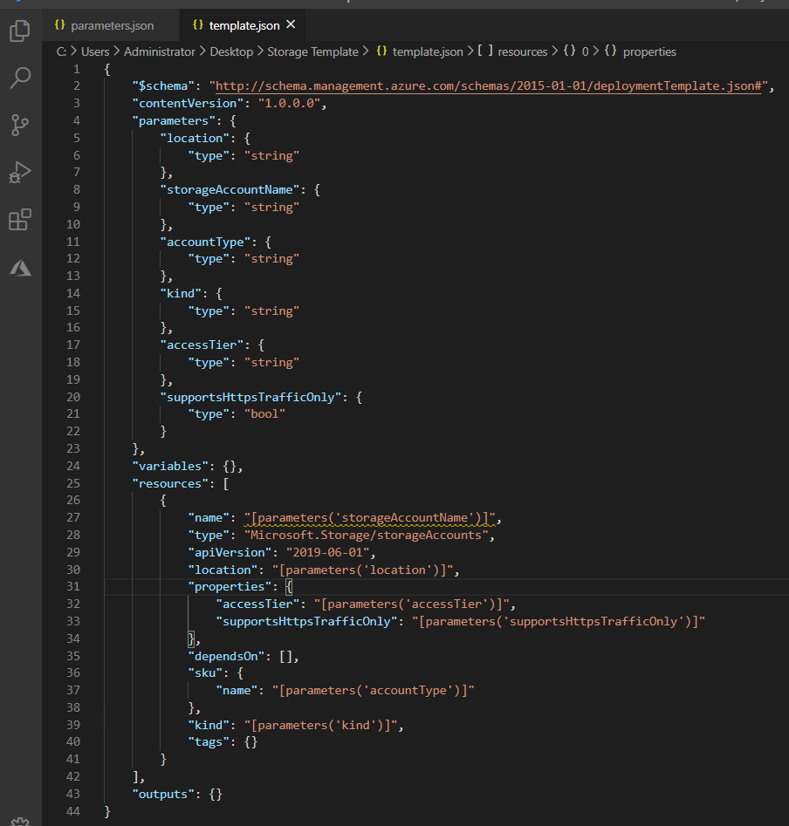

**Contents of parameters file**

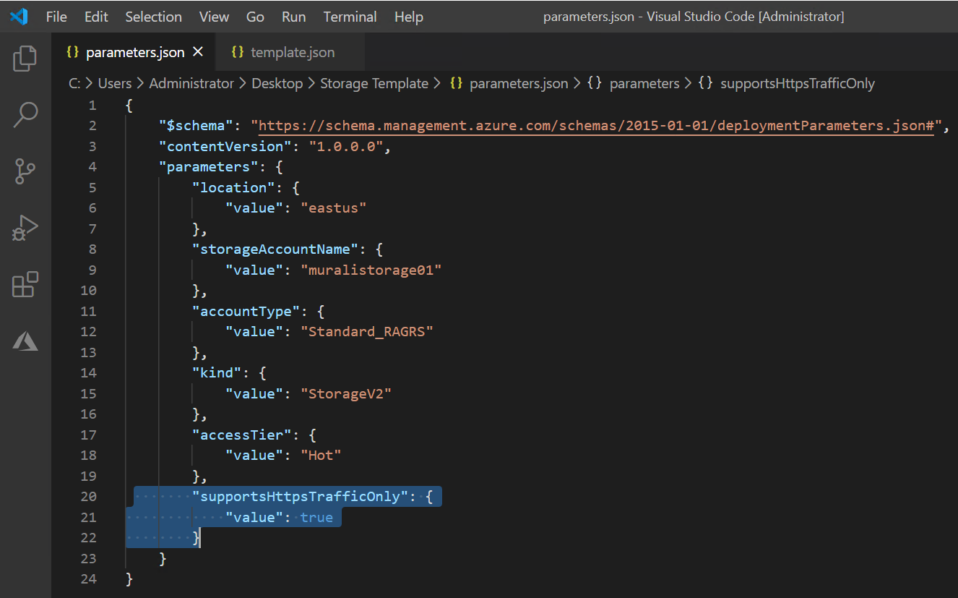

**Listing required files under Storage Template folder to create storage account which allows https traffic.**

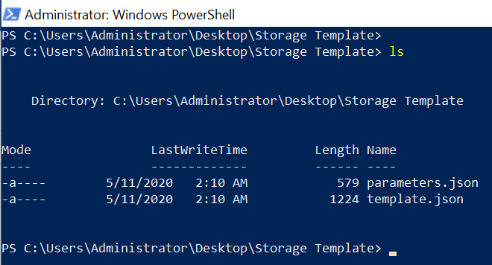

**Open PowerShell and excute below command to create azure storage account.**

New-AzureRmResourceGroupDeployment -Name 201StorageDeploy -ResourceGroupName 201StorageRG -TemplateFile .\template.json -TemplateParameterFile .\parameters.json -Force –Verbose

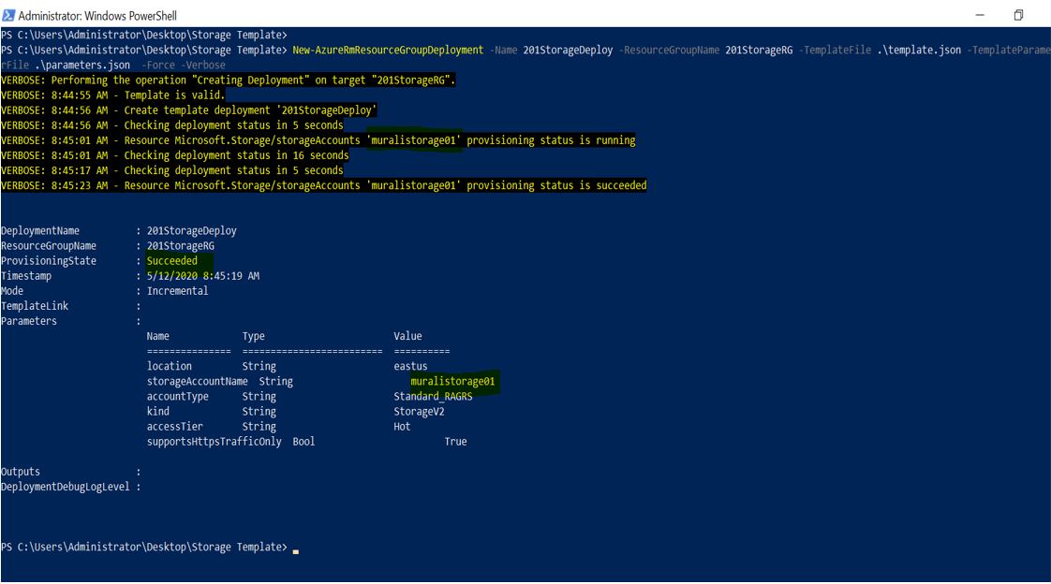

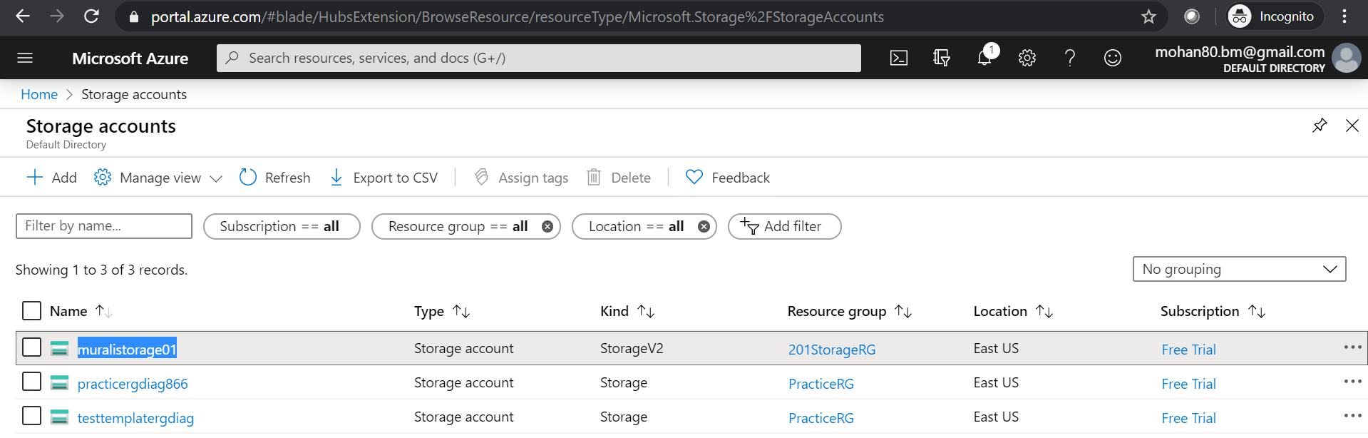

**Storage account named muralistorage01 created successfully under 201StorageRG resource group.**

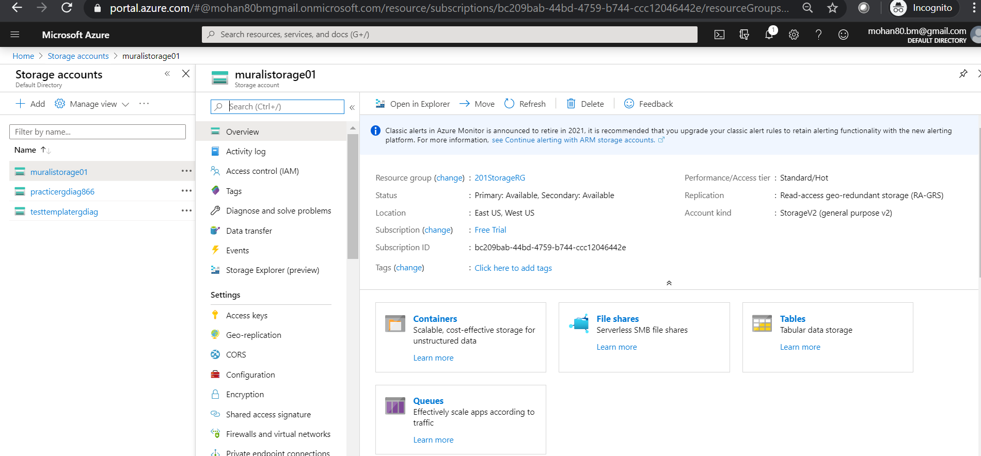

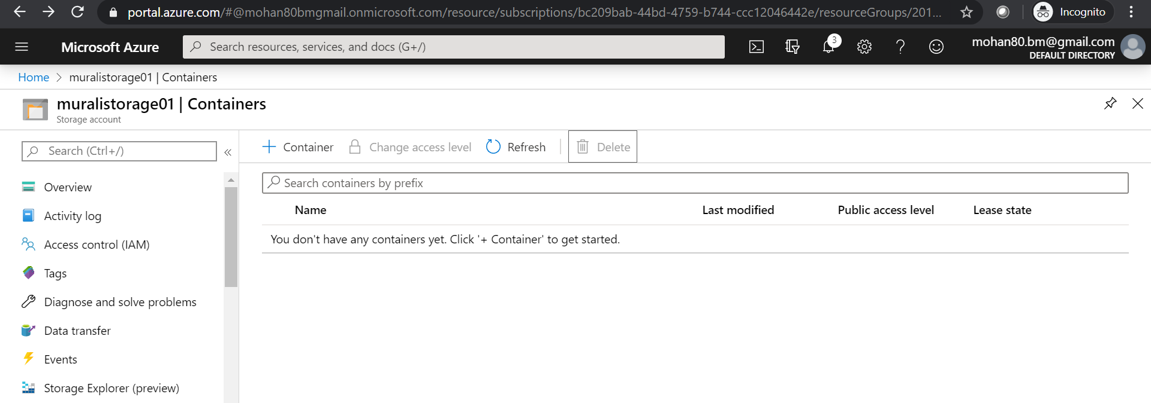

**Click on Container to create new container.**

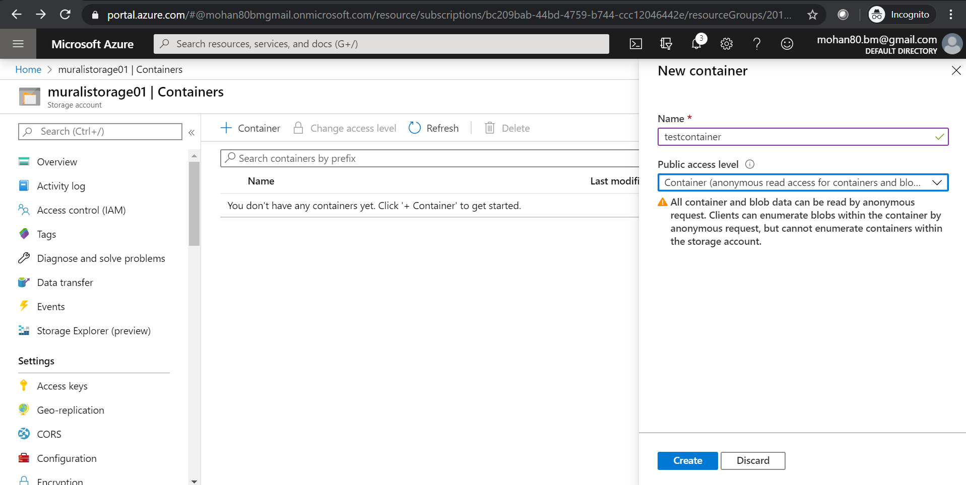

**New container called testcontainer created as shown below.**

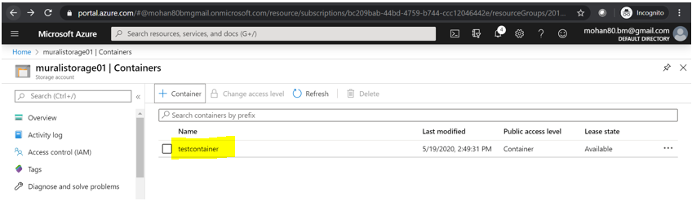

**Create SampleText.html in local machine and Click on Upload button to upload the content into newly created container.**

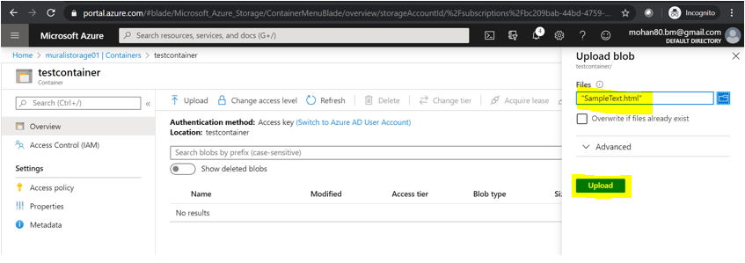

**Click on overview, which will display the summary of newly uploaded file. Copy URL link and paste it in a browser.**

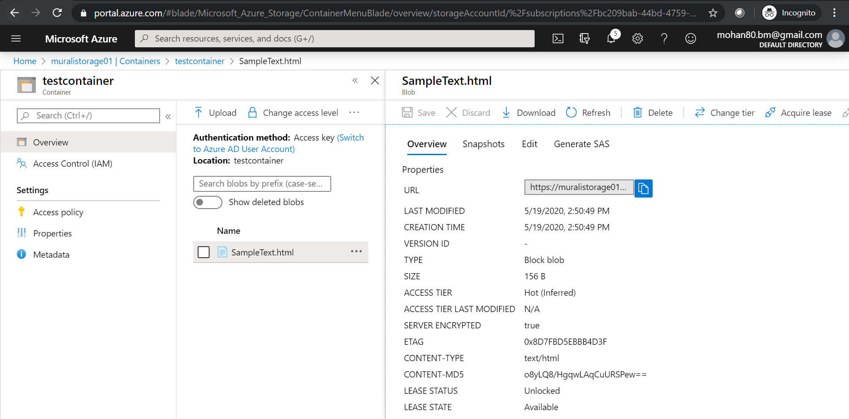

**As the below screen we need to use https to access the newly created container. It will display content inside html file.**

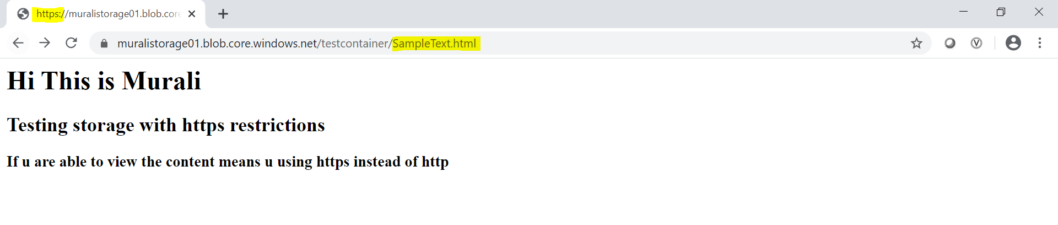

**If I try to access the same URL using http it will throw an error saying that it doesn’t allow to view the HTML page using http.**

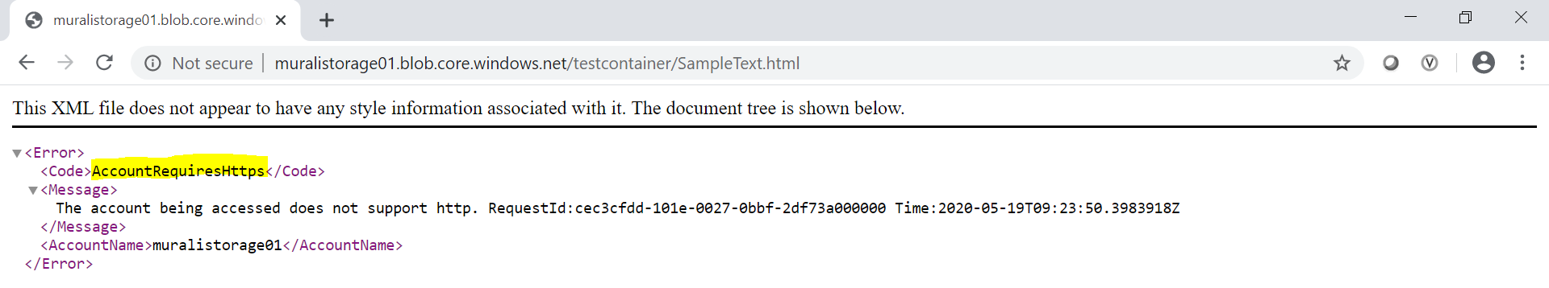

**AZURE NETWORK:**

**Create a folder called vNetTemplate which contains template.json and parameters.json file as well.**

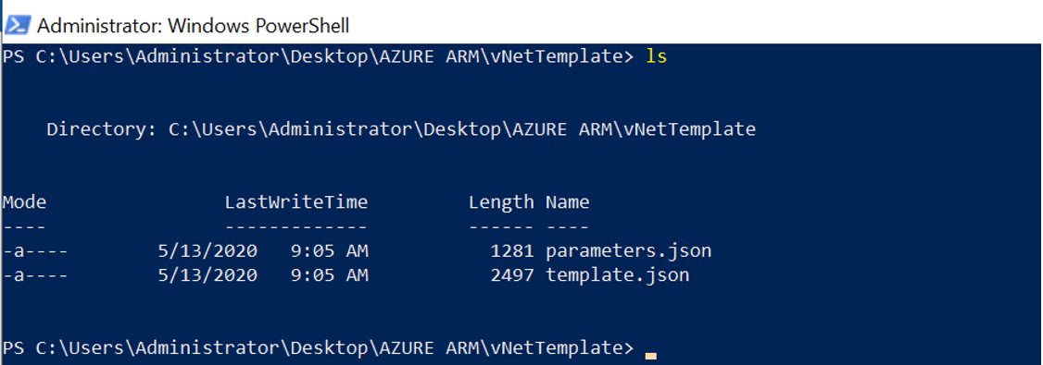

**Run the below command to create a Network under Azure201RG.**

New-AzureRmResourceGroupDeployment -Name Azure201vNET1 -ResourceGroupName Azure201RG -TemplateFile .\template.json -TemplateParameterFile .\parameters.json -Force –Verbose



**The below output shows Azure201vNET1 created successfully in Azure201RG resource group.**

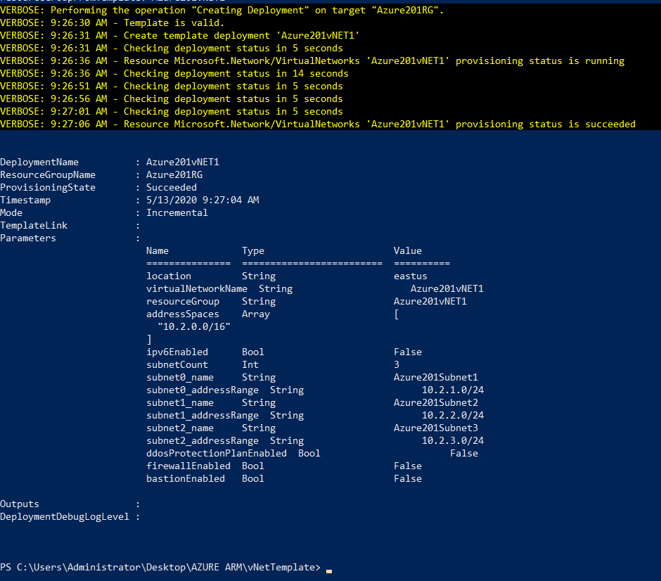

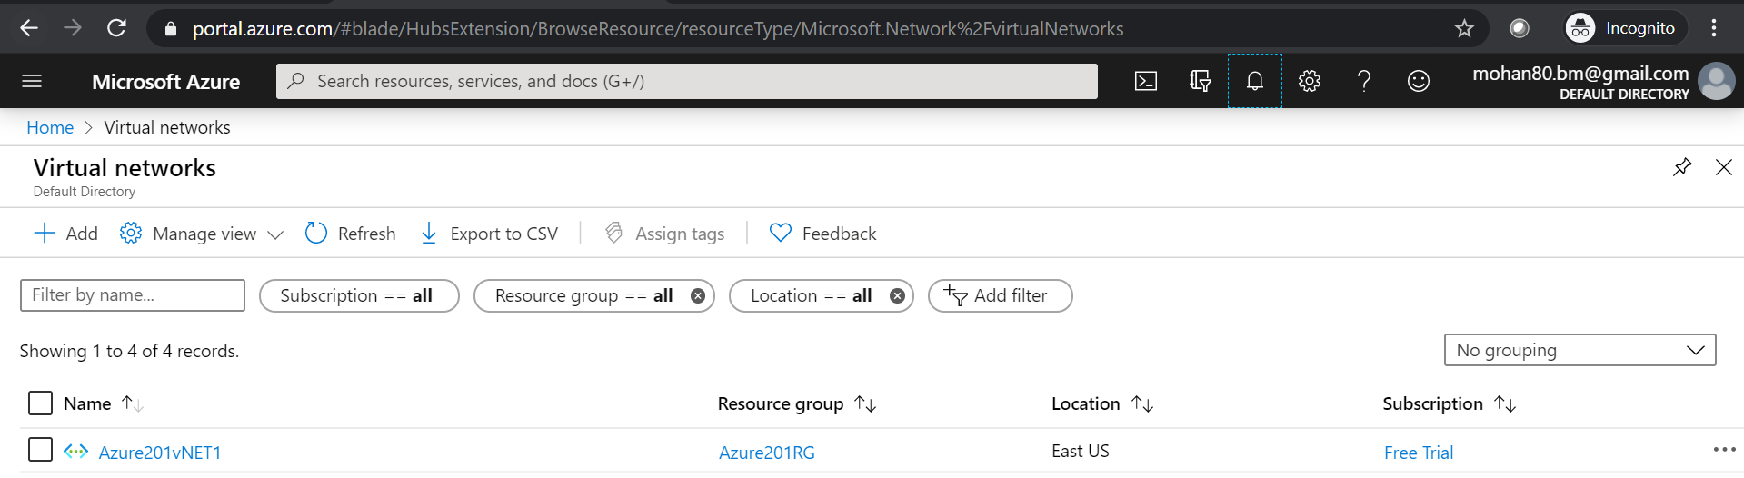

**NETWORK SECURITY GROUP:**

**Below two files listed under NSG Template folder will create security group.**

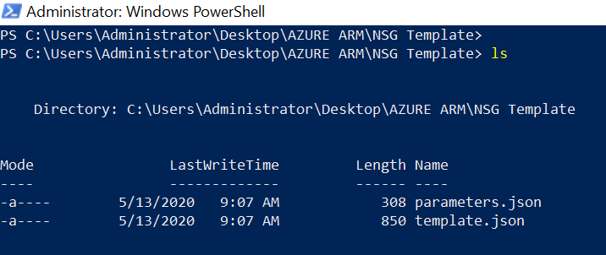

**Run the below command to create a Network Security Group under Azure201RG resource group.**

New-AzureRmResourceGroupDeployment -Name Azure201NSG -ResourceGroupName Azure201RG -TemplateFile .\template.json -TemplateParameterFile .\parameters.json -Force -Verbose

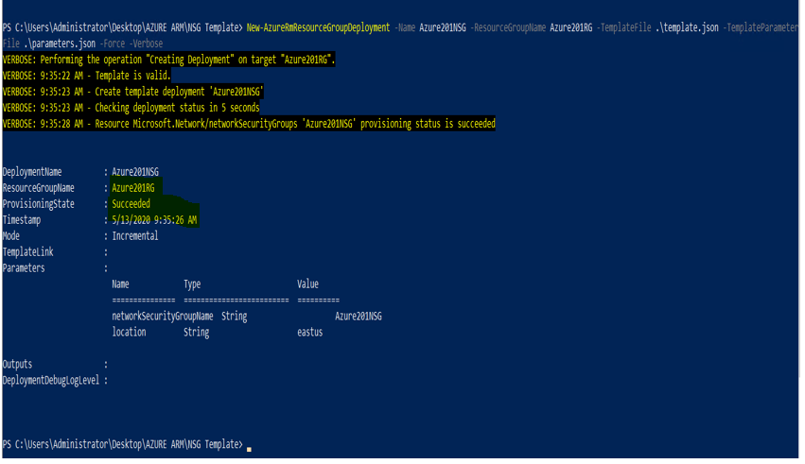

**Now Network and Network Security Group available in the Azure201RG in the Azure portal.**

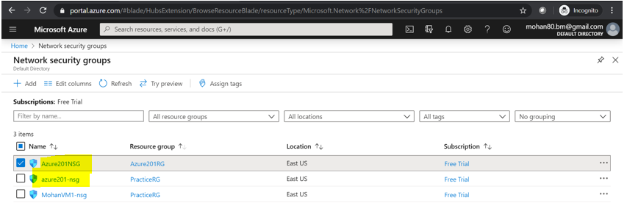

**PUBLIC IP:**

**Create a folder called PublicIPtemplate and place required files inside the folder.**

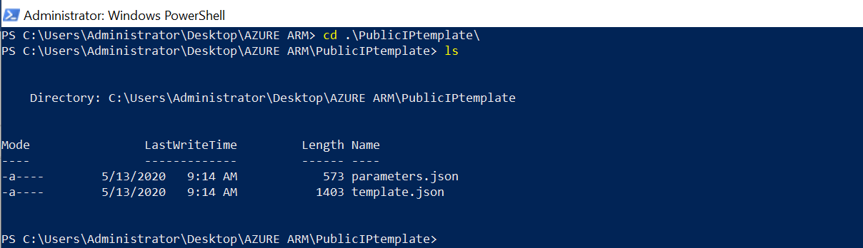

**Run the below command to create public IP**

New-AzureRmResourceGroupDeployment -Name Azure201PublicIP-ResourceGroupName Azure201RG -TemplateFile .\template.json -TemplateParameterFile .\parameters.json -Force -Verbose



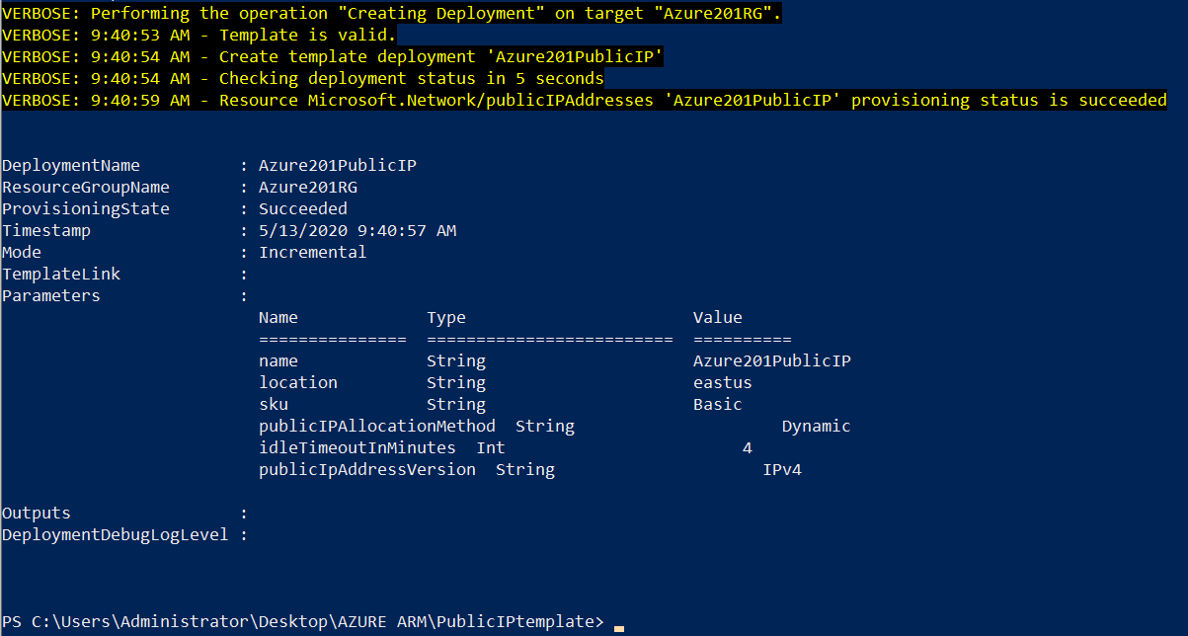

**As the above output shows, public IP created successfully and that is available in Azure Portal.**

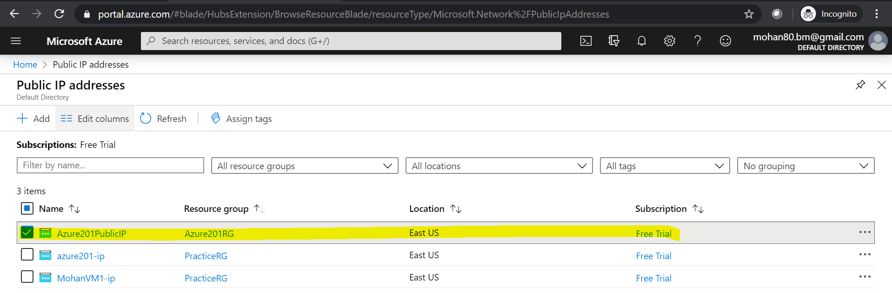

**Creating VM with existing Resources:**

**Using the created resources like Network, Network Security Group and Public IP in the previous section and deploying virtual machine in azure with ARM template.**

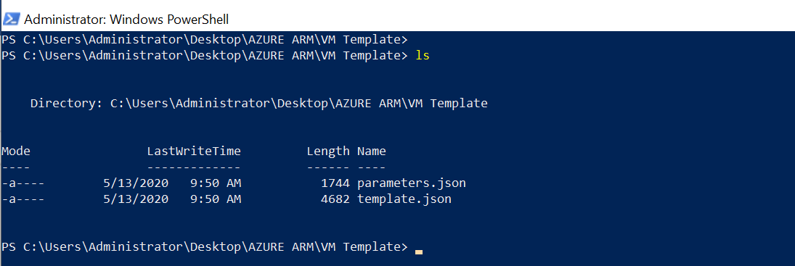

**Trigger deployment by using the below command.**

New-AzureRmResourceGroupDeployment -Name Azure201VM -ResourceGroupName Azure201RG -TemplateFile .\template.json -TemplateParameterFile .\parameters.json -Force –Verbose

**We can see the deployment triggered and we can track it in the azure portal.**

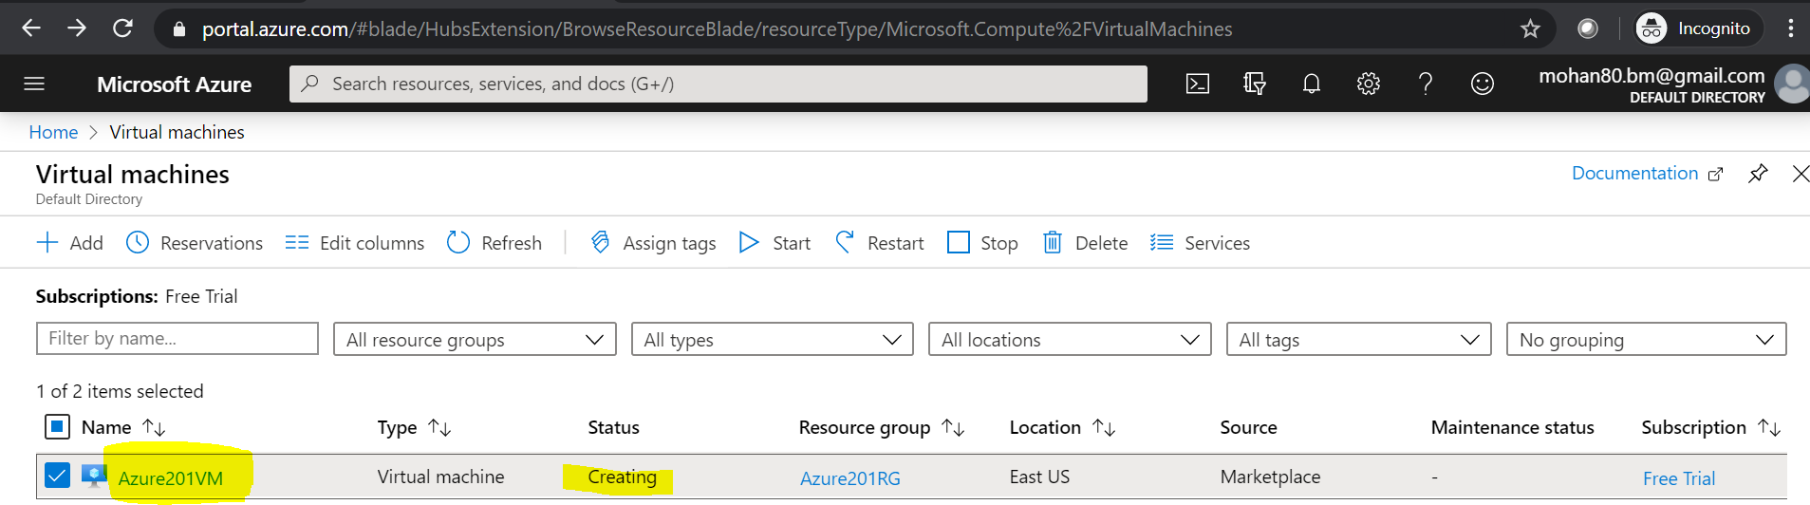

**Few resources are available in the azure portal so it will not take much time to deploy the virtual machine. We can track it in power shell console and azure portal as well.**

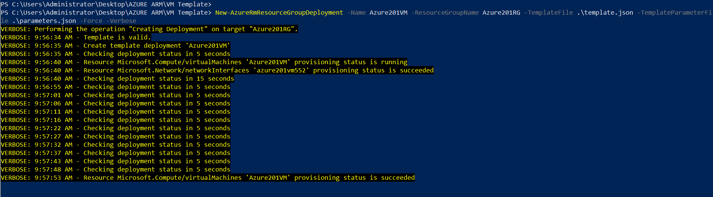

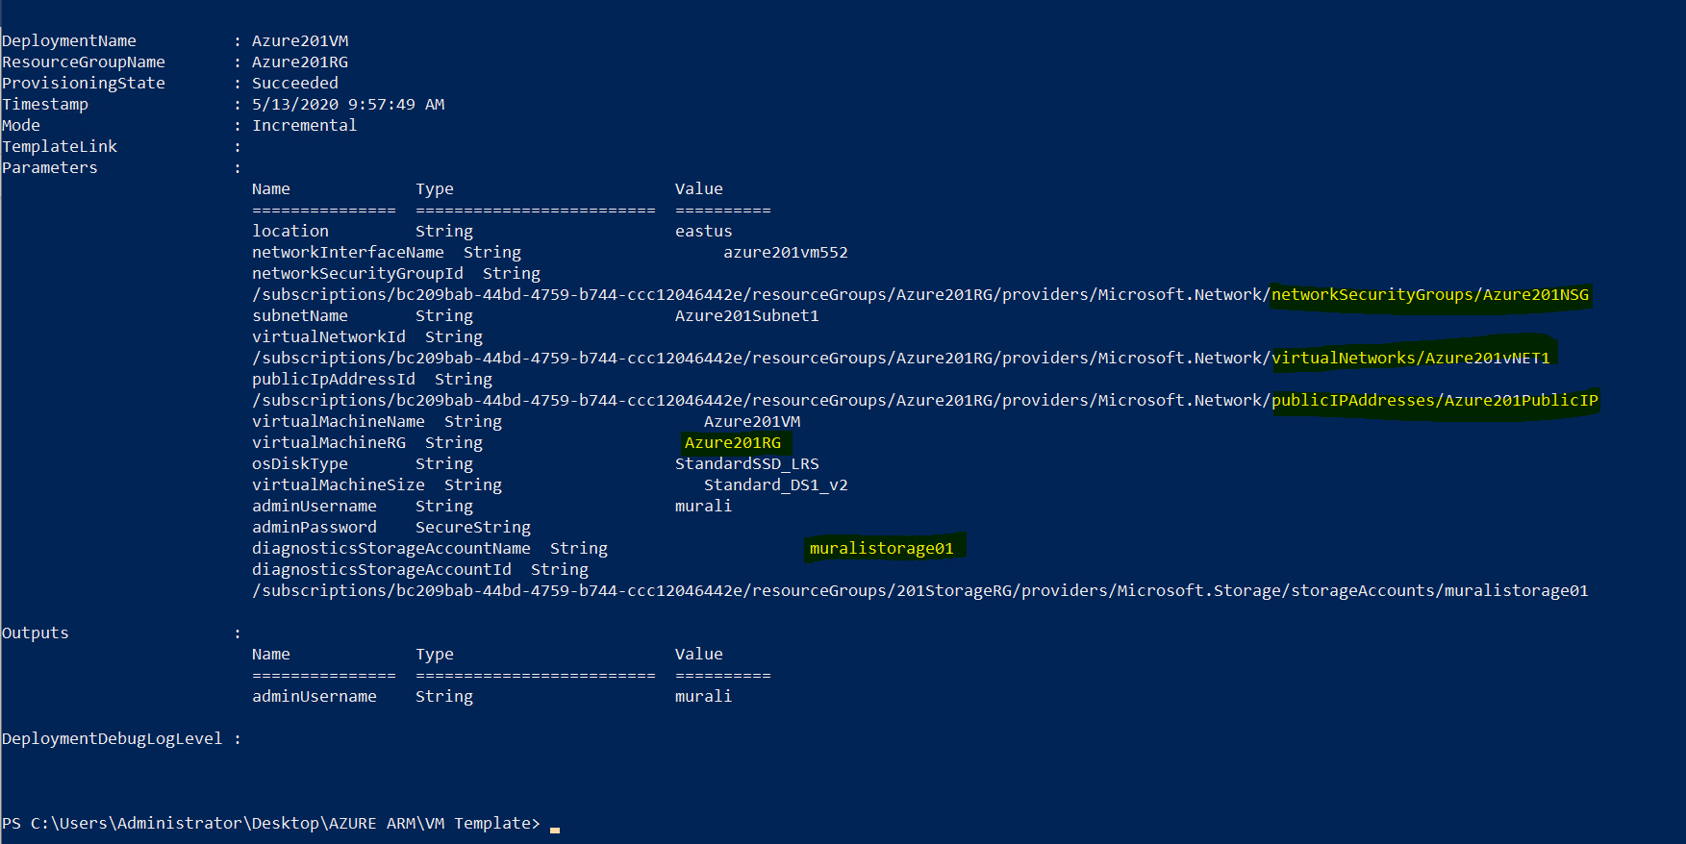

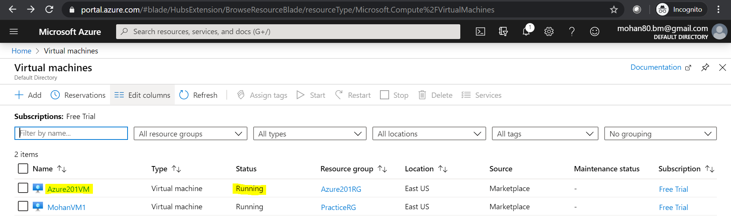

**By clicking on Overview, we can get the newly deployed virtual machine details like public Ip, Computer Name, Location and Network details.**

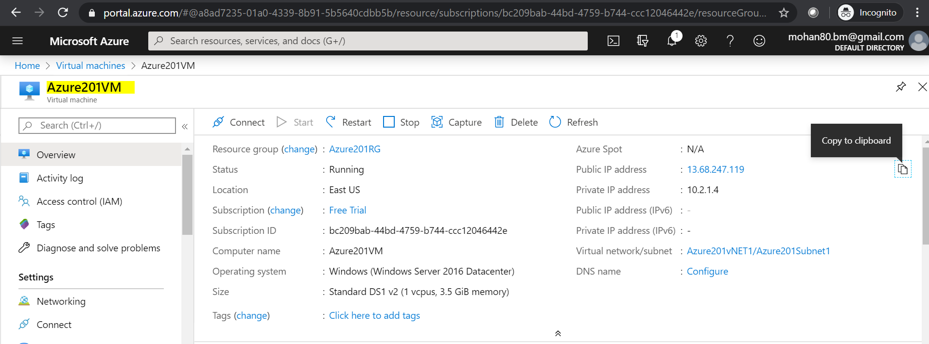

**Accessing VM:**

**We can access VM in two ways.**

1. **Downloading RDP Client from Azure Portal**
2. **Using public IP**

**After downloading VM RDP to local click on that which will prompt for password as it is already have username and other details.**

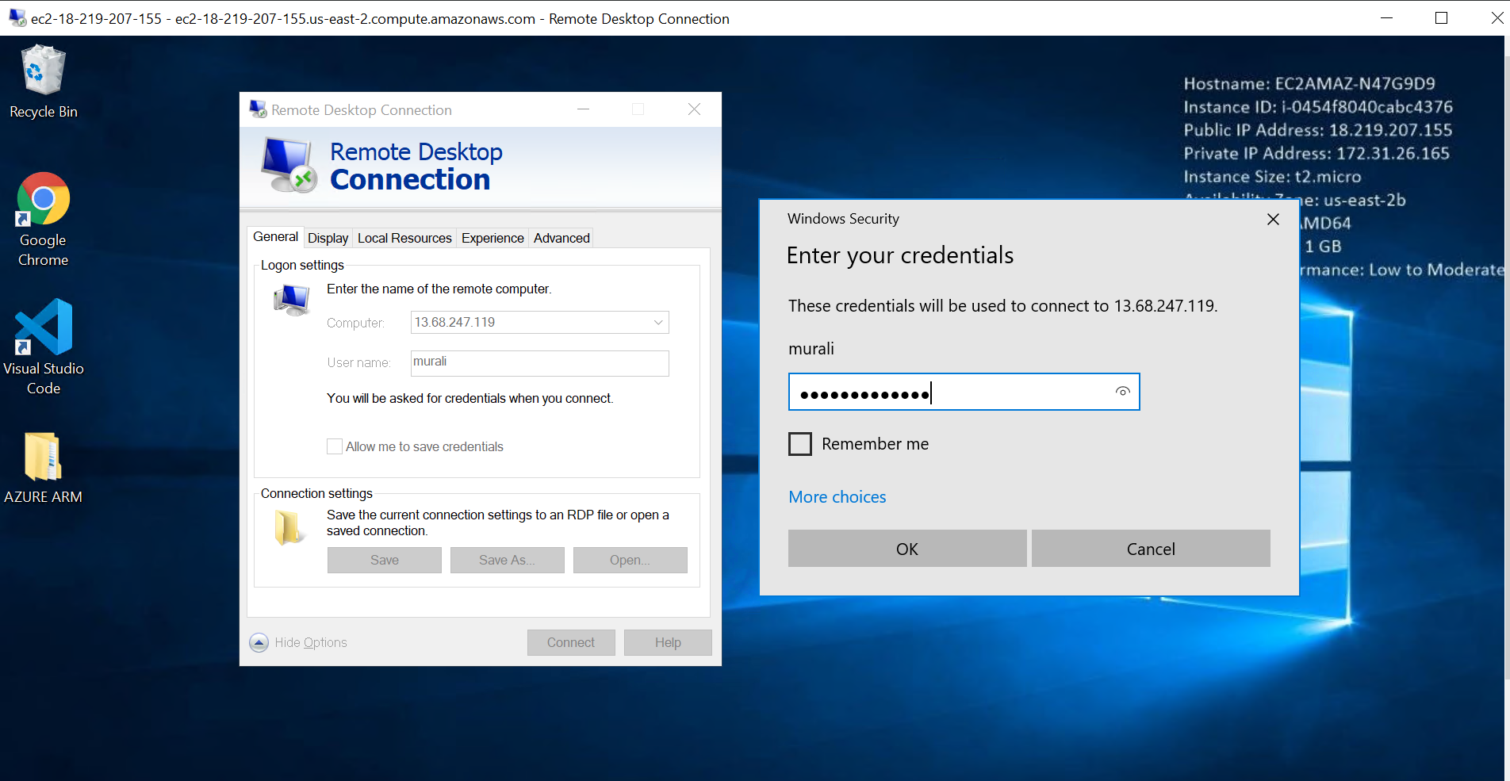

**After login open Server Manger 🡪 Local Server 🡪 Search for IE Enhanced Security Configuration under properties section 🡪 Check off for both users and Administrators.**

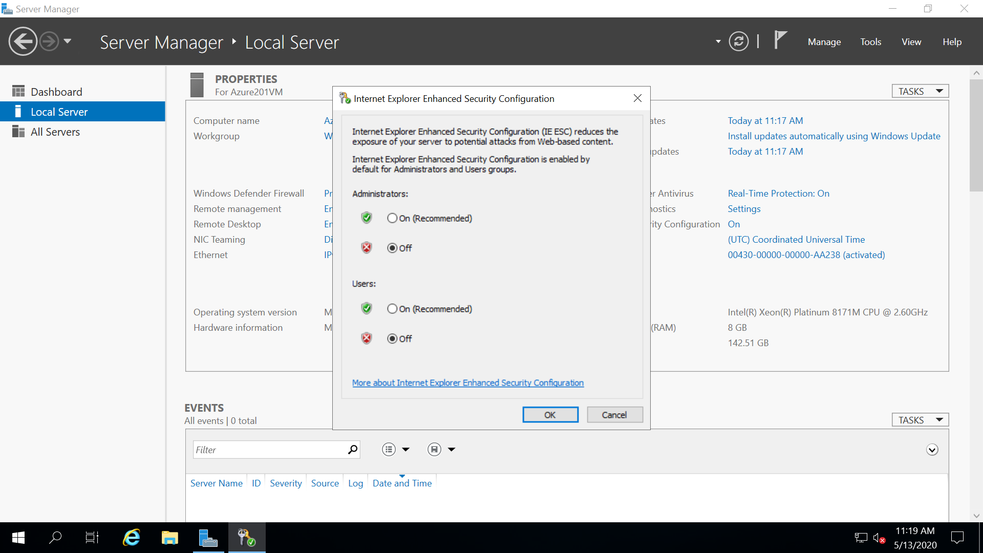

**Install required things in the VM, as I install web Server manually to enable IIS (Internet information Services) , Visual Studio Code (Text Editor) and chrome web browser.**

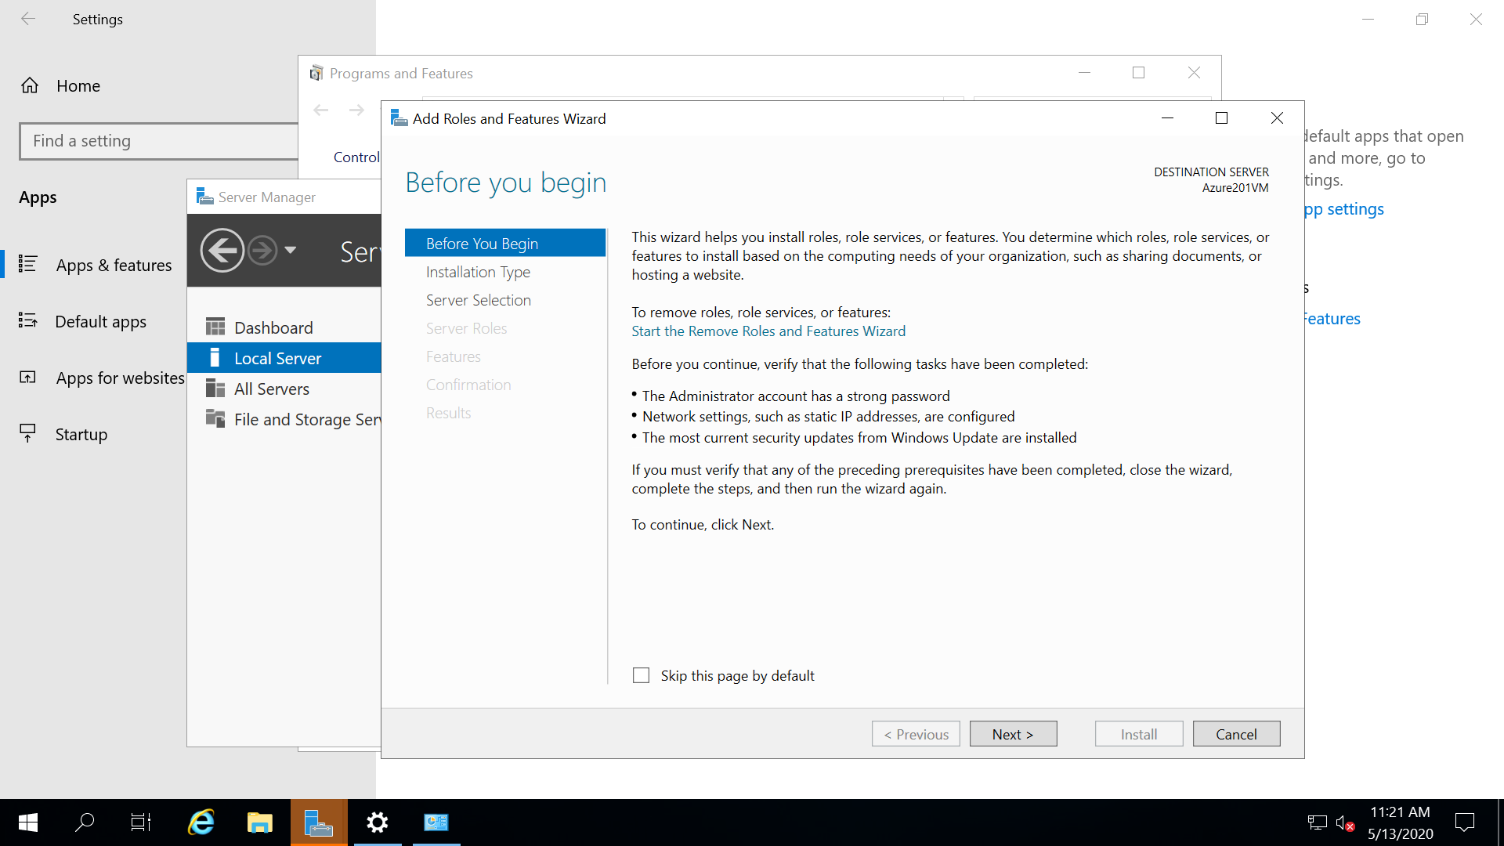

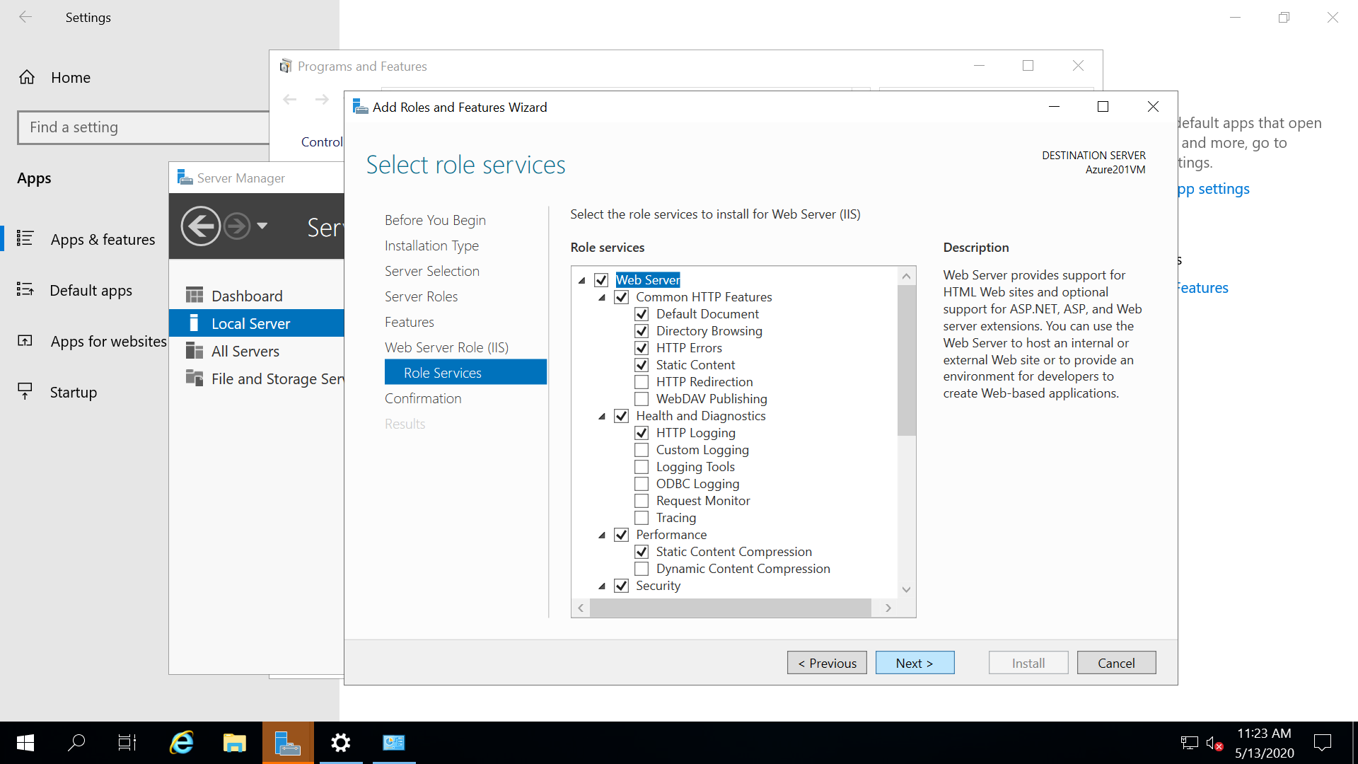

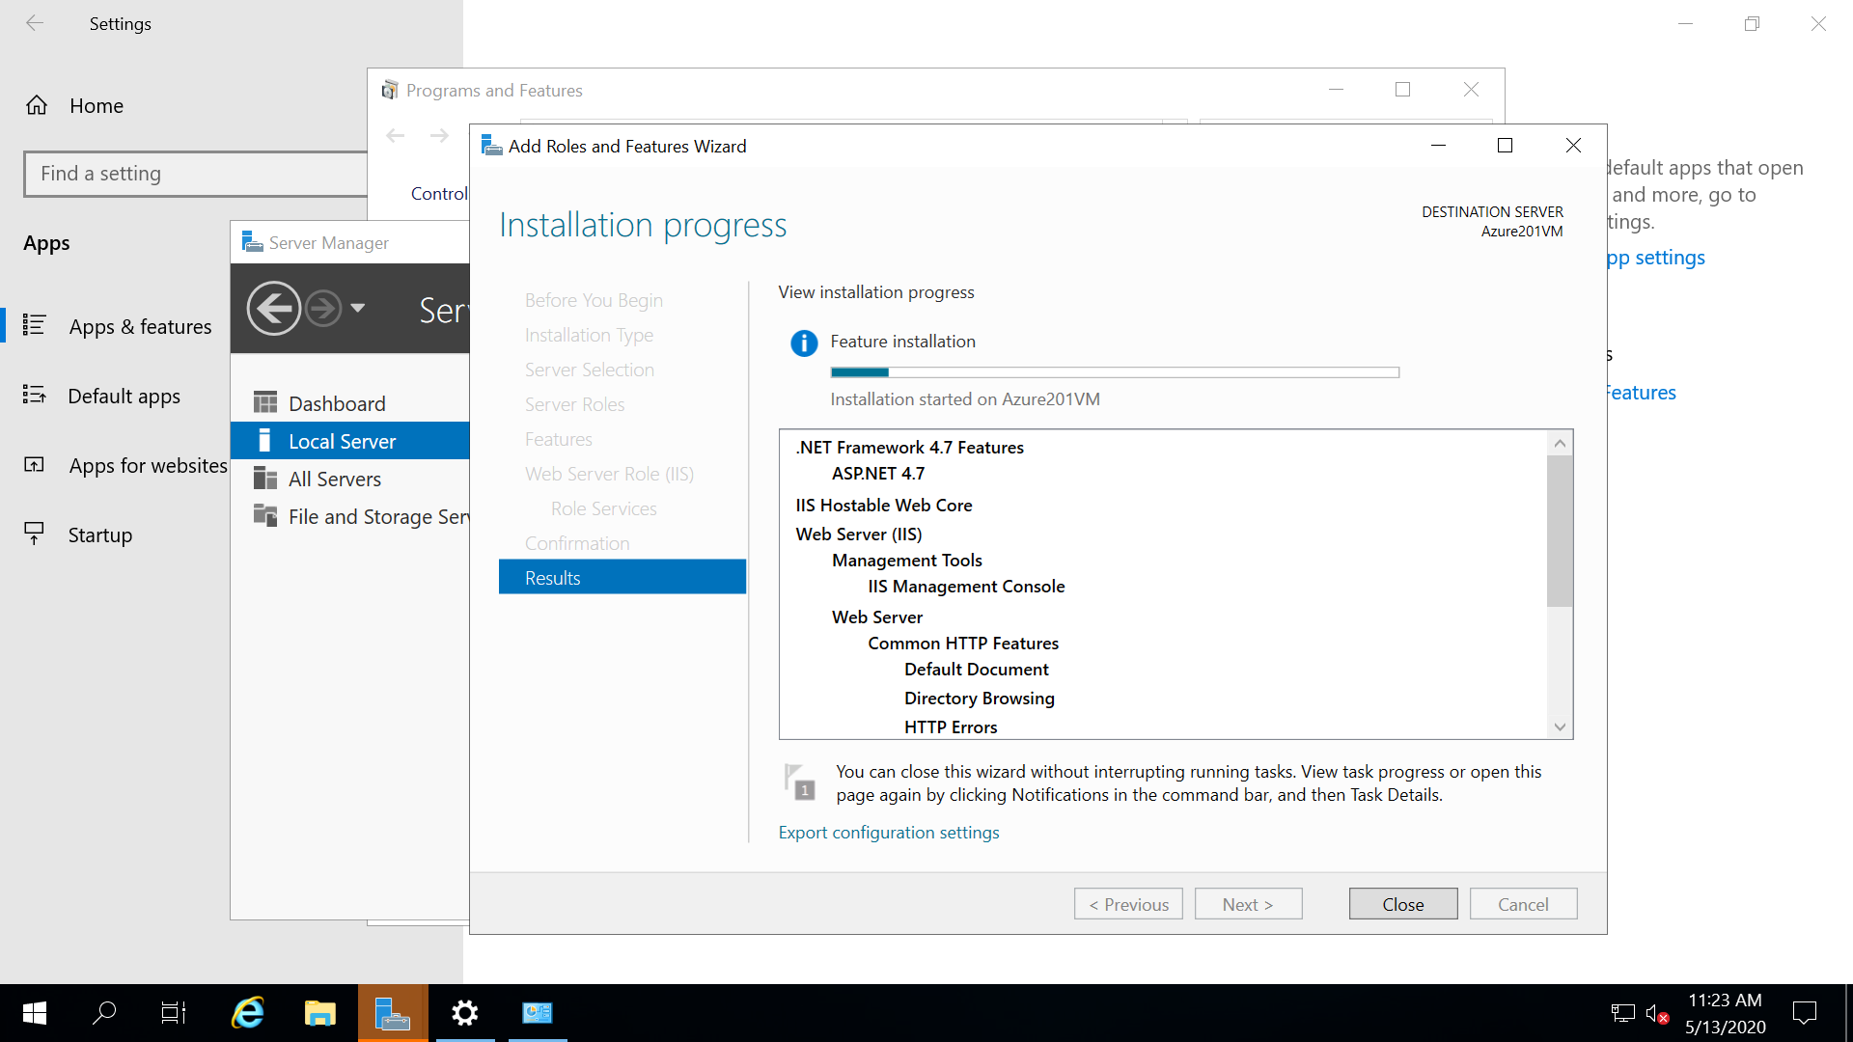

**It will take a while to complete the procedure. After that, open a browser and type localhost to check the web server installation.**

**As it is showing IIS windows server home page so installation done successfully.**

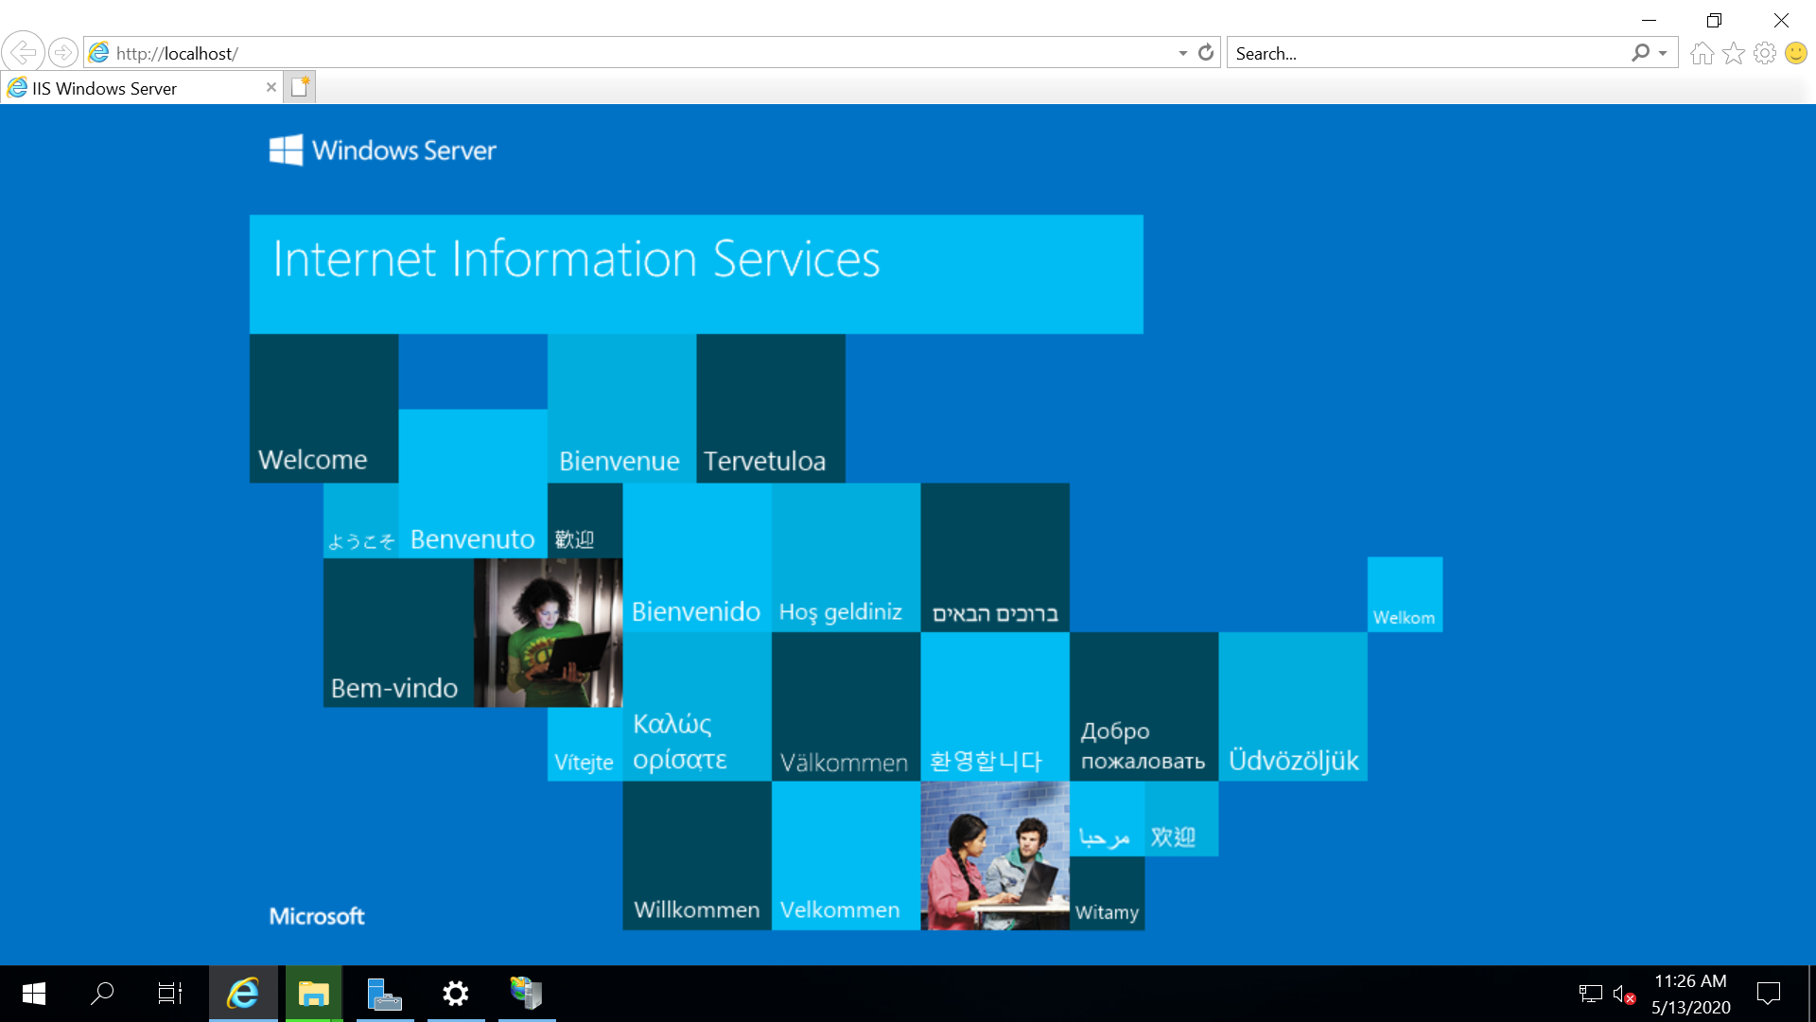

**Deploying Application:**

**Create a sample HTML application and host it in IIS.**

**Change the binding port number to 80 and assign different port number to Default Web Site. So that we can access it with localhoat.**

**To test that open browser inside the VM and type localhost hit enter will display the content as shown below.**

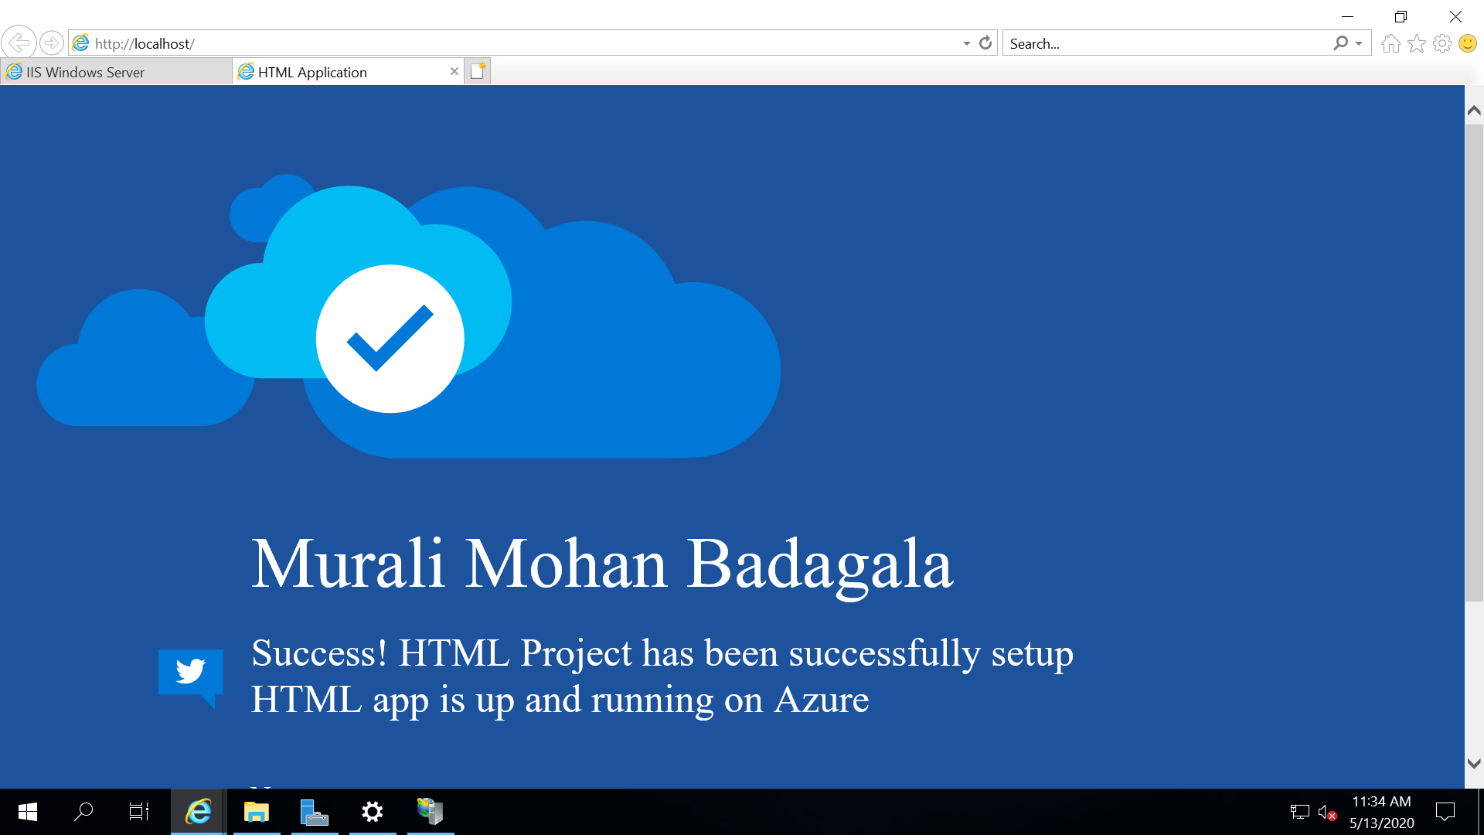

**To test it in outside VM copy public IP and paste it in the browser in local laptop and it will display the same as we get in the VM Browser.**

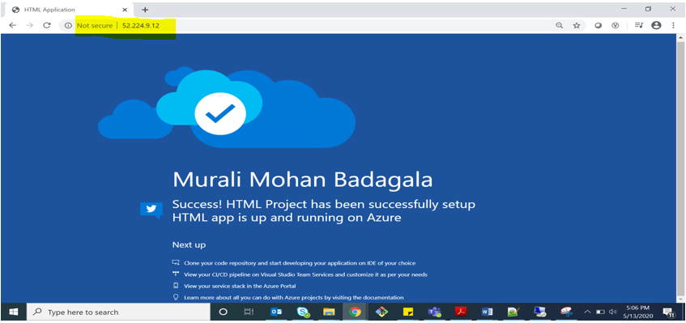

**AZURE APPSERVICES:**

**1). Deploying HTML Application in App Services:**

**Creating HTML Application :**

**Installed Visual Studio Code Text Editor. Click on Extensions 🡪Search for Azure App Service🡪 install that extension as shown.**

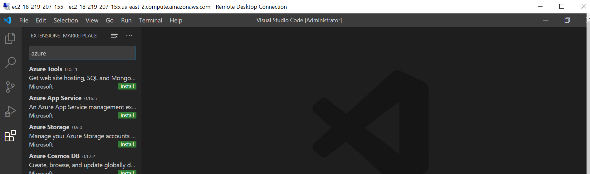

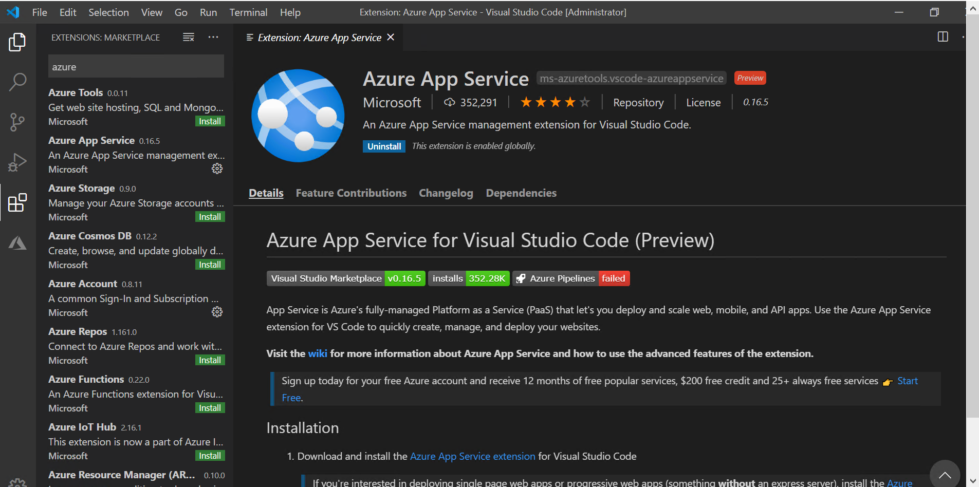

**After installation for the first time it will ask for azure signin credentials. Provide credentials.**

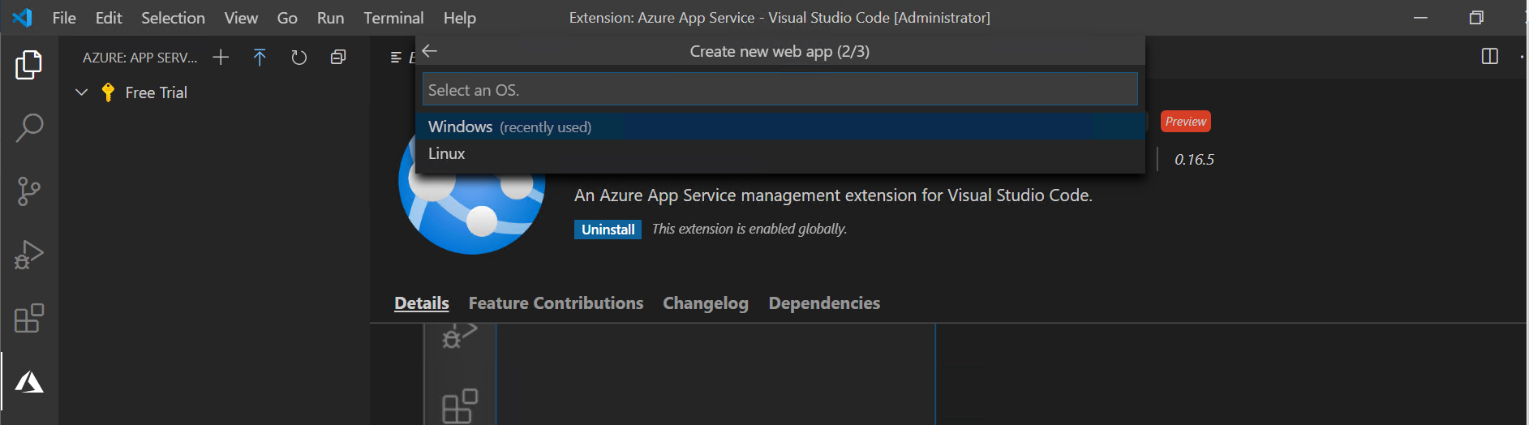

**Create a sample HTML application for windows environment.**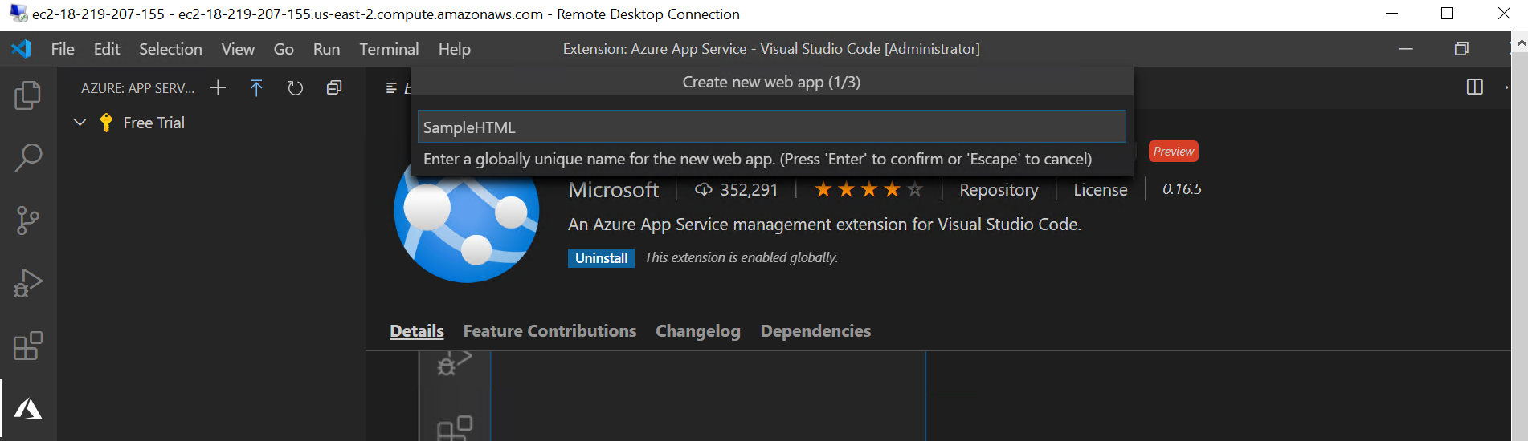

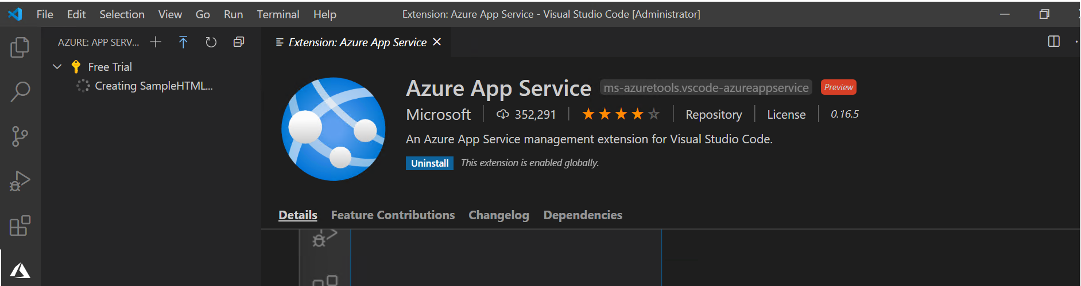

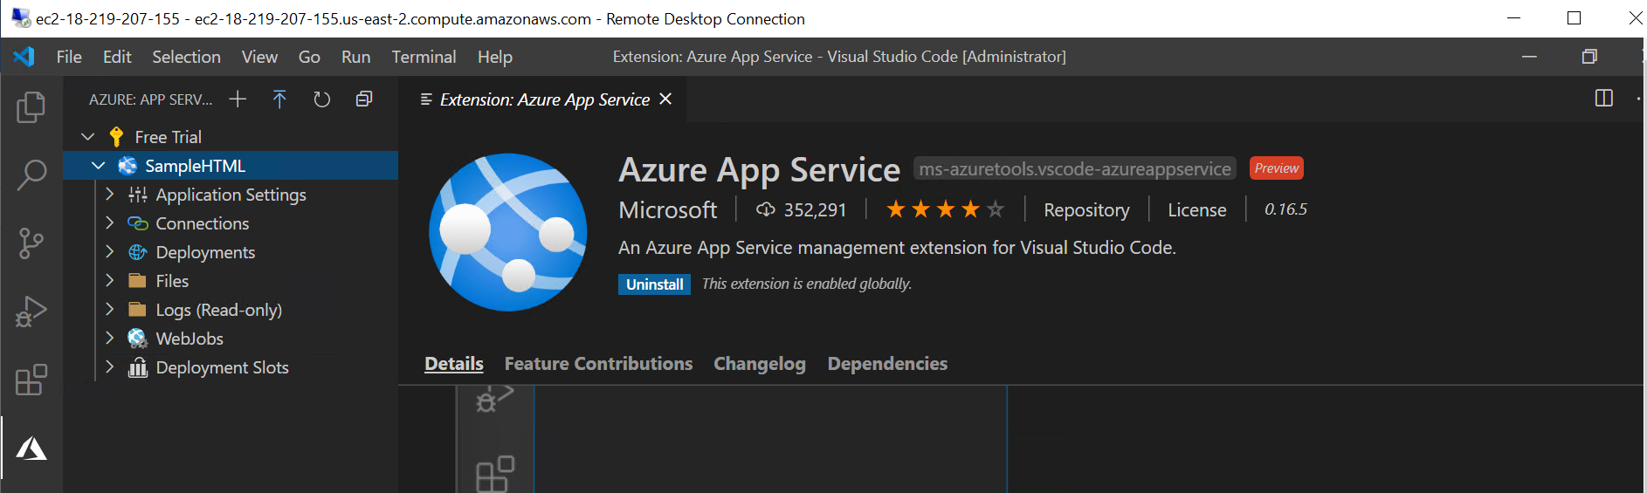

**As the above screen SampleHTML application is generated using Visual Studio Code and we can see that in Azure Portal.**

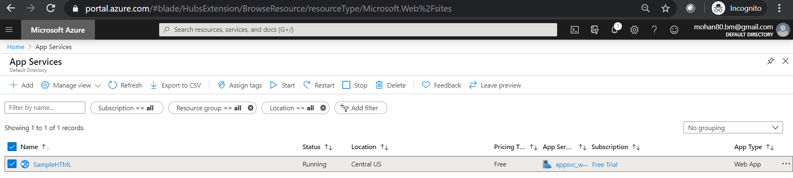

**Go to Overview page and grab URL to test that app service.**

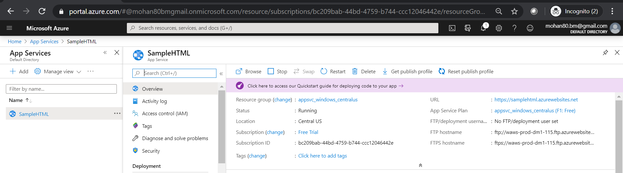

**Paste the URL in Web Browser will display the web page as show below.**

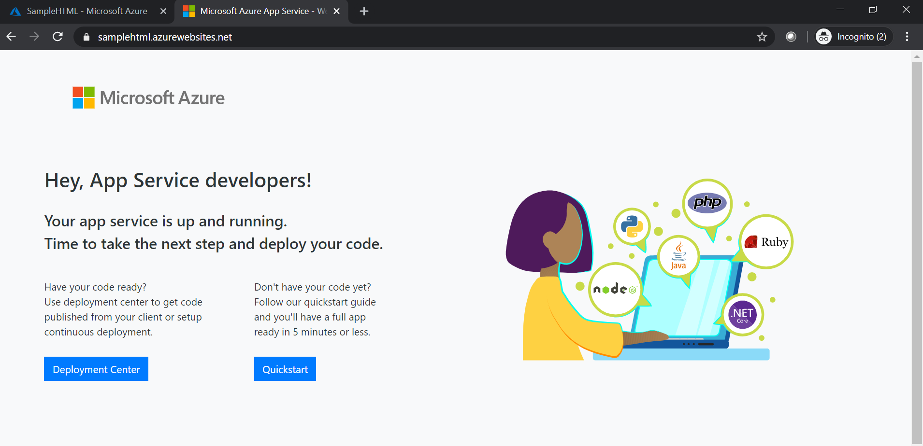

**Hosting Web Application In the deployed Virtual Machine:**

**Testing the Newly deployed virtual machine by entering the Public IP in Local machine will give the**

**Default IIS web page.**

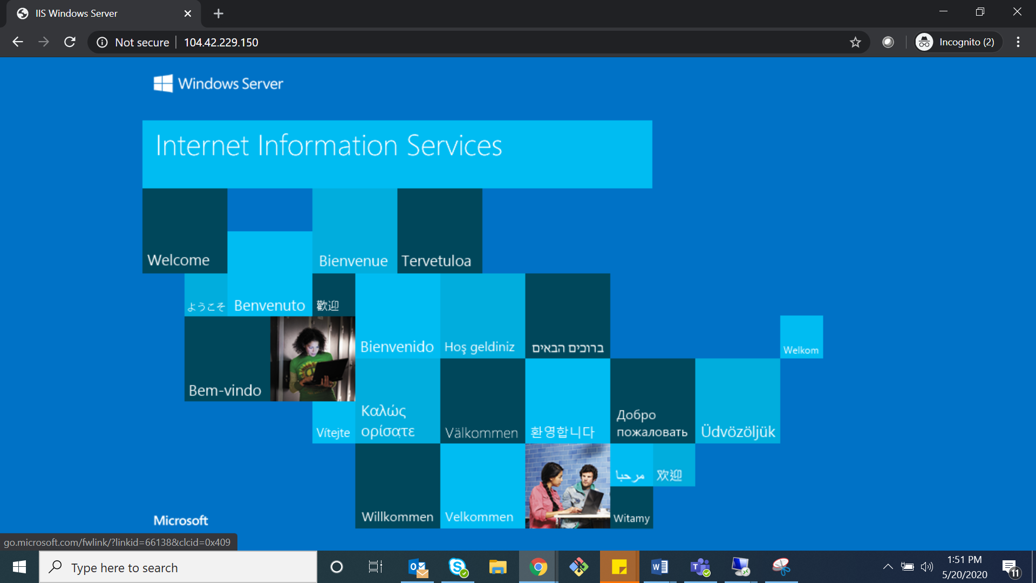

**Create a Web Application using Visual Studio 2019 build the application. After successful build for publishing the website from Visual studio to Azure Virtual Machine, we need to install WebDeploy.**

**Download it from official Microsoft site and install WebDeploy.**

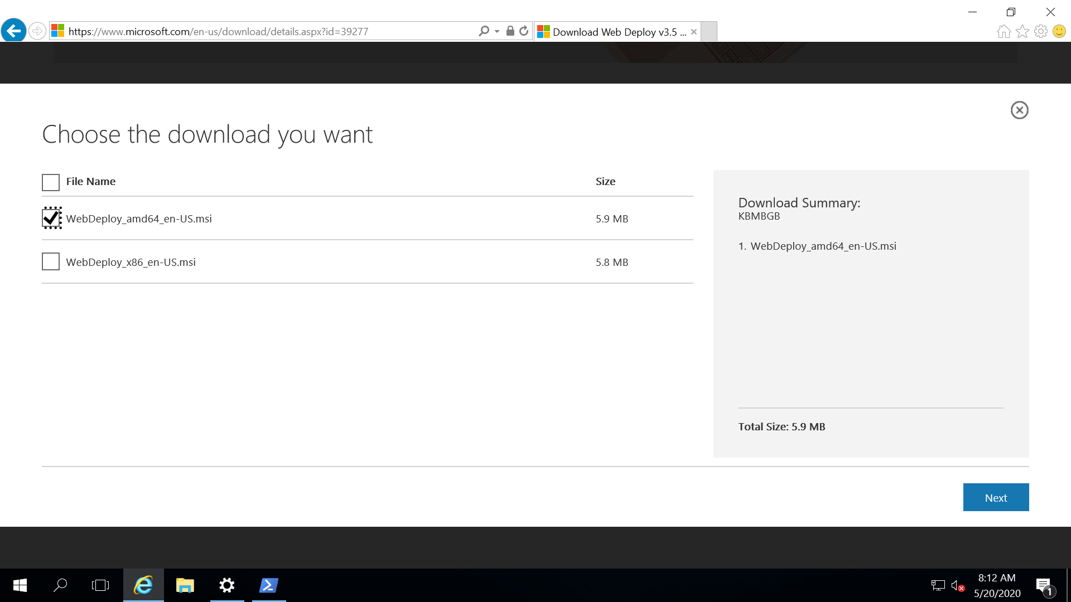

**In Visual Studio right click on application 🡪 Click on publish to deploy it to Azure.**

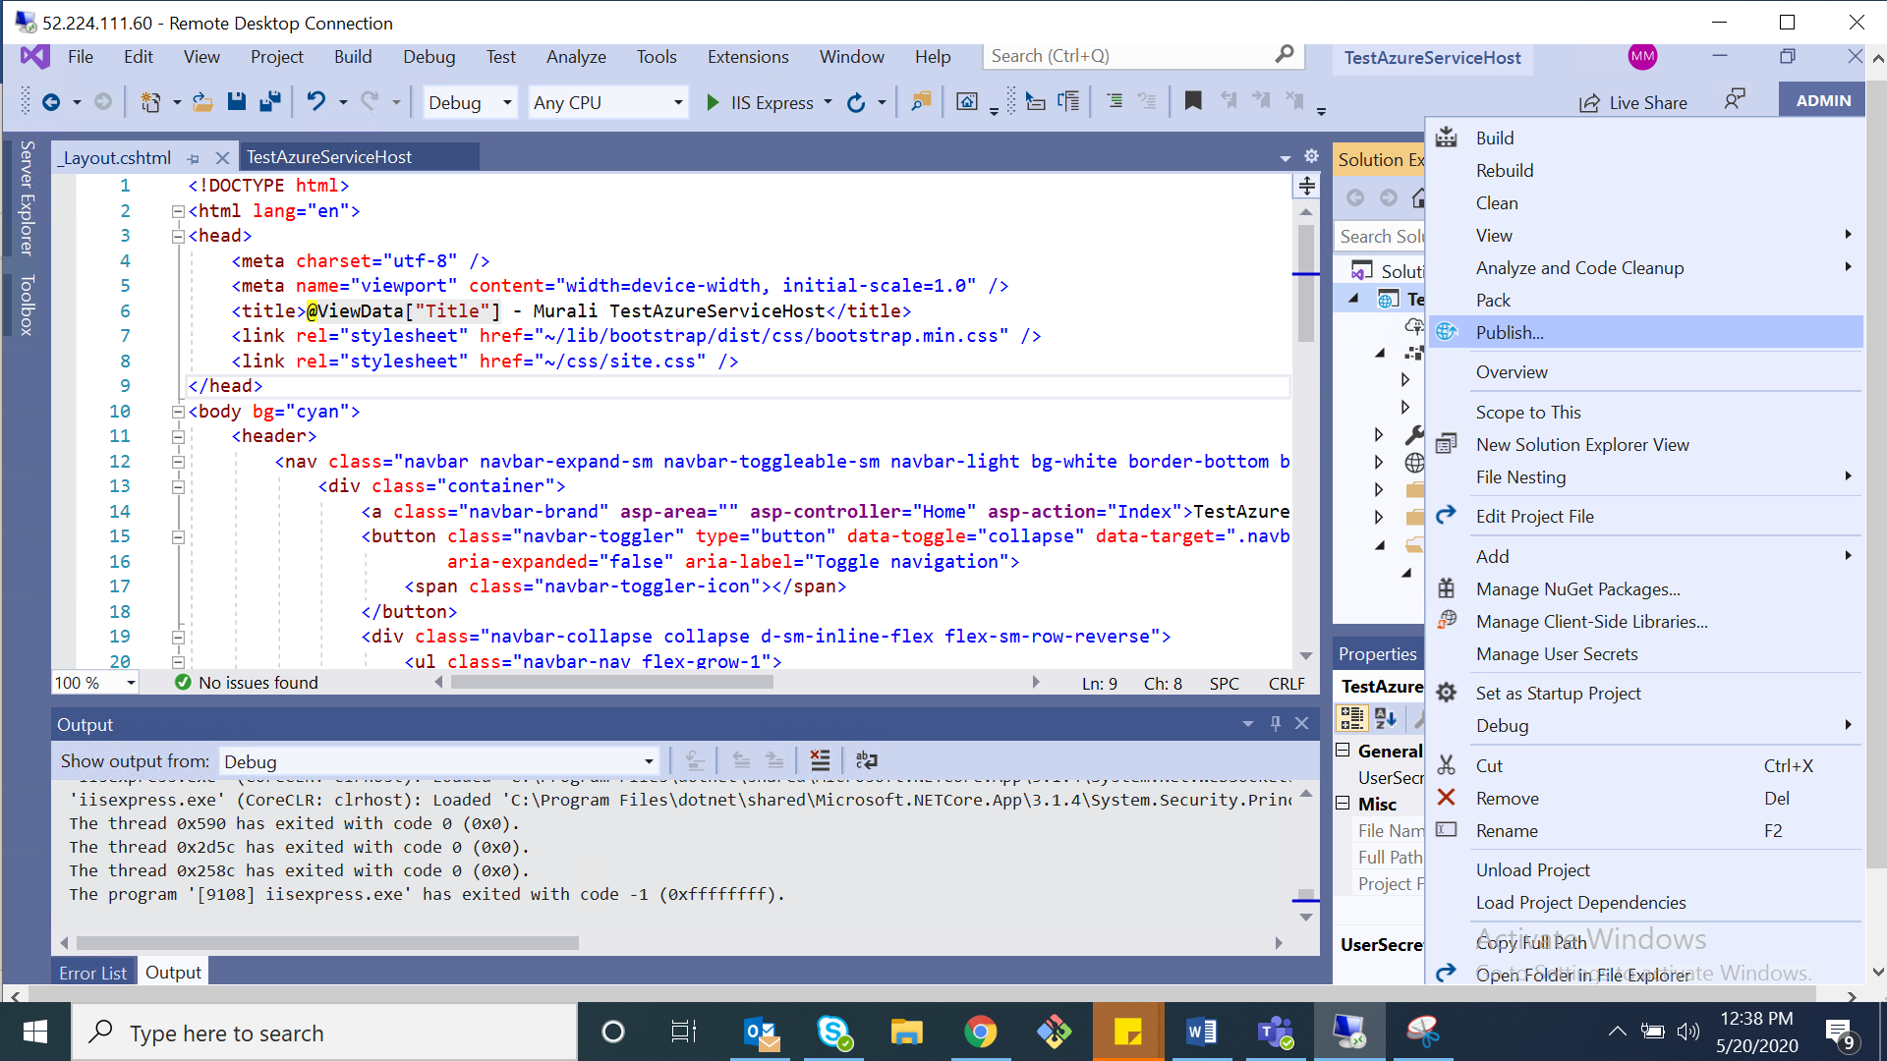

**In the publish wizard Select New 🡪 Select IIS, FTP, etc. as a target 🡪 Select Configure Checkbox and Click on Create Profile** 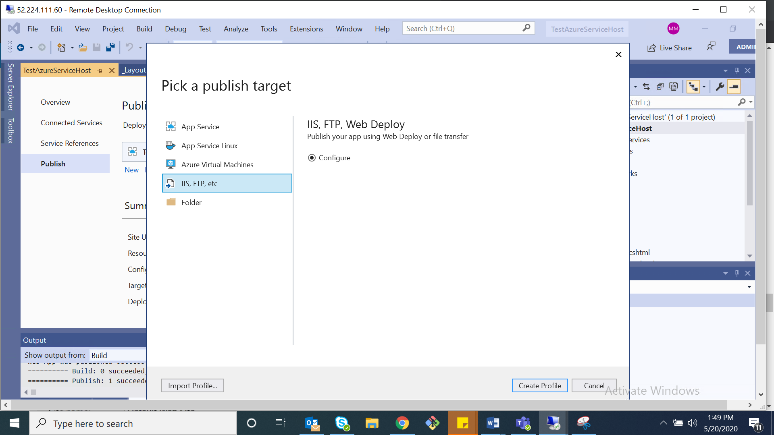

**In the Custom Profile Wizard Select Web Deploy as a publish method. And Provide Server Detials(Public IP of the VM),Credentials to login 🡪 Click on Validate Connection🡪Click on Next**

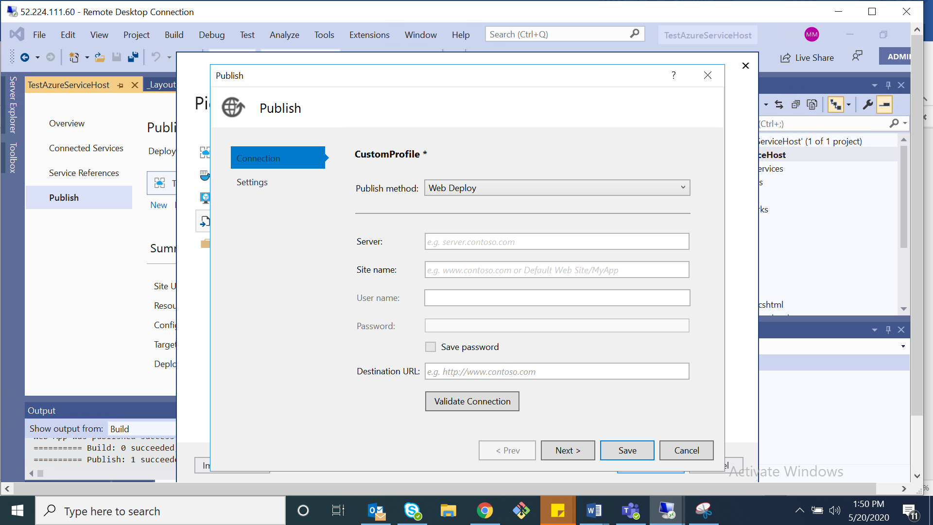

**Accept the Security Certificate and Publish profile created successfully.**

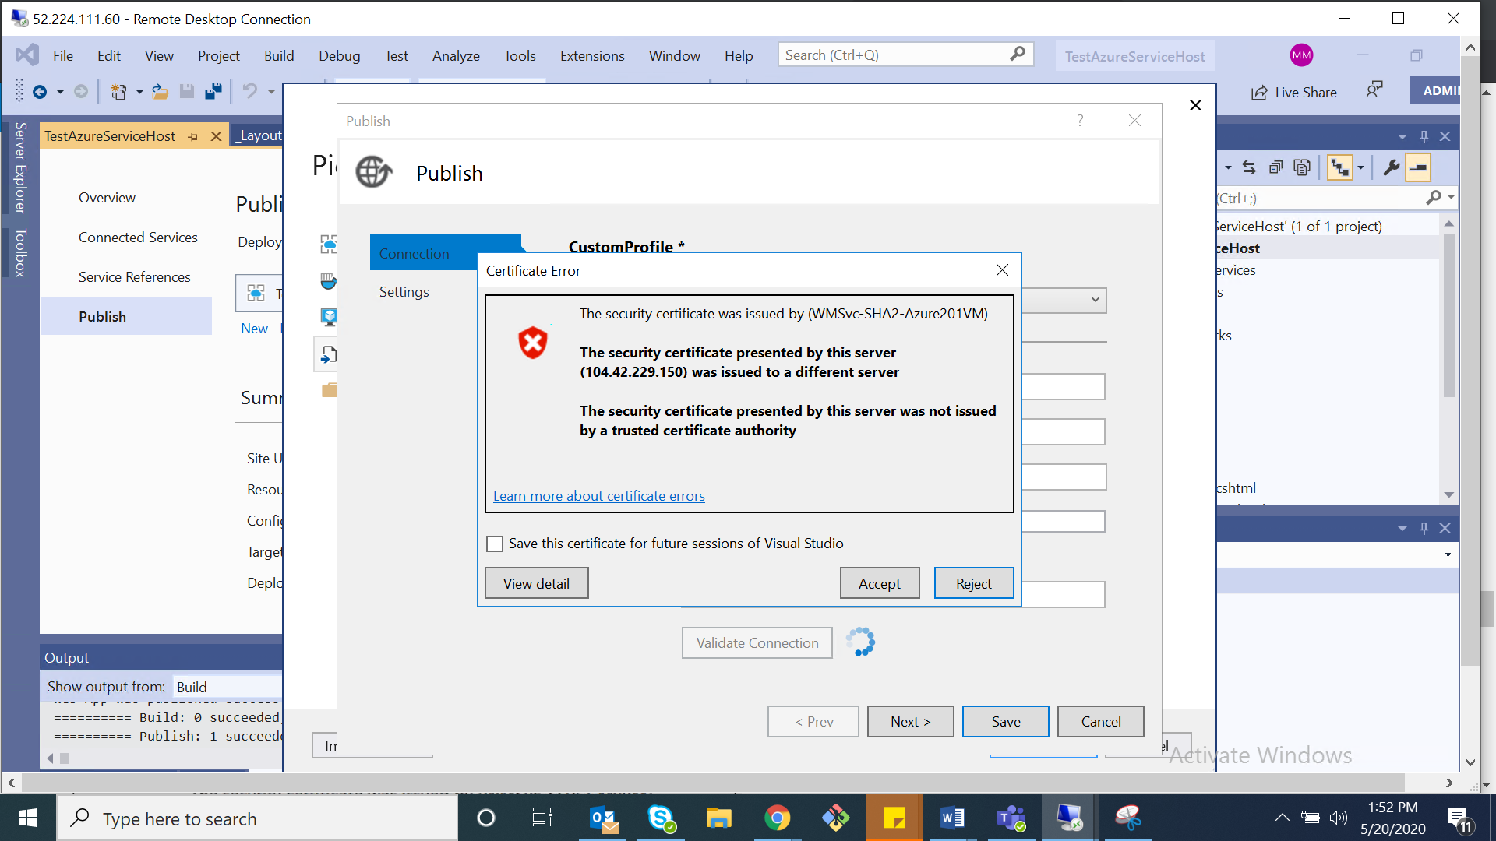

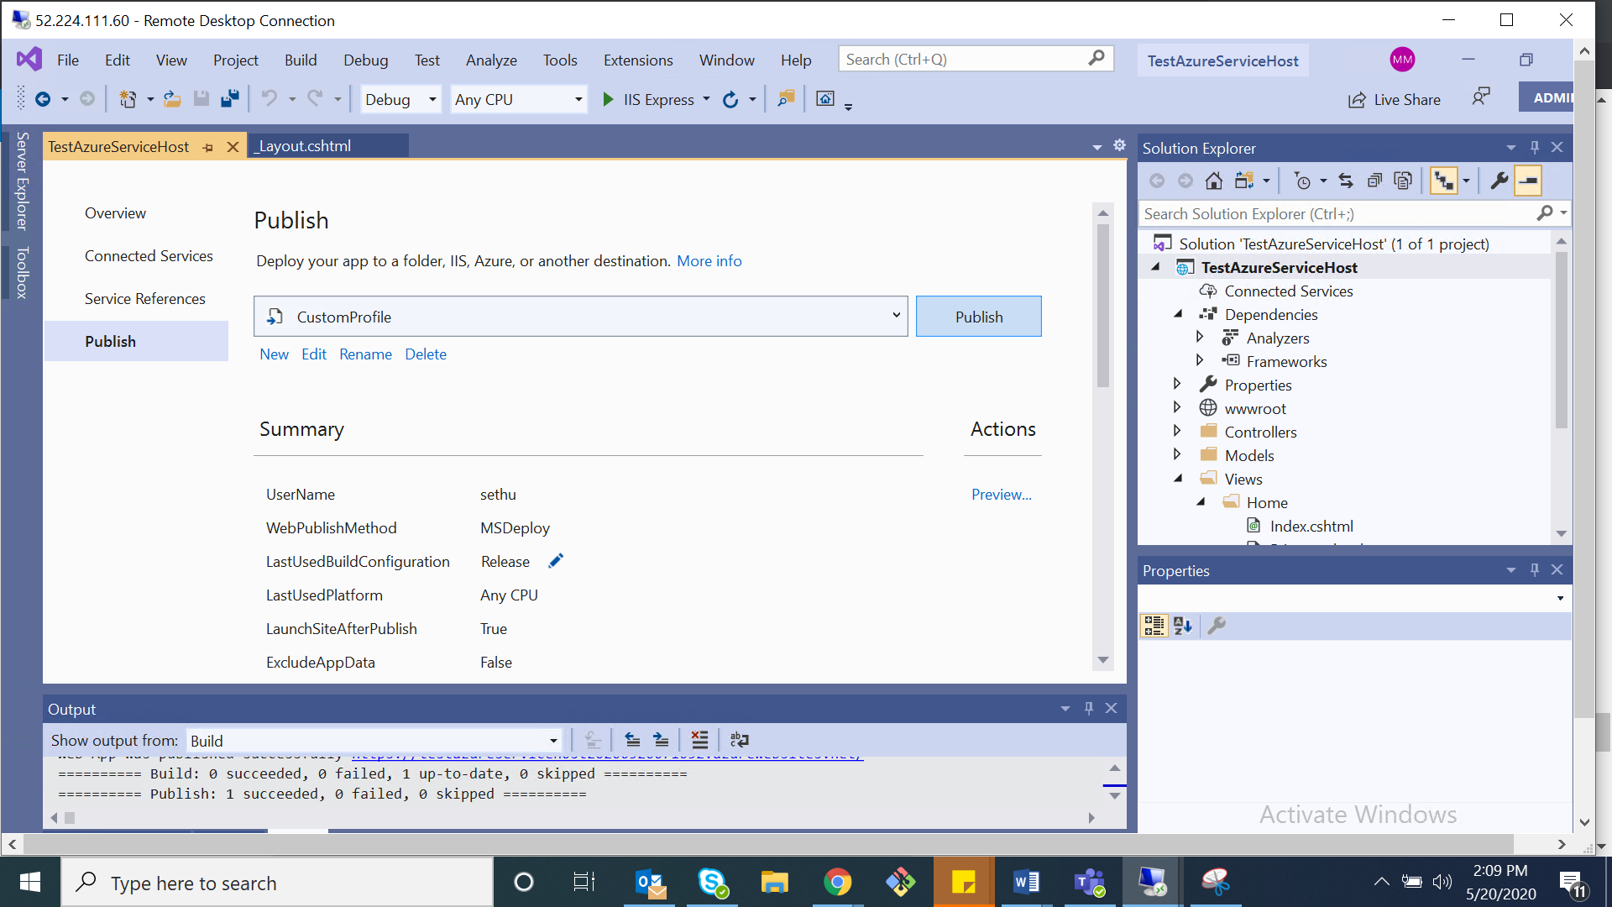

**Click on publish to host the application in Azure Virtual Machine. Below screen shows Build and publish succeed.**

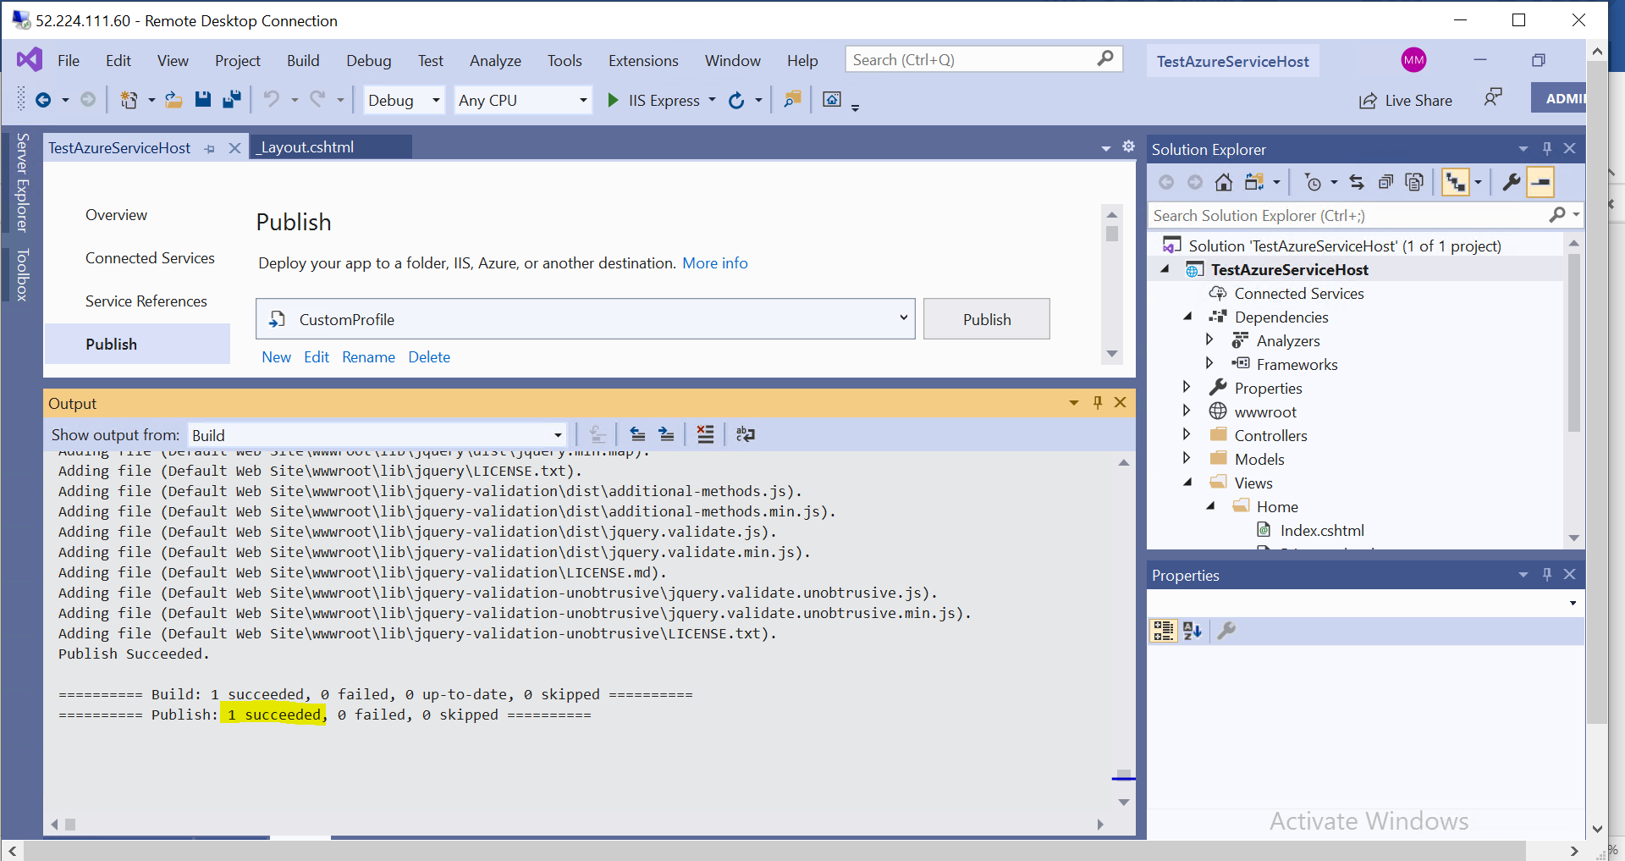

**Go to Internet information Service to Check the published code .in my case testazureservicehost is published successfully.**

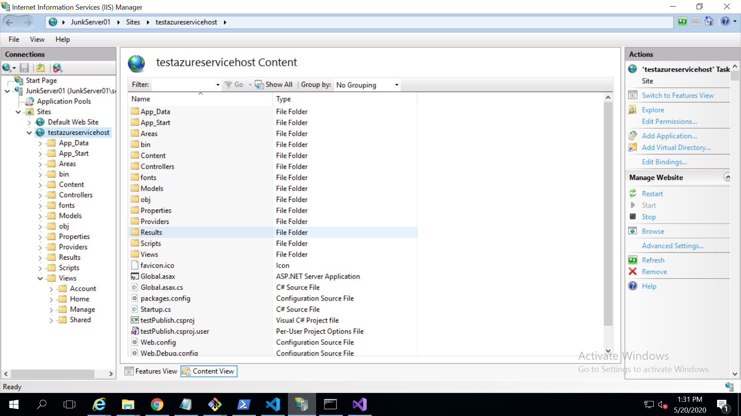

**Before host it will display IIS webserver as a default page.**

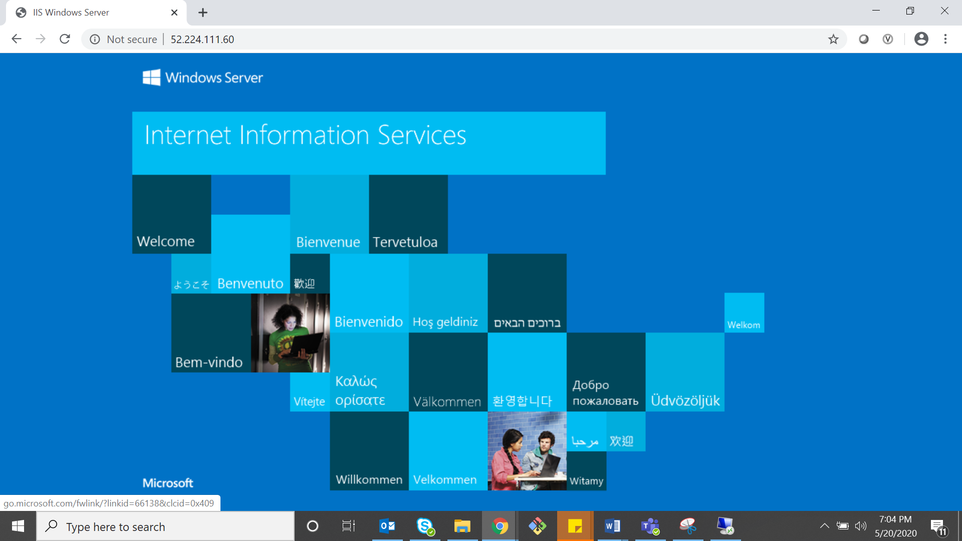

**After host, it will display the TestAzureServiceHost home page.**

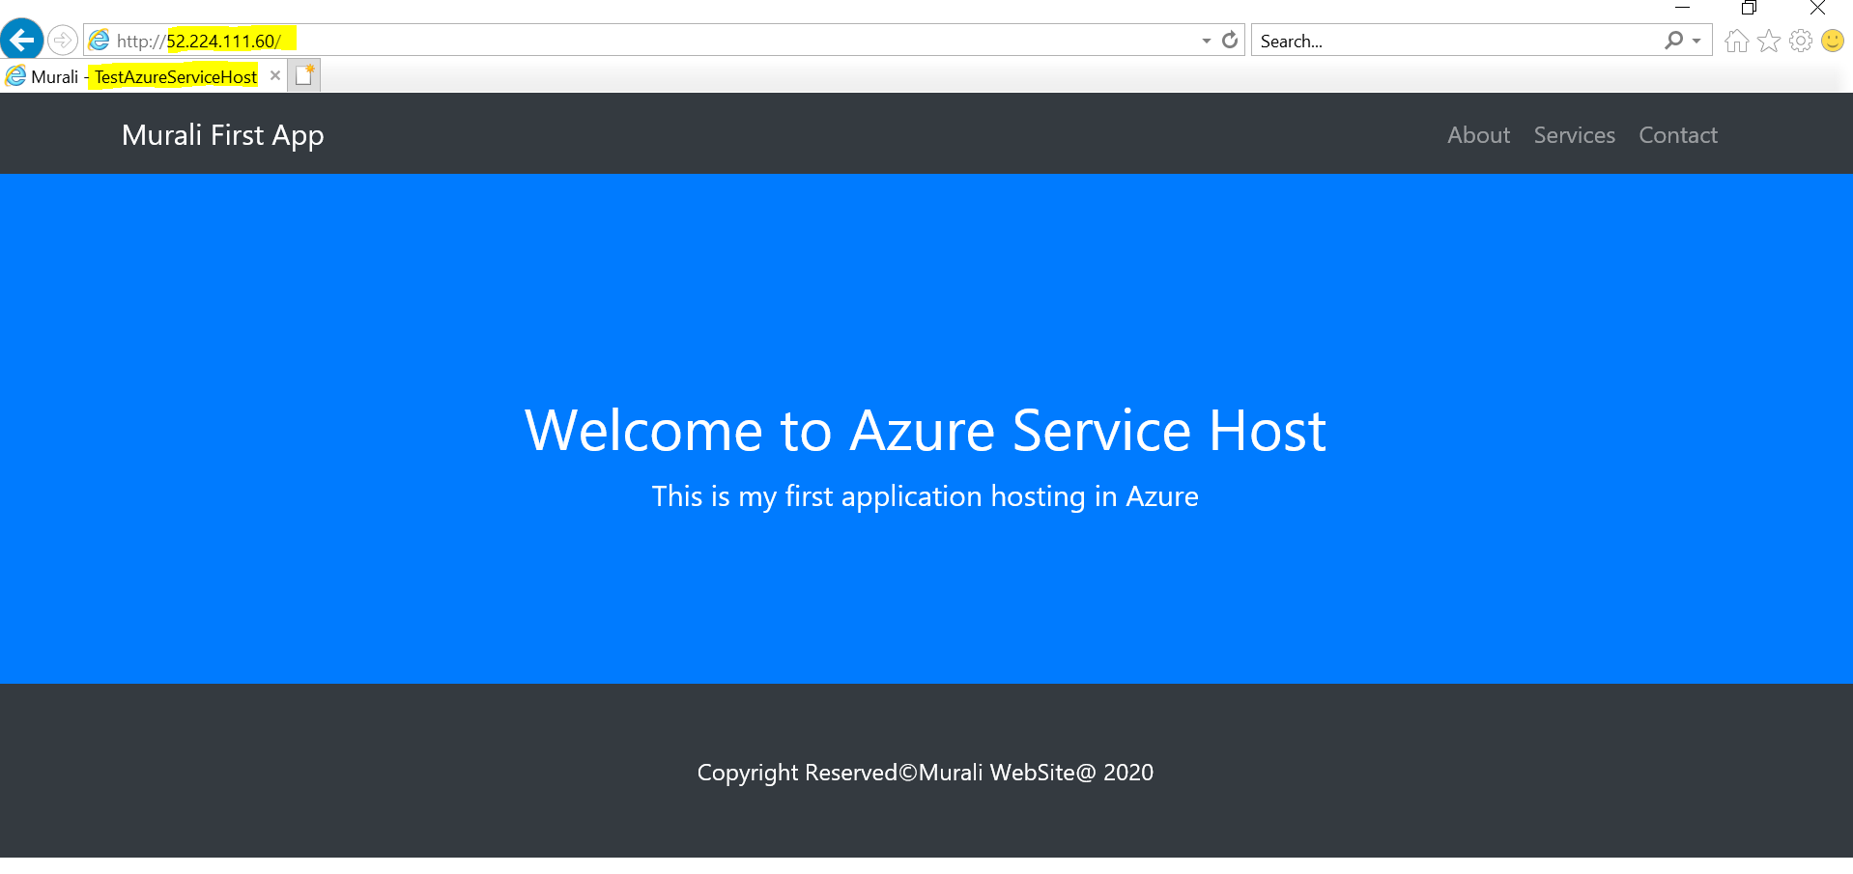

**AZURE FUNCTIONS:**

**Create a folder called Function Template and place ARM templates as shown below.**

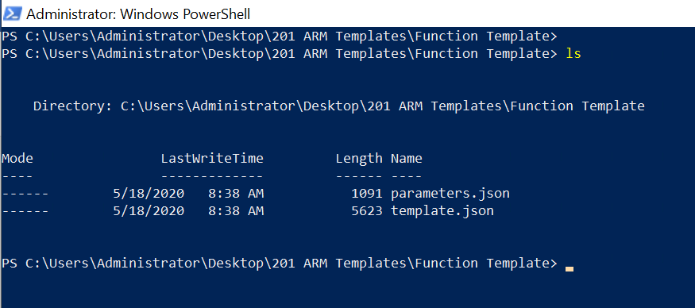

**Run the below command to create azure function under MuraliFunctionRG resource group.**

New-AzureRmResourceGroupDeployment -Name Azure201Deploy -ResourceGroupName MuraliFunctionRG -TemplateFile .\template.json -TemplateParameterFile .\parameters.json -Force –Verbose



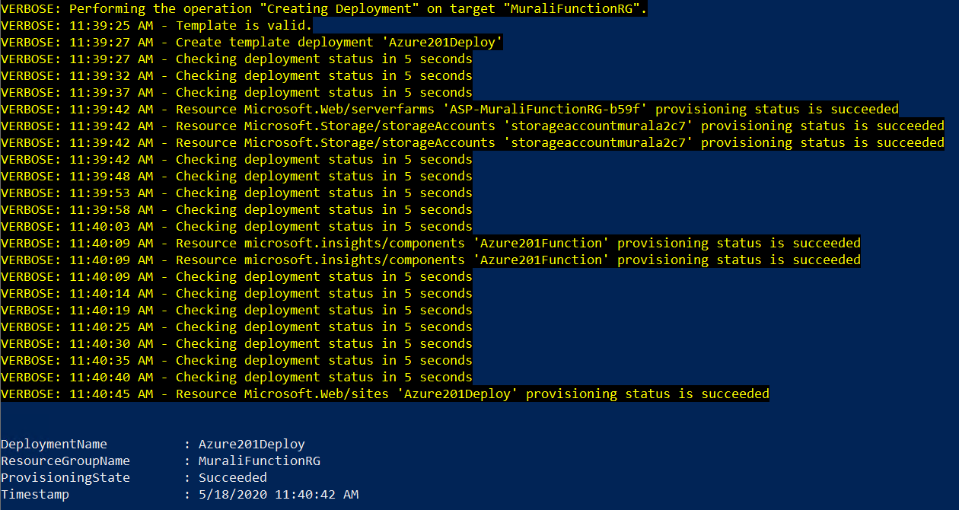

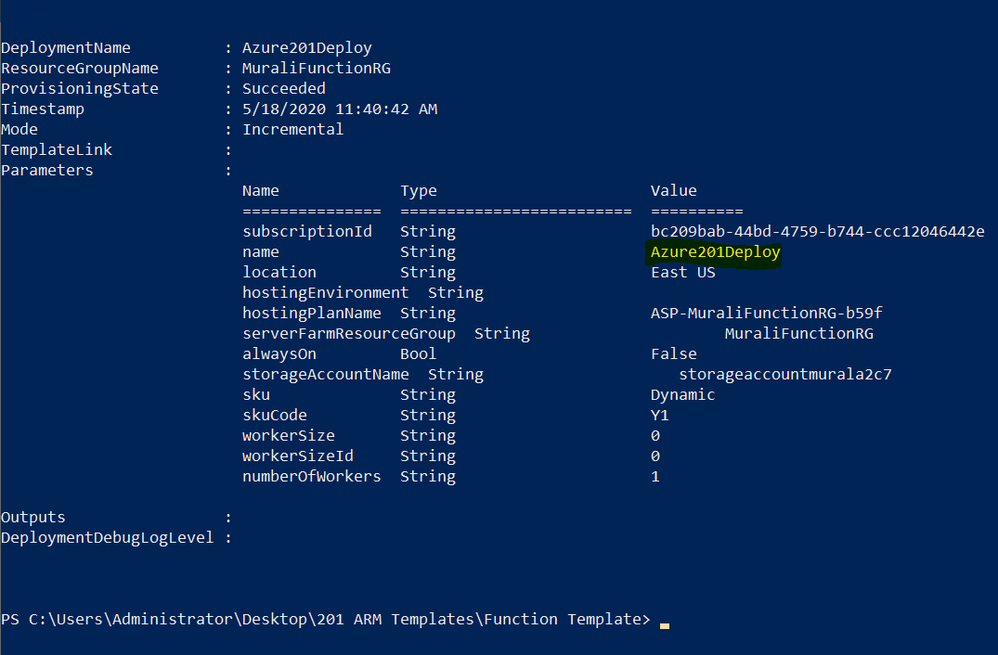

**Check the deployed azure function in the azure portal.**

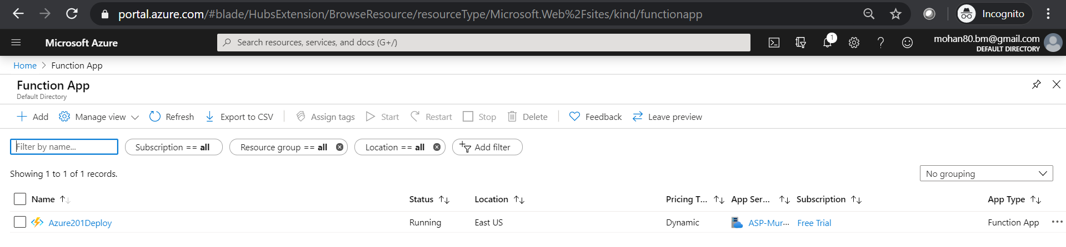

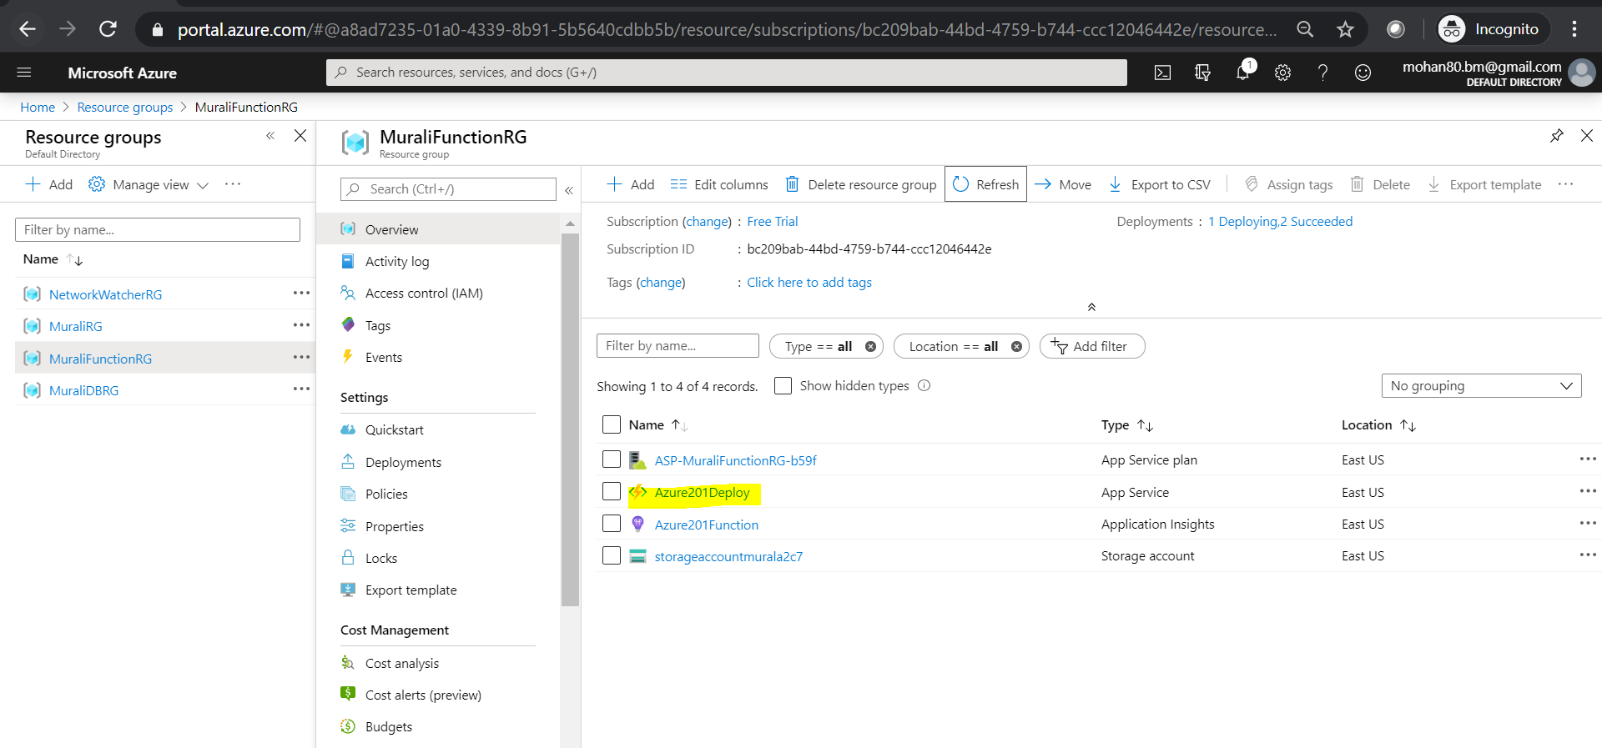

**Add a new HTTP trigger Function for testing.**

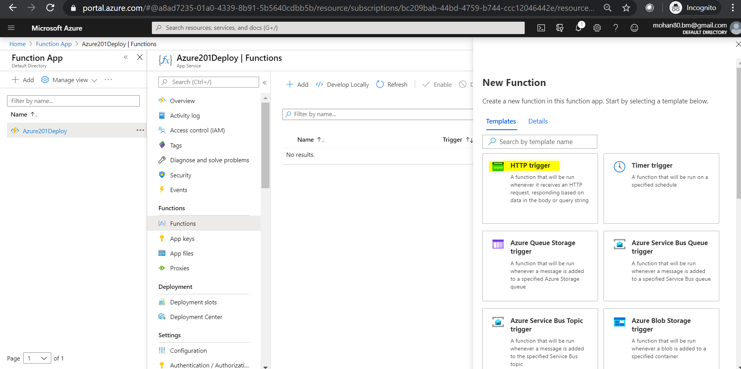

**Azure201HttpTrigger1 function is created successfully with the code. It will accept a input as a parameter in the query string.**

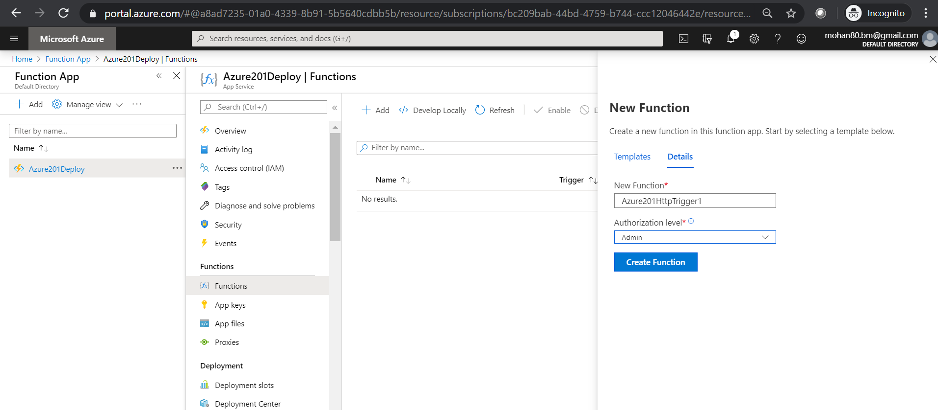

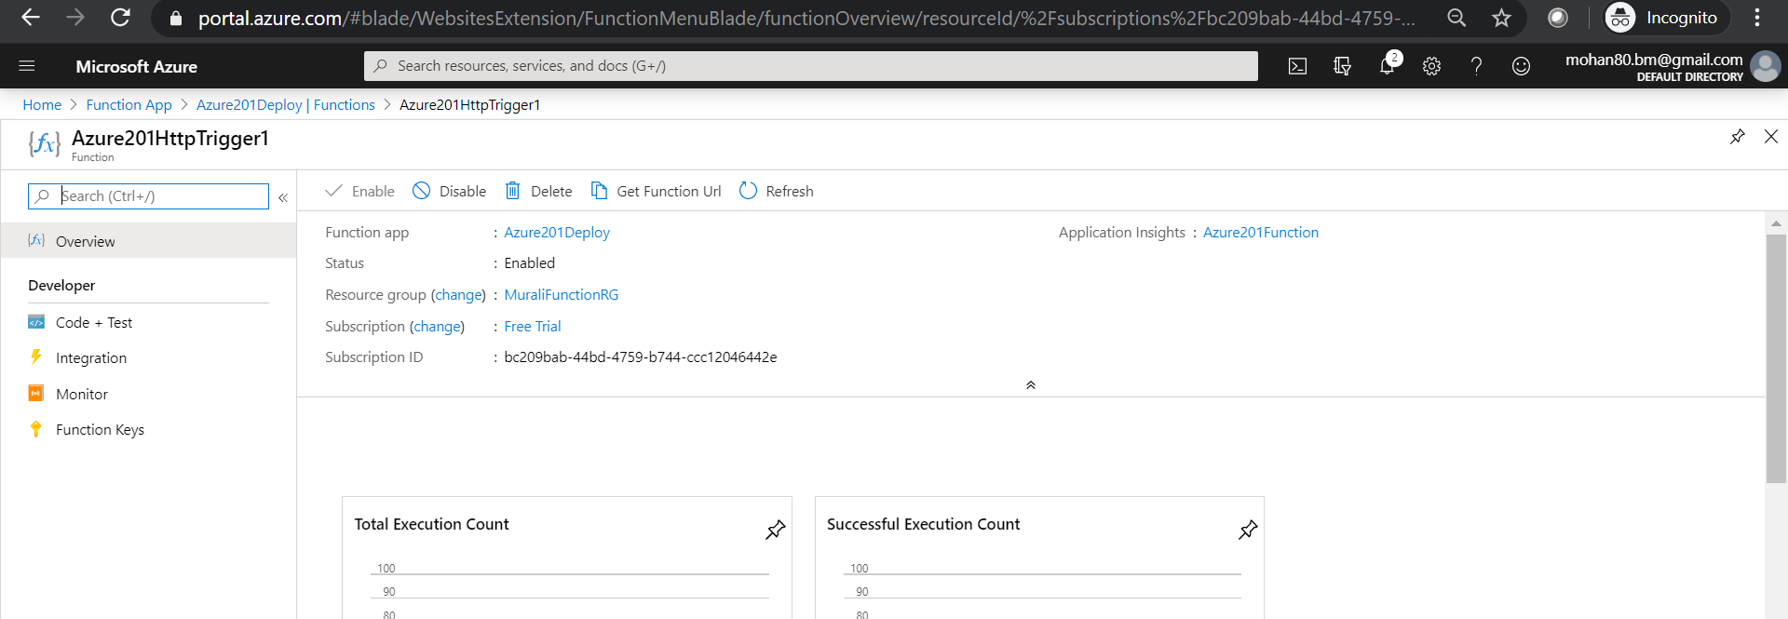

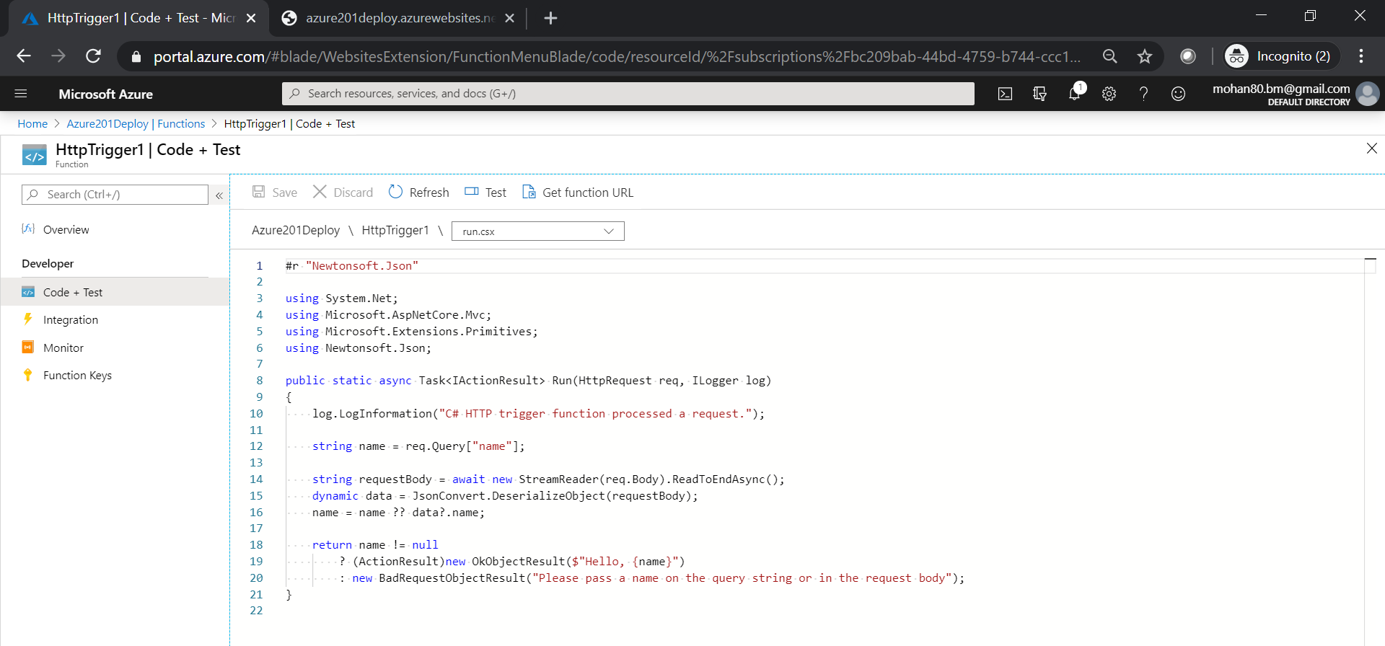

**Click on the Get Function Url and copy and paste it in browser to test the azure function.**

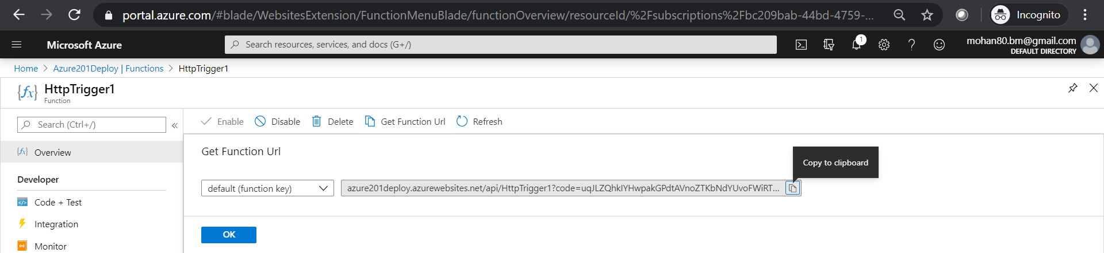

**Run the URL without passing a query string parameter then it will throw error.**

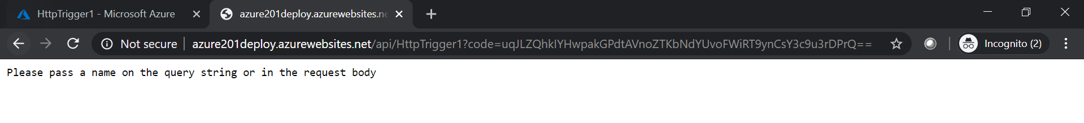

**Now pass the name a query string parameter then it will display Hello Message.**

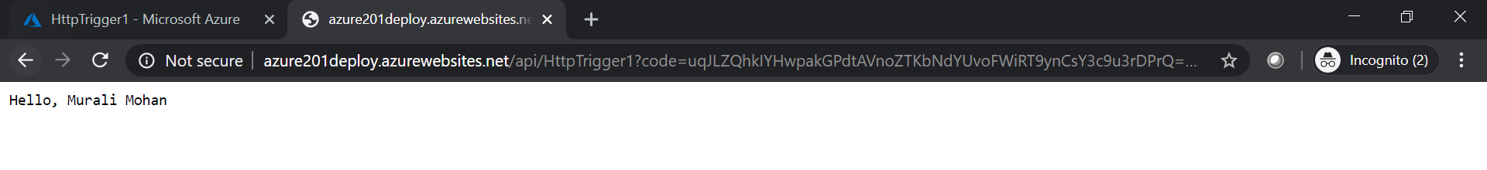

**Create Azure Cosmos DB trigger function.**

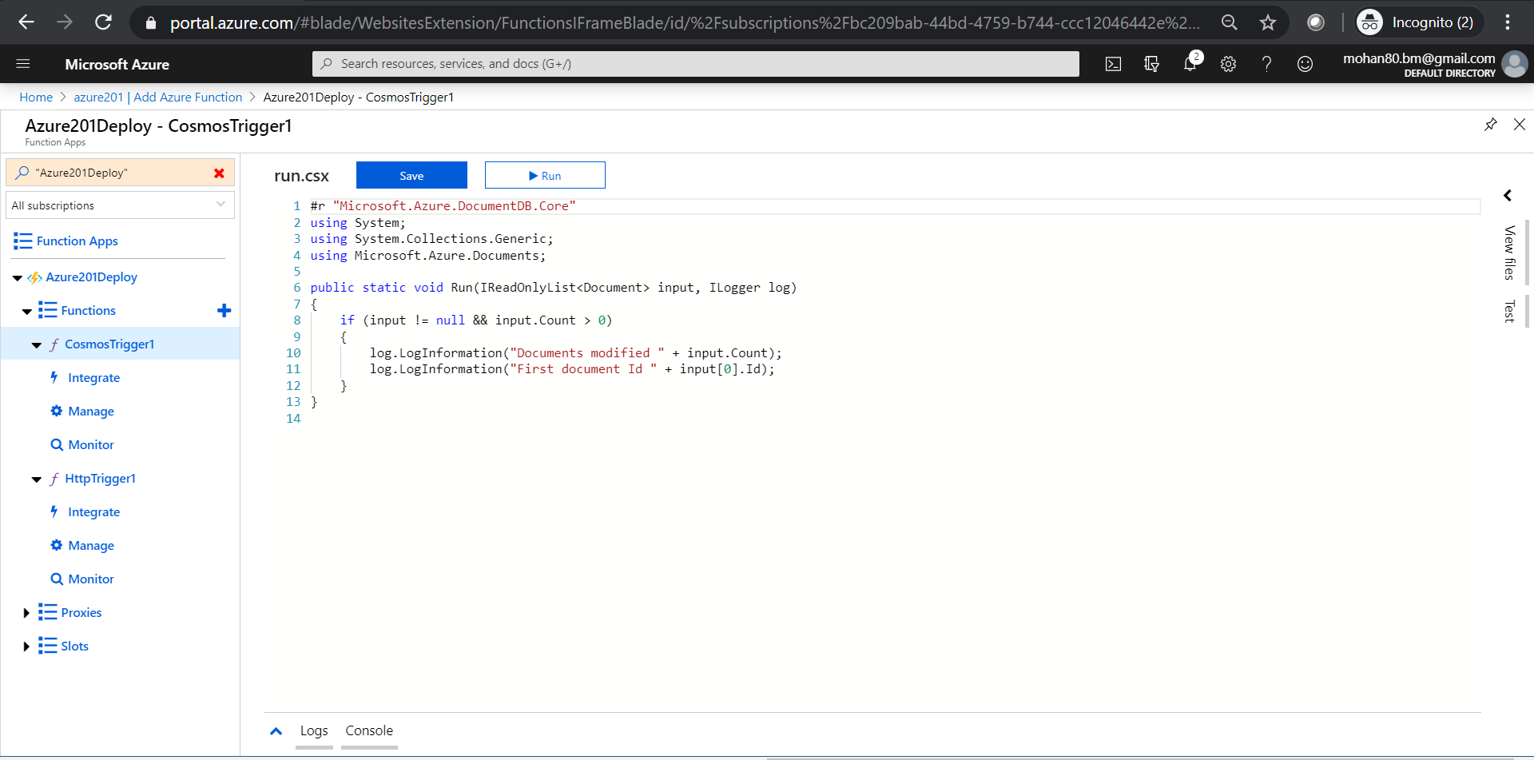

**AZURE COSMOS DB:**

**Create a dbTemplate folder and place required json files to create Azure Cosmos Db using ARM templates.**

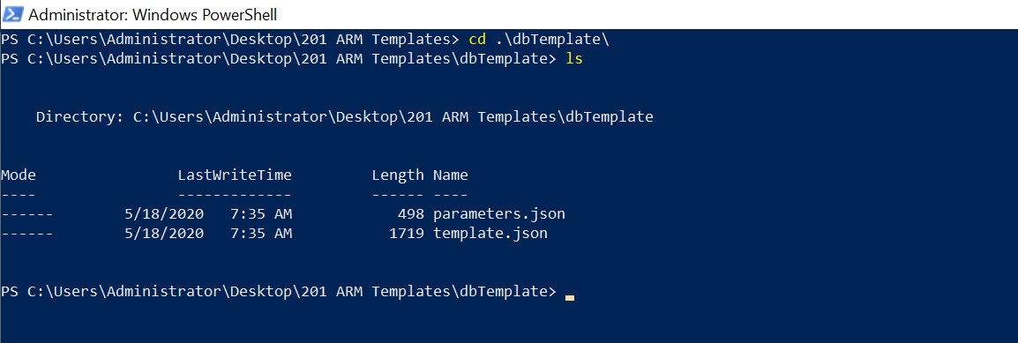

**Open PowerShell and execute the below command to create a cosmos db under MuraliDbRG resource group.**

New-AzureRmResourceGroupDeployment -Name azure201 -ResourceGroupName MuraliDBRG -TemplateFile .\template.json -TemplateParameterFile .\parameters.json -Force –Verbose



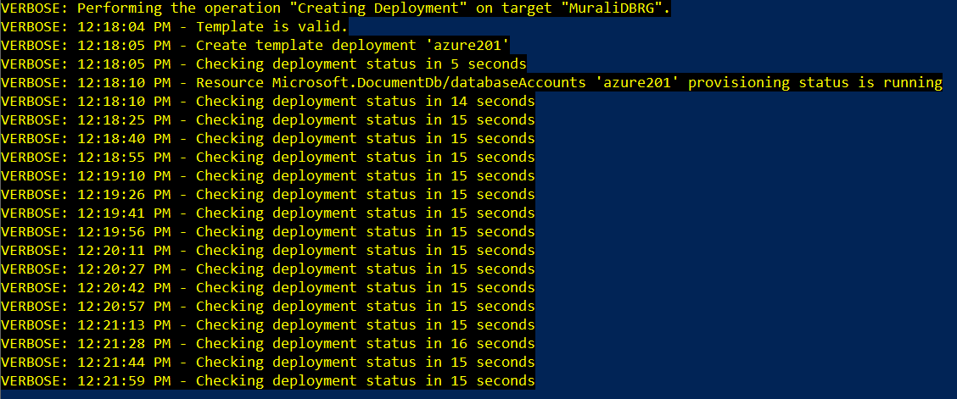

**Above command execution still in progress we can find the status of azure201 as Unknown.**

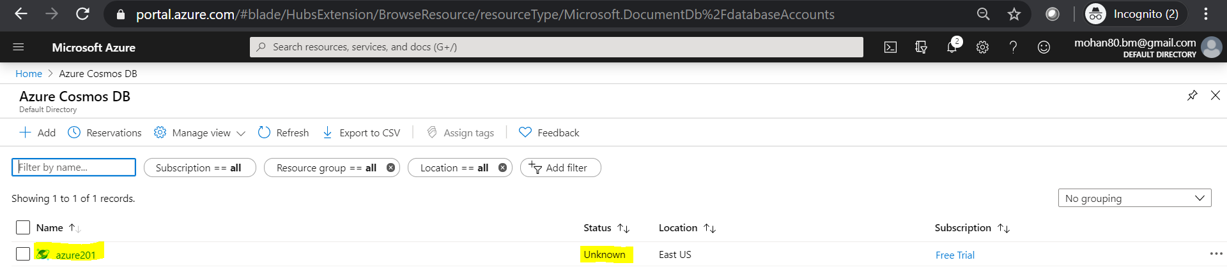

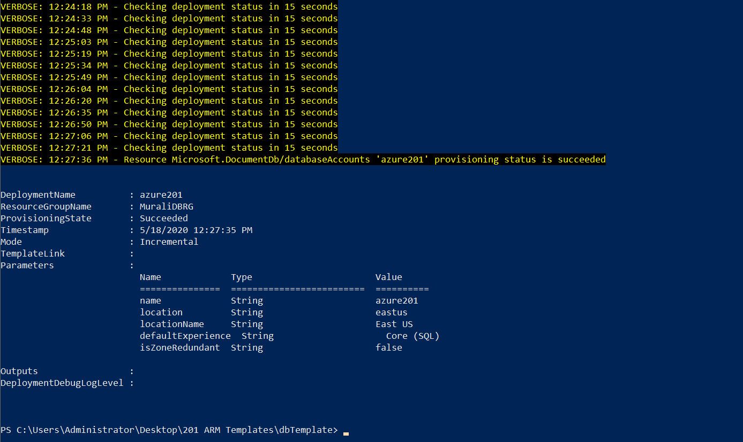

**Command executed successfully database creation done as the status of azure201db turned to Online. We can see that in azure portal.**

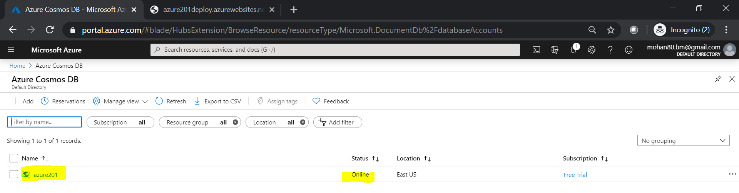

**Click on Data Explorer 🡪 Click on New Container 🡪 and provide the Database name, Container name and partition key. 🡪 Click on OK.**

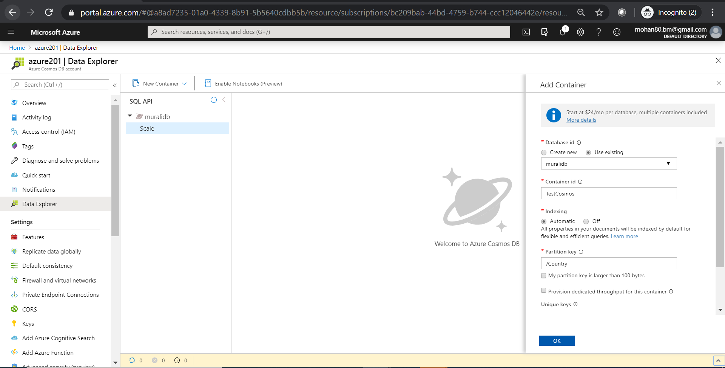

**Expand muralidb database to see the items.**

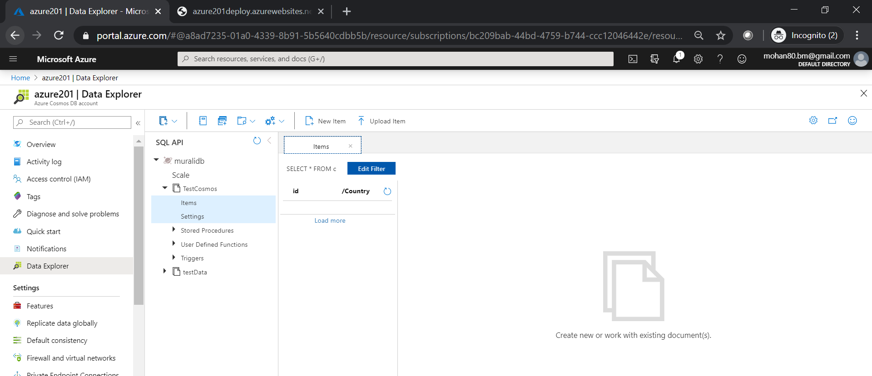

**Click on upload Item. In my case, I created a testData.json file with sample data to enter multiple items at a time. Click Upload to add.**

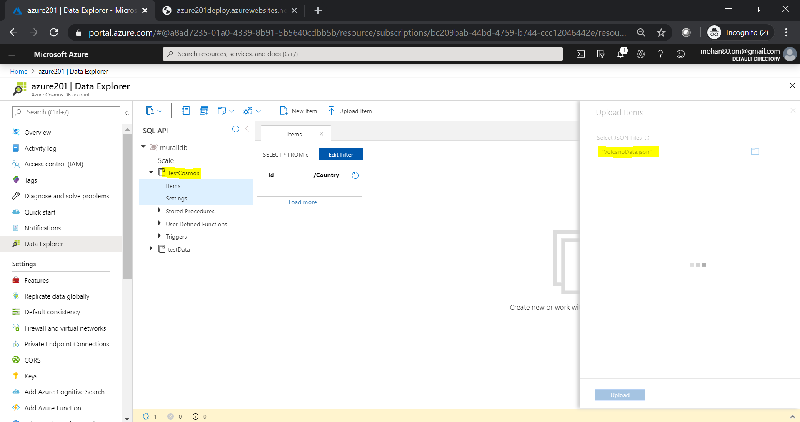

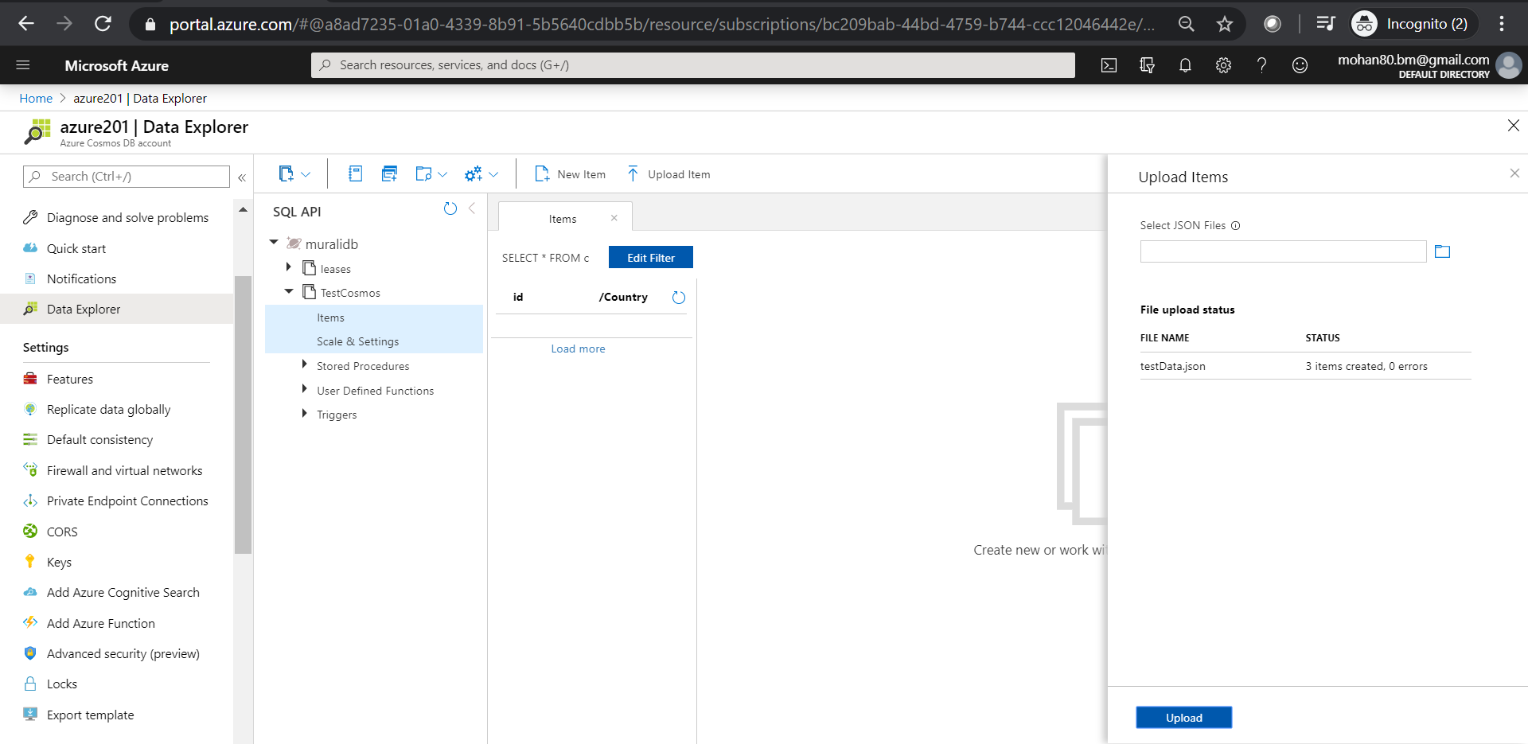

**In the filter box, enter the query to display required fileds as show below. After executing the query it will display items based on the query.**

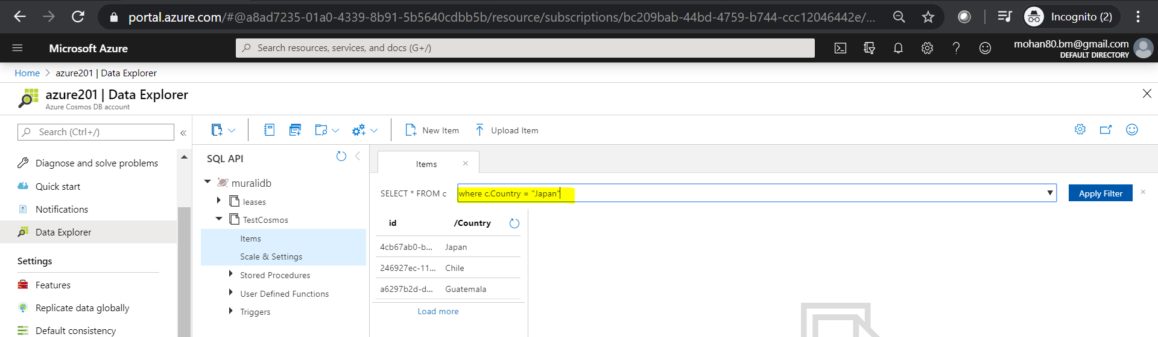

**Create a new azure function to get the log details.**

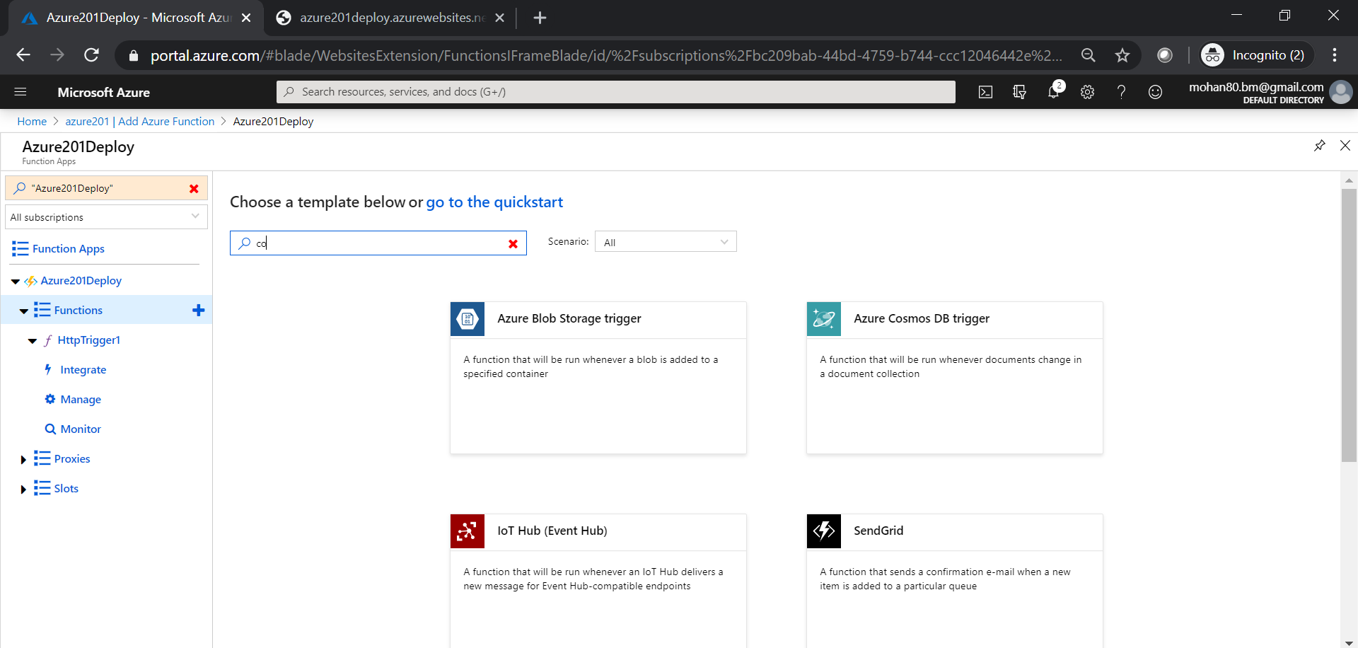

**Provide the name , select the connection string details, collection name, and select appropriate db name and click on create.**

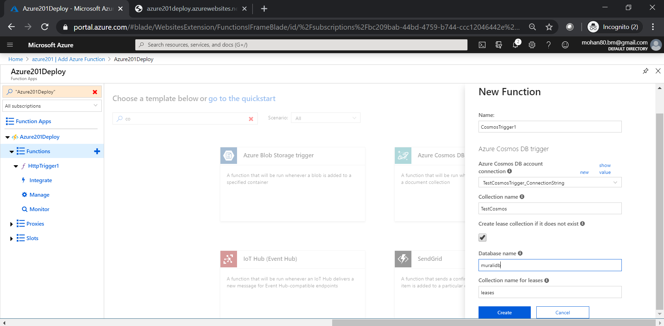

**The below screen shot shows CosmosTrigger1 function is created and status is enabled.**

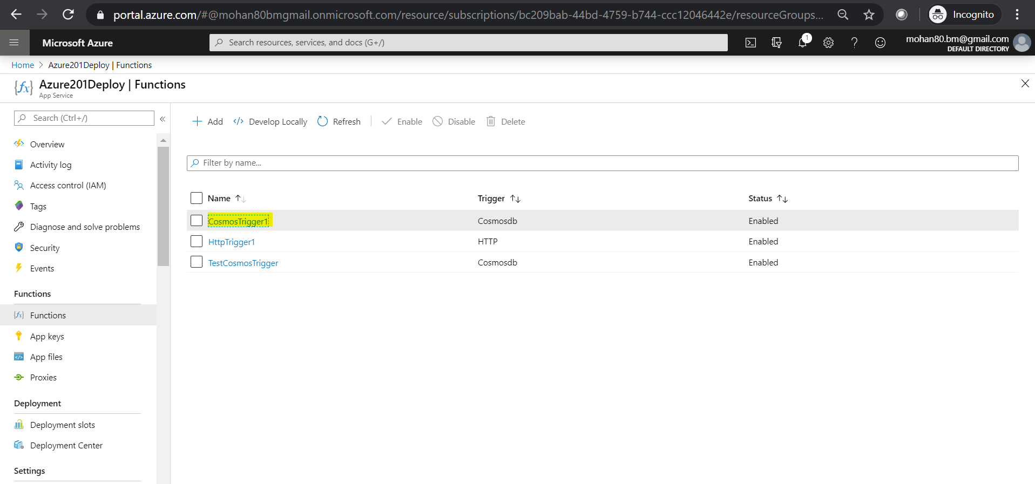

**Click on created CosmosTrigger1 Function**

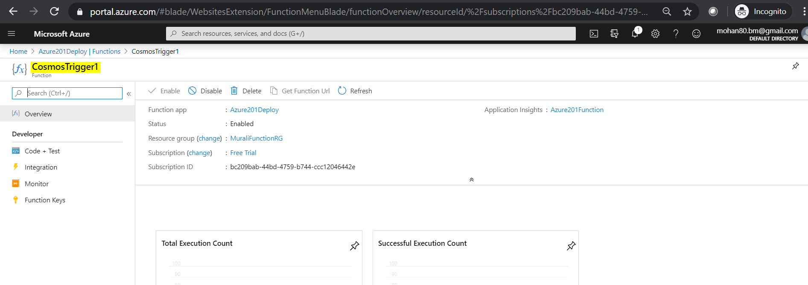

**Click on Code + Test to view the sample code. It will display modified or added items and first document id.**



**Click on Test and enter content to upload the content.**

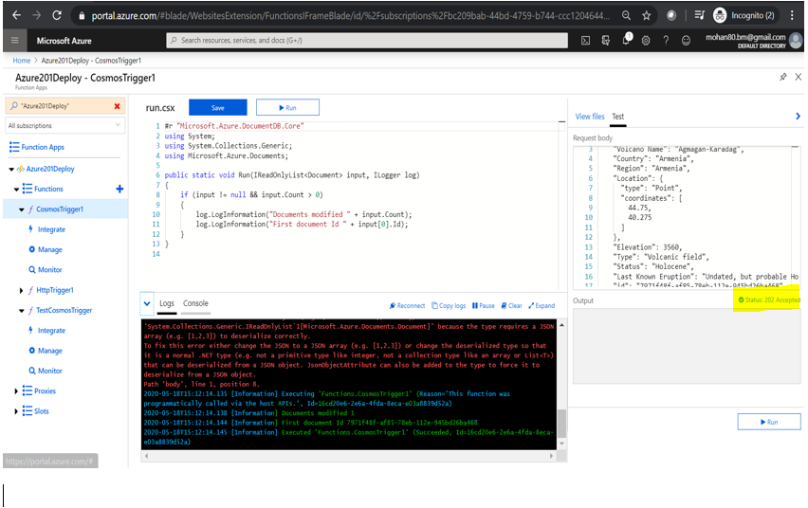

**Click on run to add data. Log Section showing documents modified and document ID.**

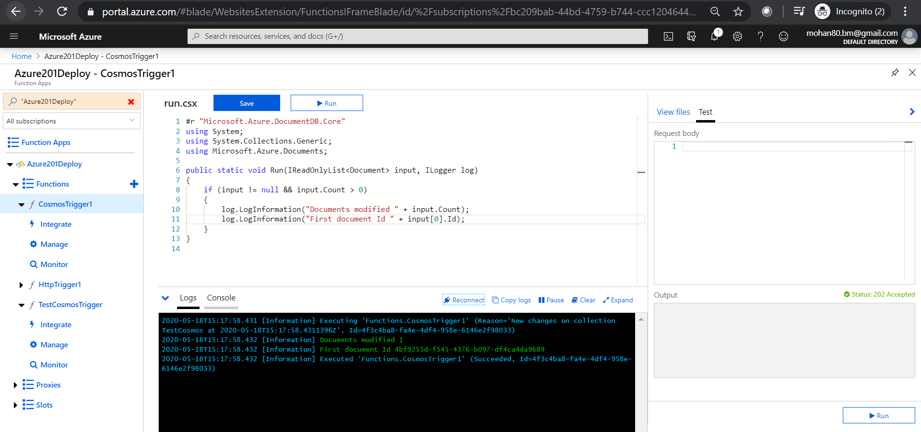

**In the Items Section click on load more will display the newly created data.**

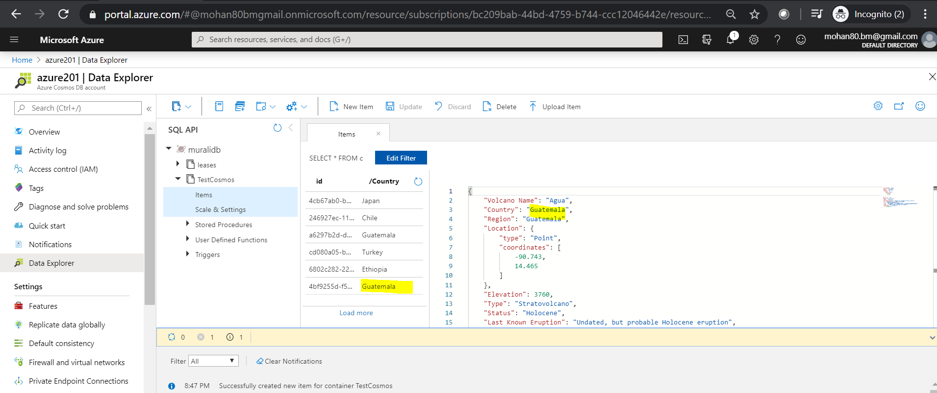

**Logs for the latest operation shows that document added successfully and also first document Id .**

**2020-05-18T15:17:58.431 [Information] Executing 'Functions.CosmosTrigger1' (Reason='New changes on collection TestCosmos at 2020-05-18T15:17:58.4311396Z', Id=4f3c4ba8-fa4e-4df4-958e-6146e2f98033)**

**2020-05-18T15:17:58.432 [Information] Documents modified 1**

**2020-05-18T15:17:58.432 [Information] First document Id 4bf9255d-f545-4376-b097-df4ca4da9689**

**2020-05-18T15:17:58.432 [Information] Executed 'Functions.CosmosTrigger1' (Succeeded, Id=4f3c4ba8-fa4e-4df4-958e-6146e2f98033)**

**2020-05-18T15:19:55 No new trace in the past 1 min(s).**

**2020-05-18T15:20:55 No new trace in the past 2 min(s).**

**2020-05-18T15:21:55 No new trace in the past 3 min(s).**

**2020-05-18T15:22:55 No new trace in the past 4 min(s).**

**2020-05-18T15:23:55 No new trace in the past 5 min(s).**

**2020-05-18T15:24:55 No new trace in the past 6 min(s).**

**AZURE ACTIVE DIRECTORY:**

**Click on All Services and search for Azure Active Directory.**

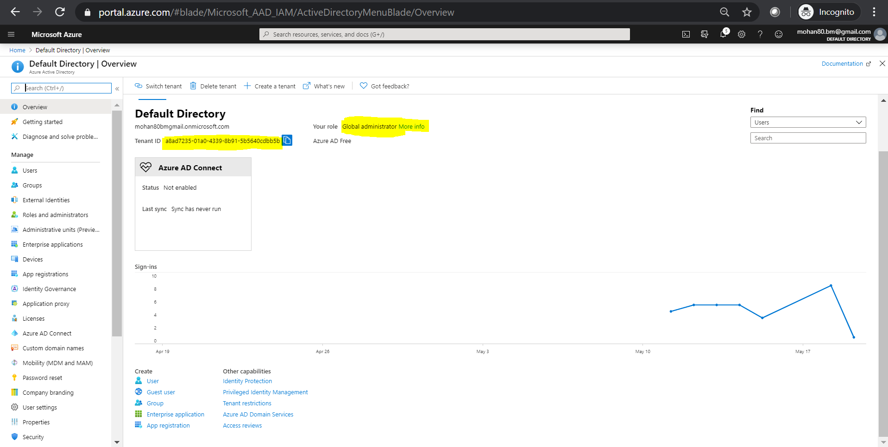

**Click on the users will display the list of users present in the current active directory.**

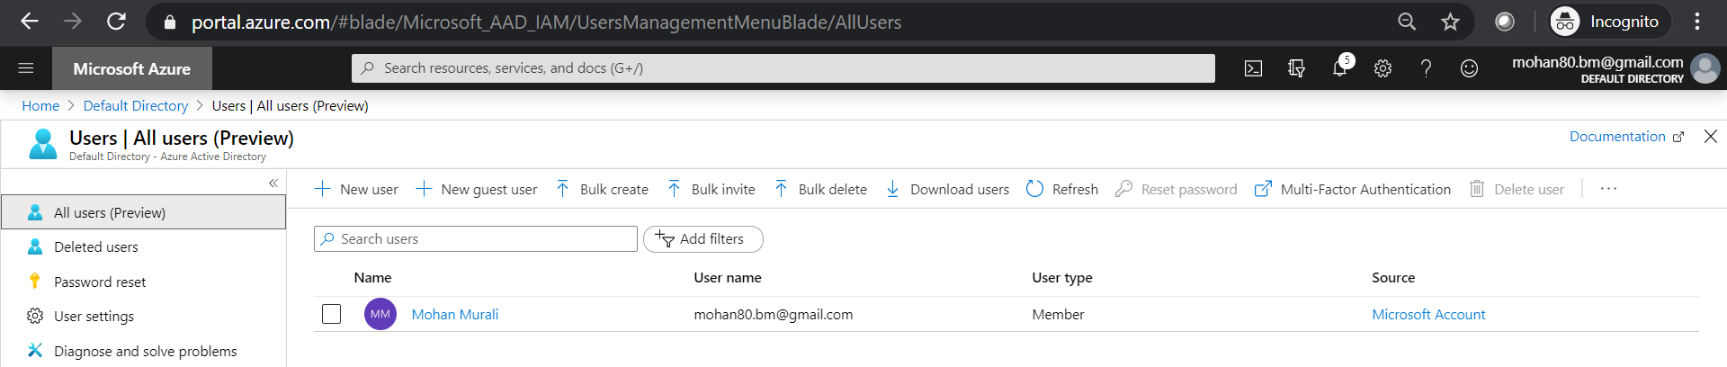

**Add more users**

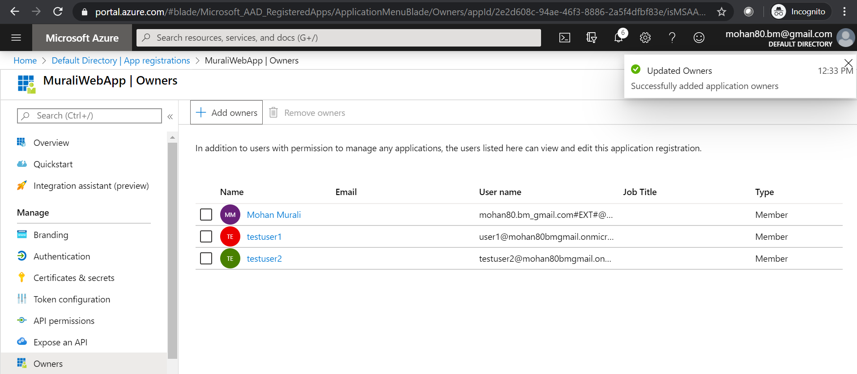

**App Registrations:**

**Click on Register an application**

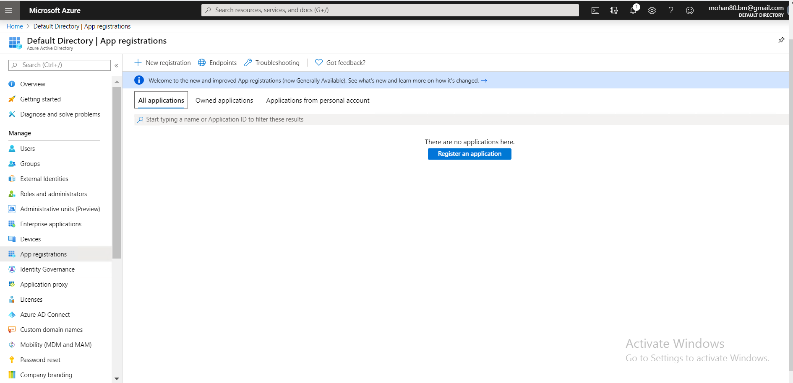

**Give a name and supported account types as shown below and Click on register Button.**

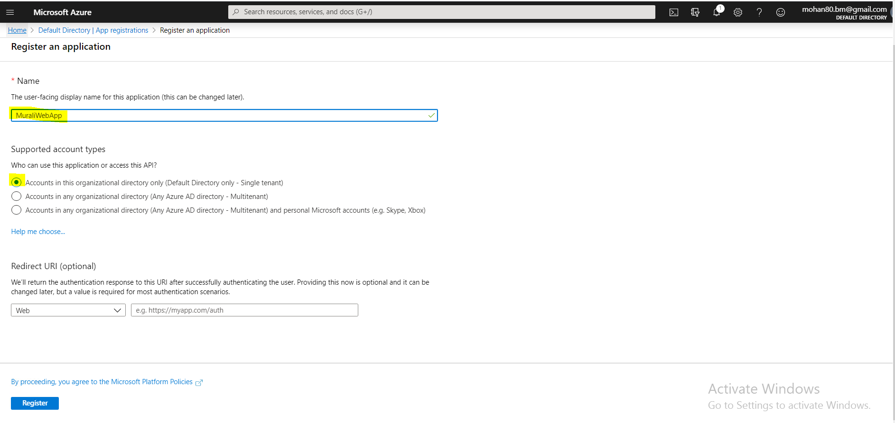

**In my case MuraliWebApp is created and click on Overview to view more details.**

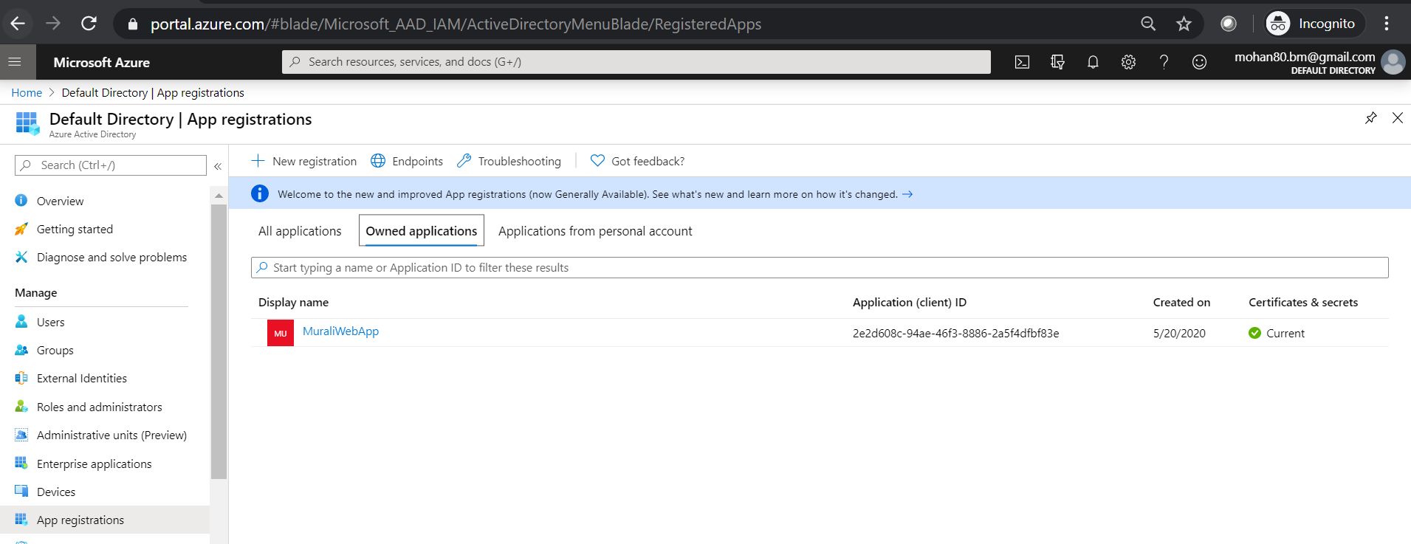

**The below screen showing Application Id(Clinet ID), Tenant ID( Directory ID).**

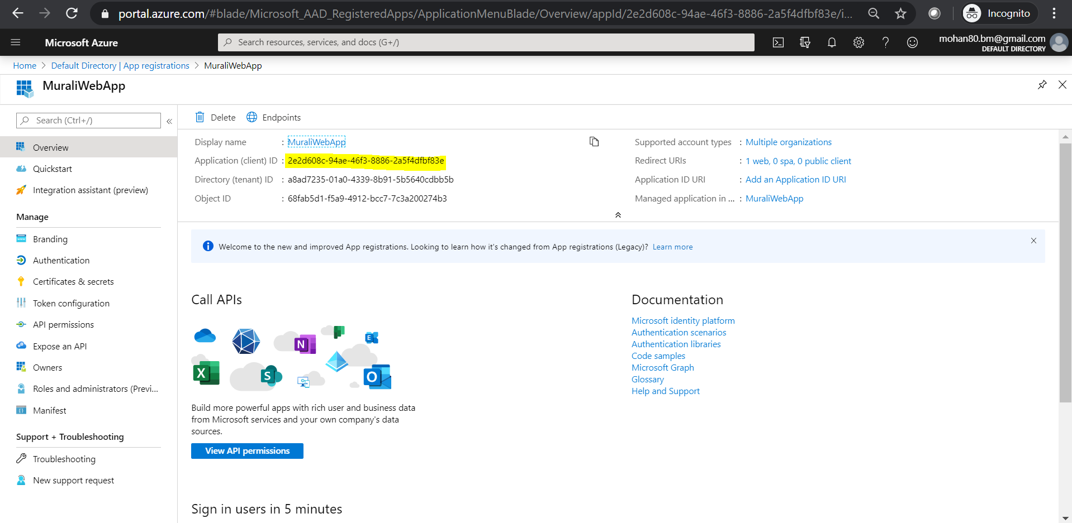

**Click on Authentication 🡪Click on Add a platform 🡪 and select Web/Singlepage Application.**

**I my case I select web.**

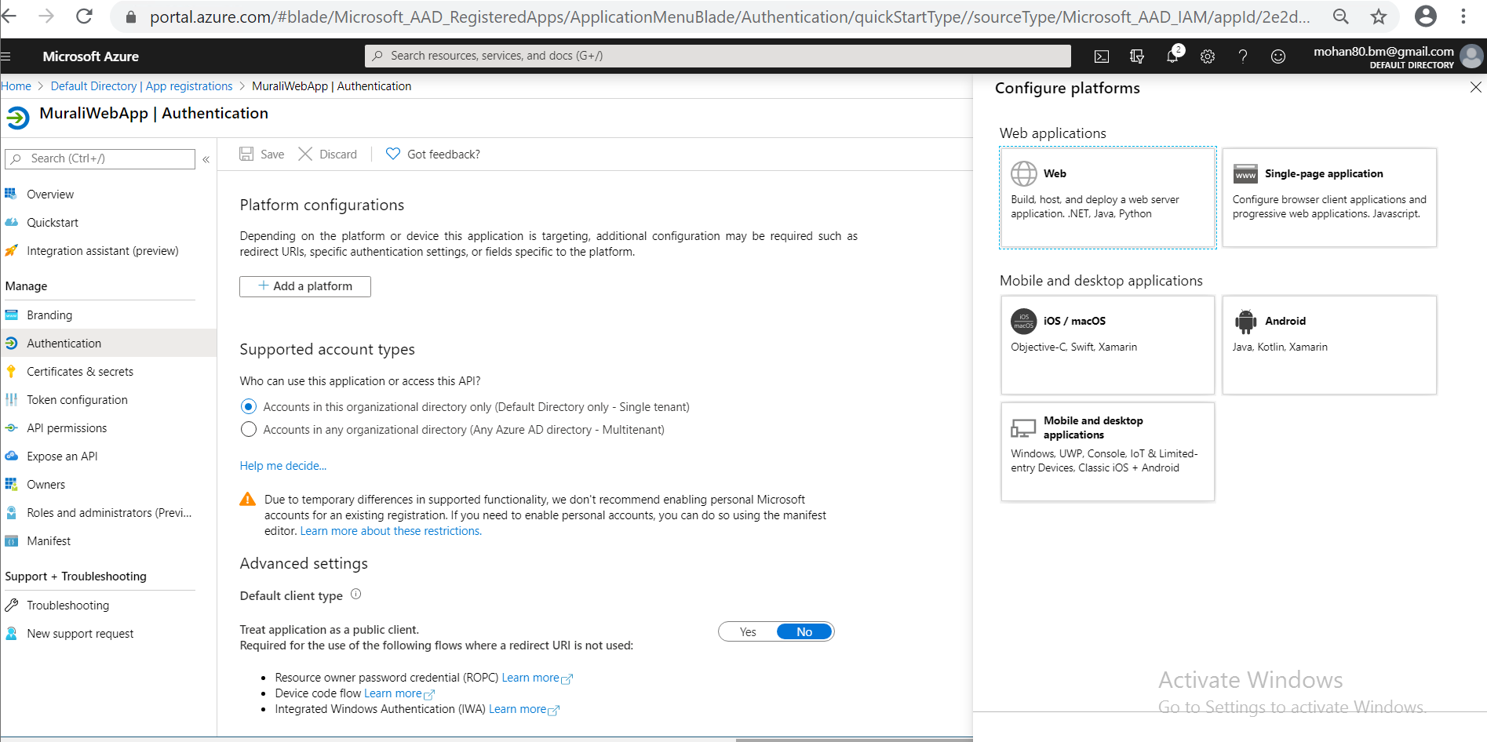

**Click on Advanced Settings to give Redirect URL’s, Logout URL and in Implicit grant section select ID tokens 🡪 Click on Configure to save the settings.**

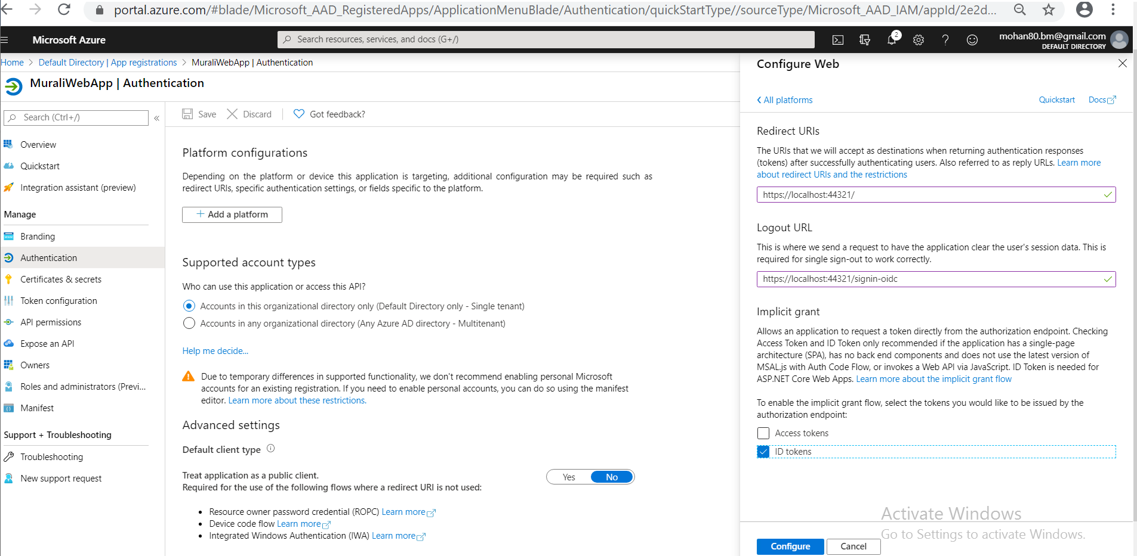

**Create users. Here 3 users created as shown below.**

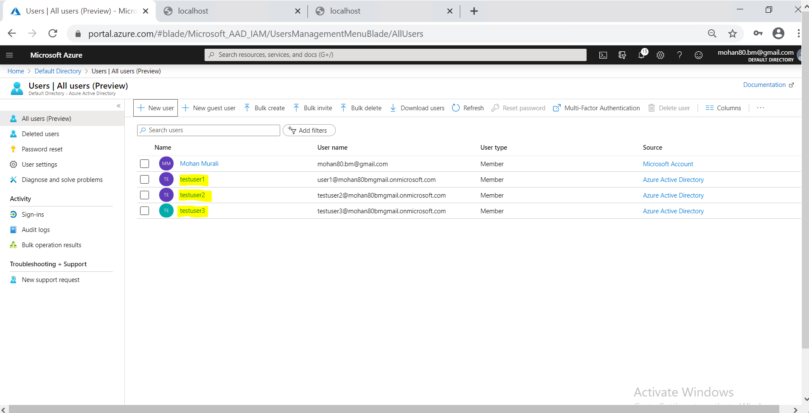

**Select API Permissions 🡪 Under Microsoft API’s 🡪 Microsoft Graph -> Click on that**

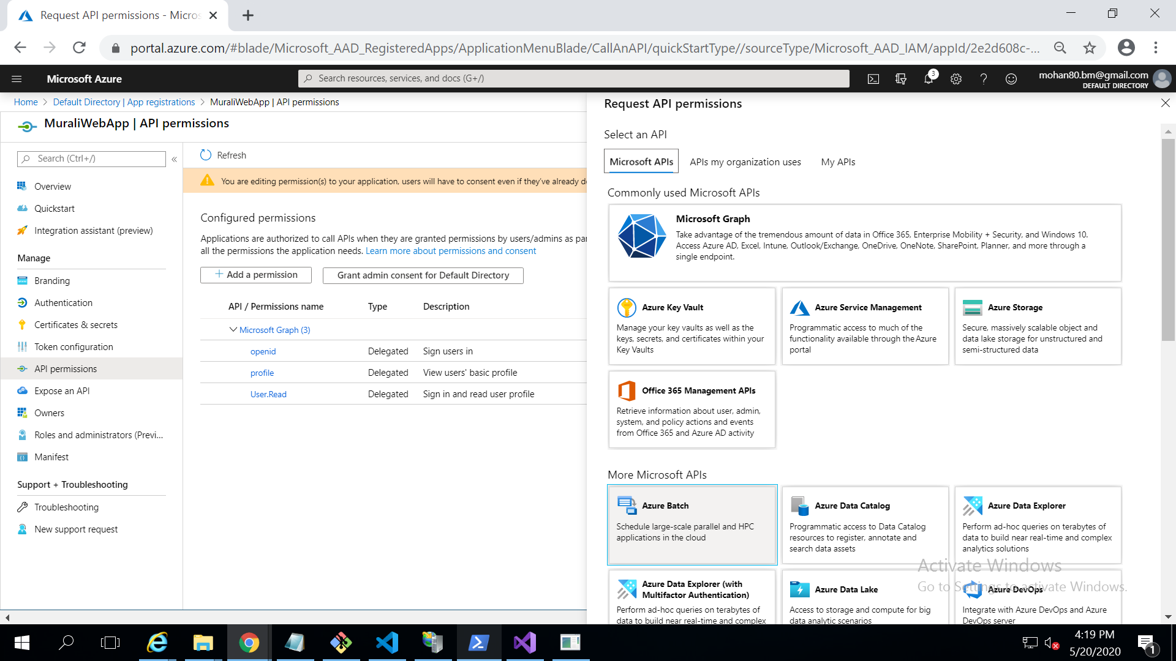

**Select API Permissions as shown below.**

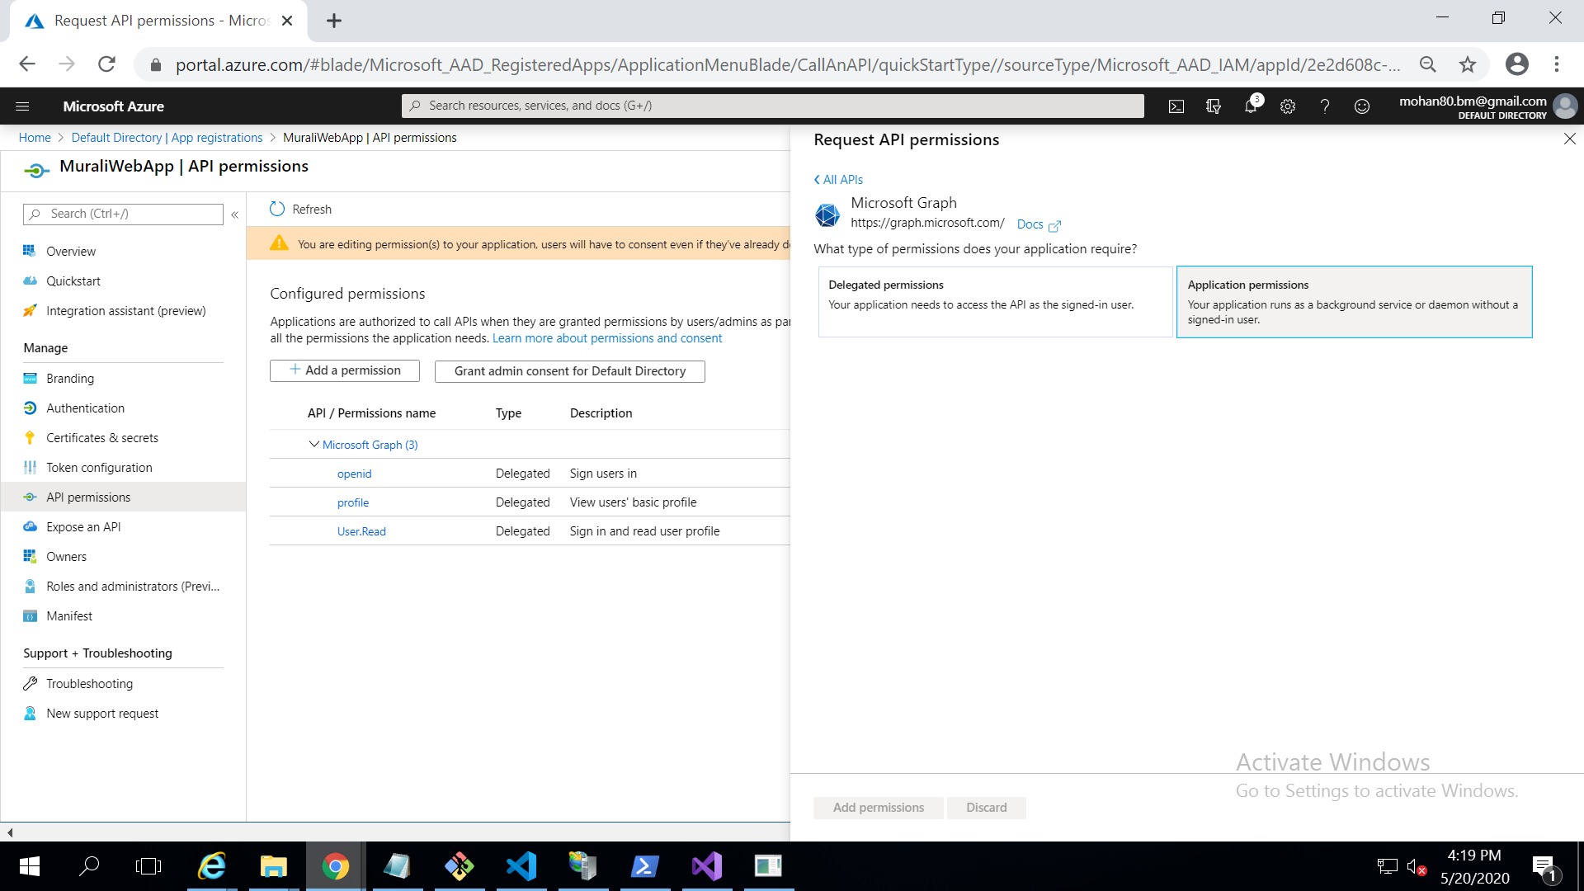

**Scroll down to users section and select appropriate permissions 🡪 click on Add permissions to save.**

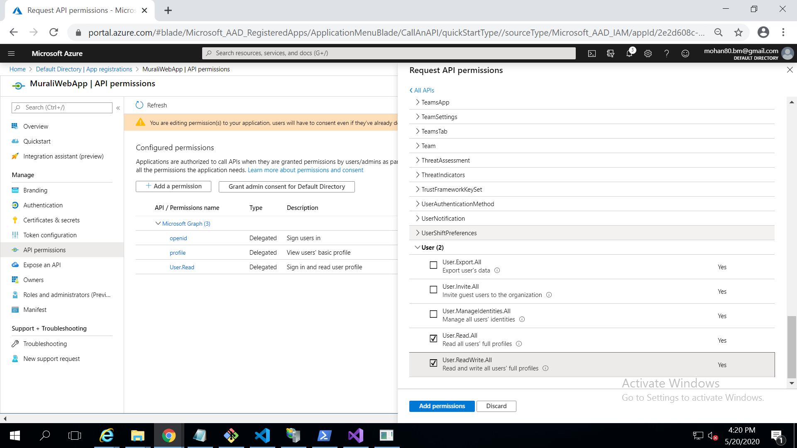

**Select Certificates & secrets to create a New client secret as shown below.**

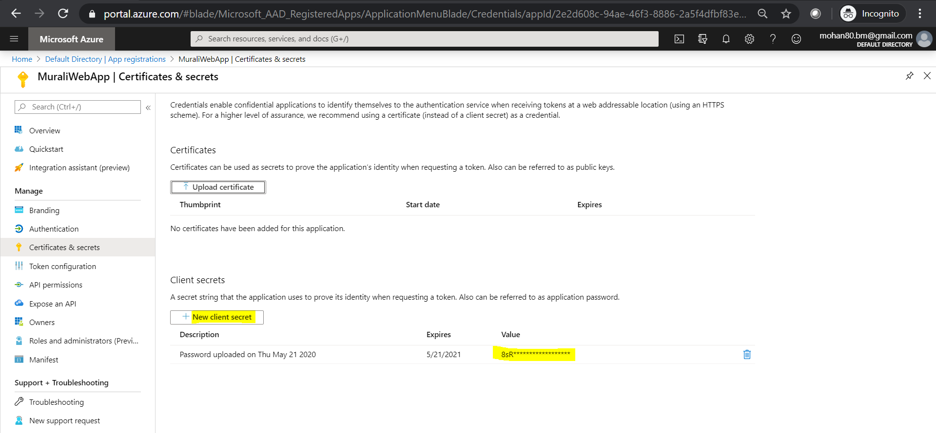

**Sample code to talk to azure AD.**

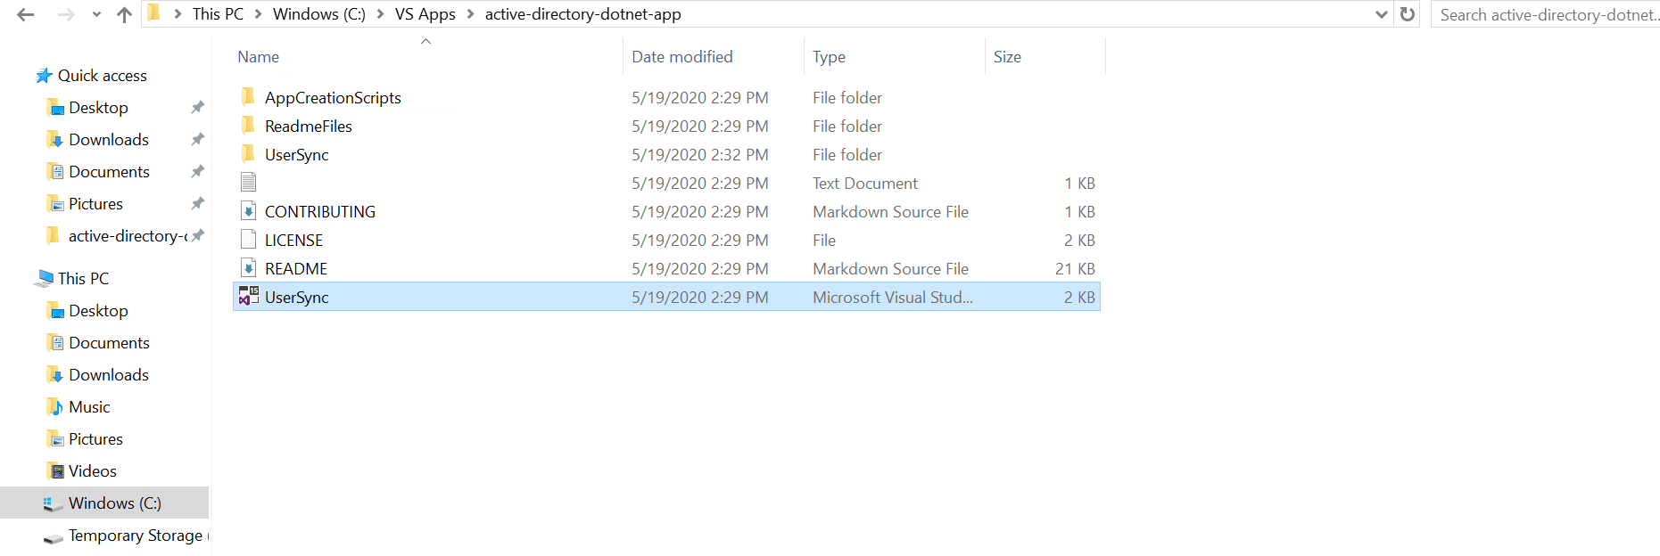

**Open the solution in Visual Studio and**

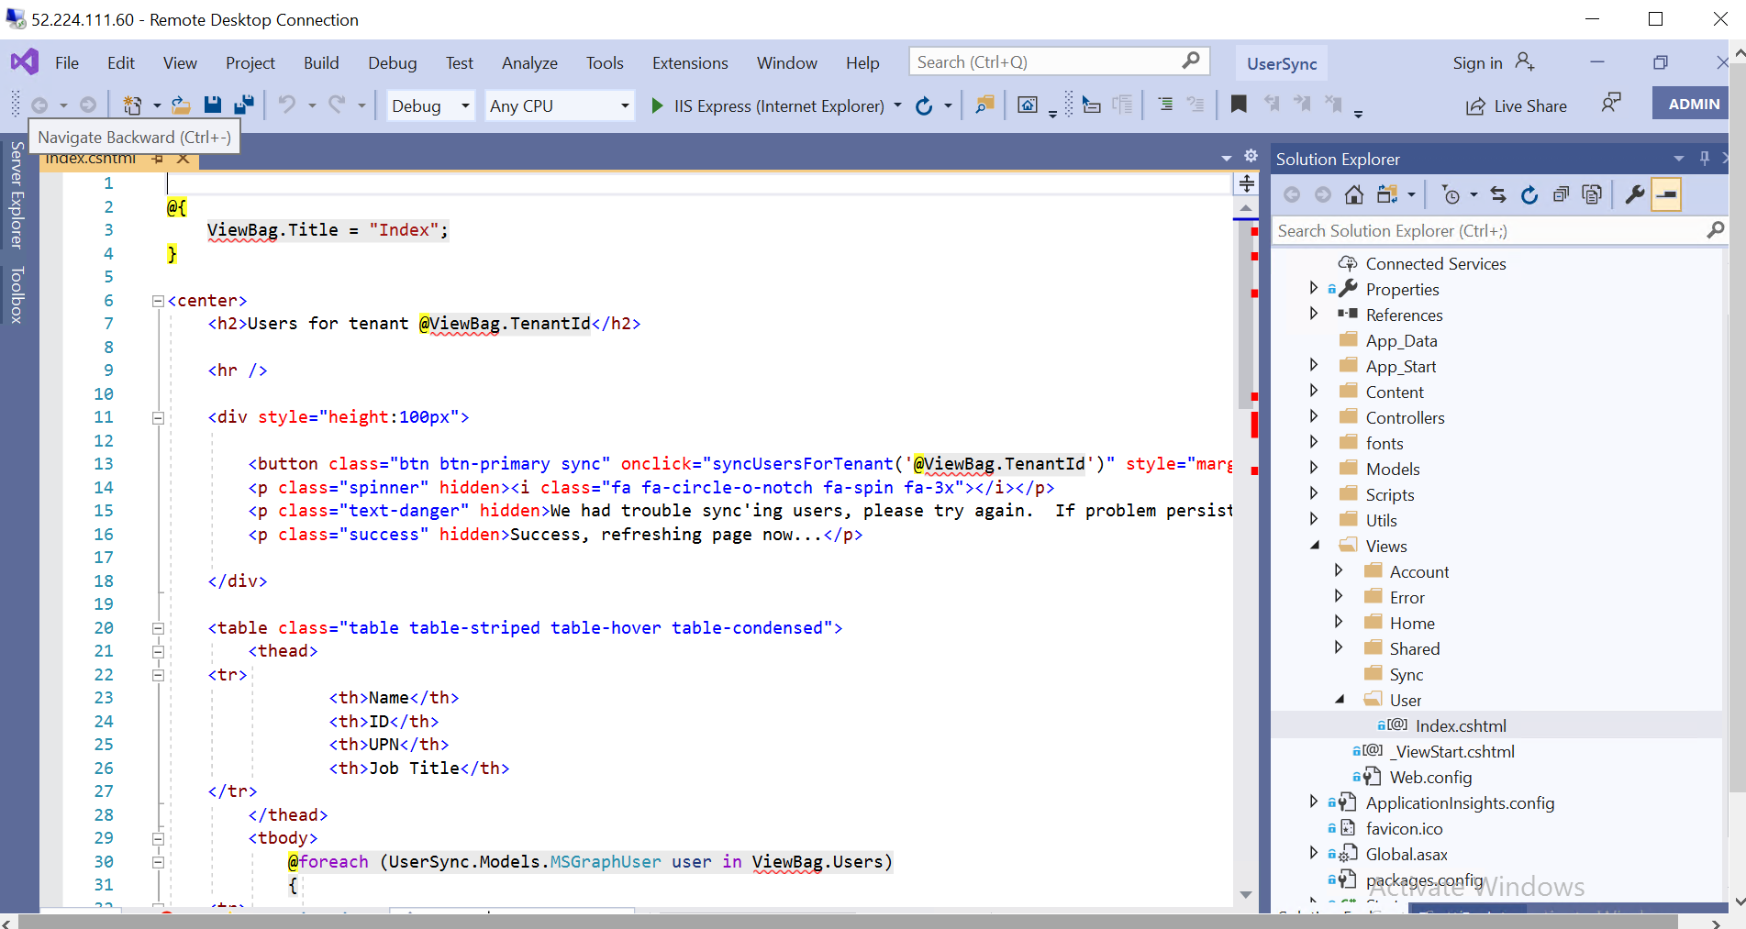

**Open Web.config file and copy Client Id/Application ID from App Registration Overview page and Client Secret from Certificates & secrets which is available in Client Secrets section. Save Web.config file.**

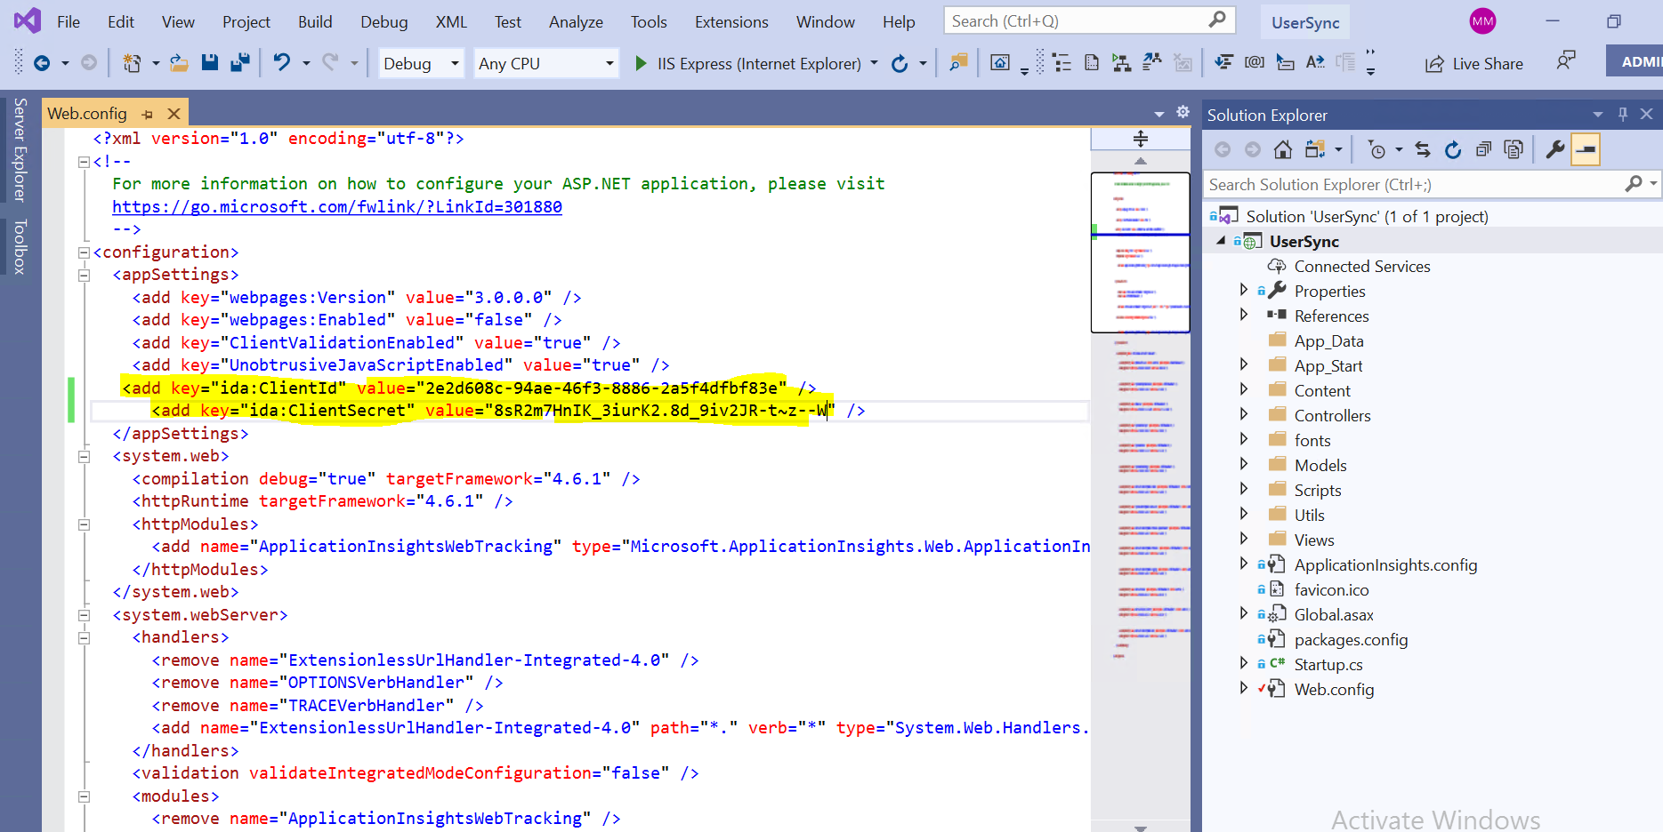

**Build the run the application.**

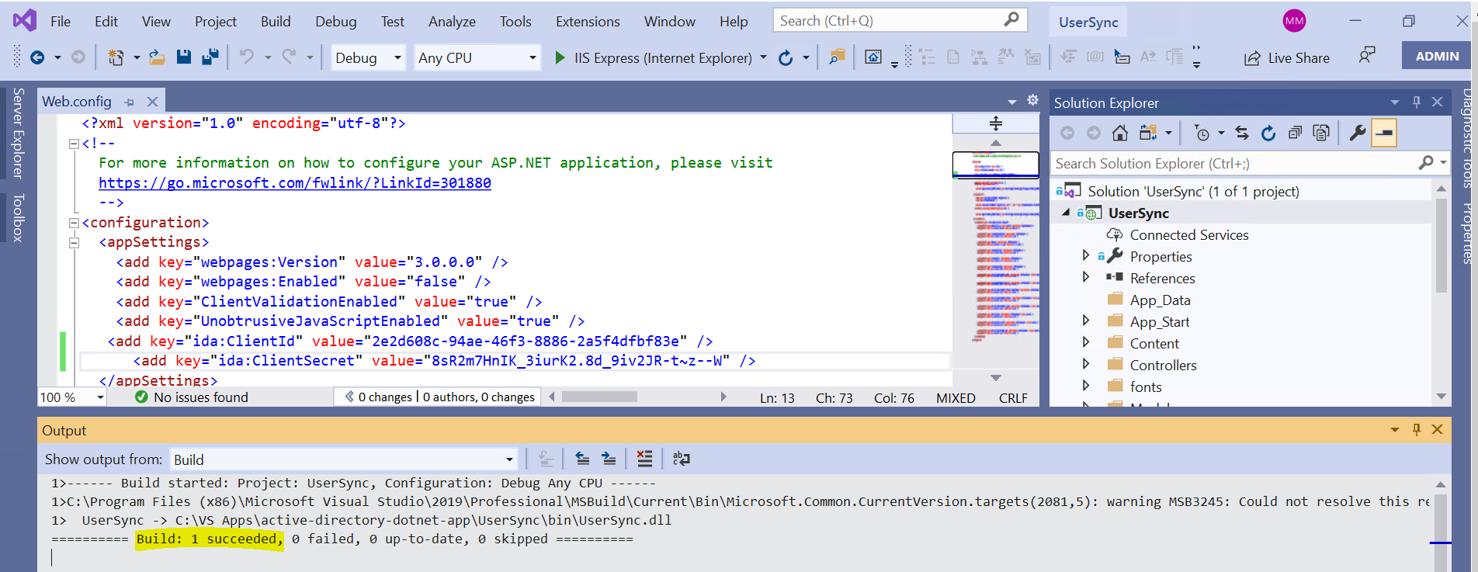

**User Sync application is running fine as we can see the home page.**

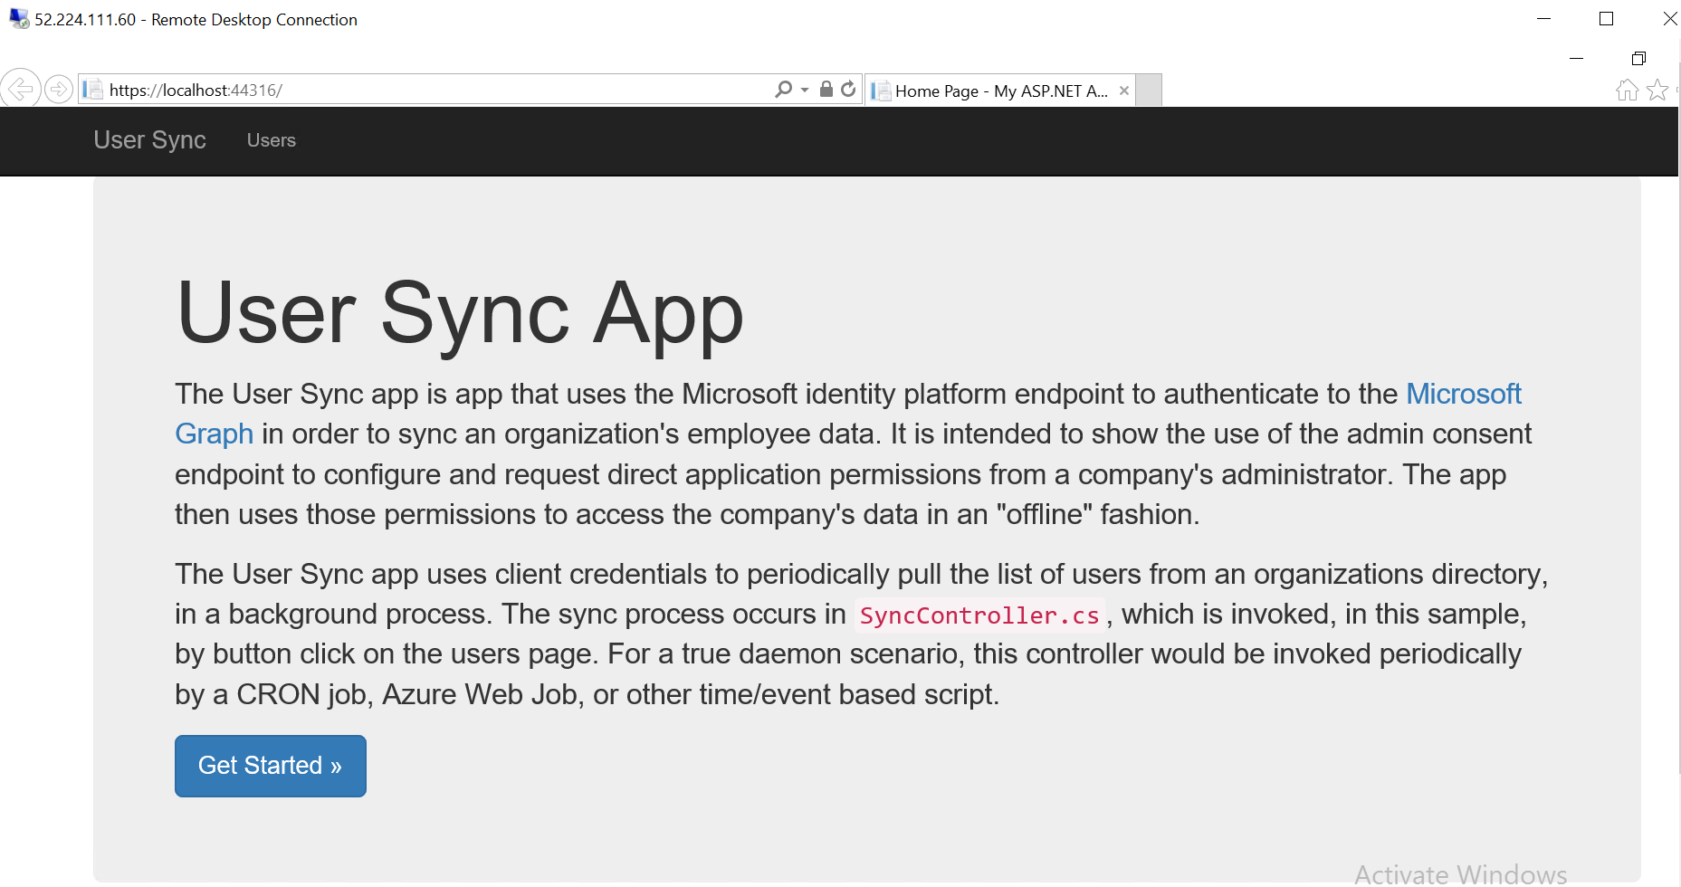

**Click on Get Started Button or Users Tab to navigate to the second page. And it will take us to account page as it is expecting to Sign In to Sync .**

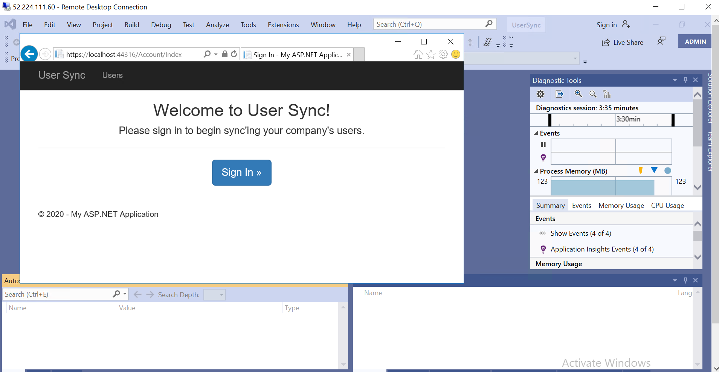

**Navigate to Owners and add recently created users ( testuser1 , testuser2) as owners as below.**

**Testuser3 created but it is not added to owners list.**

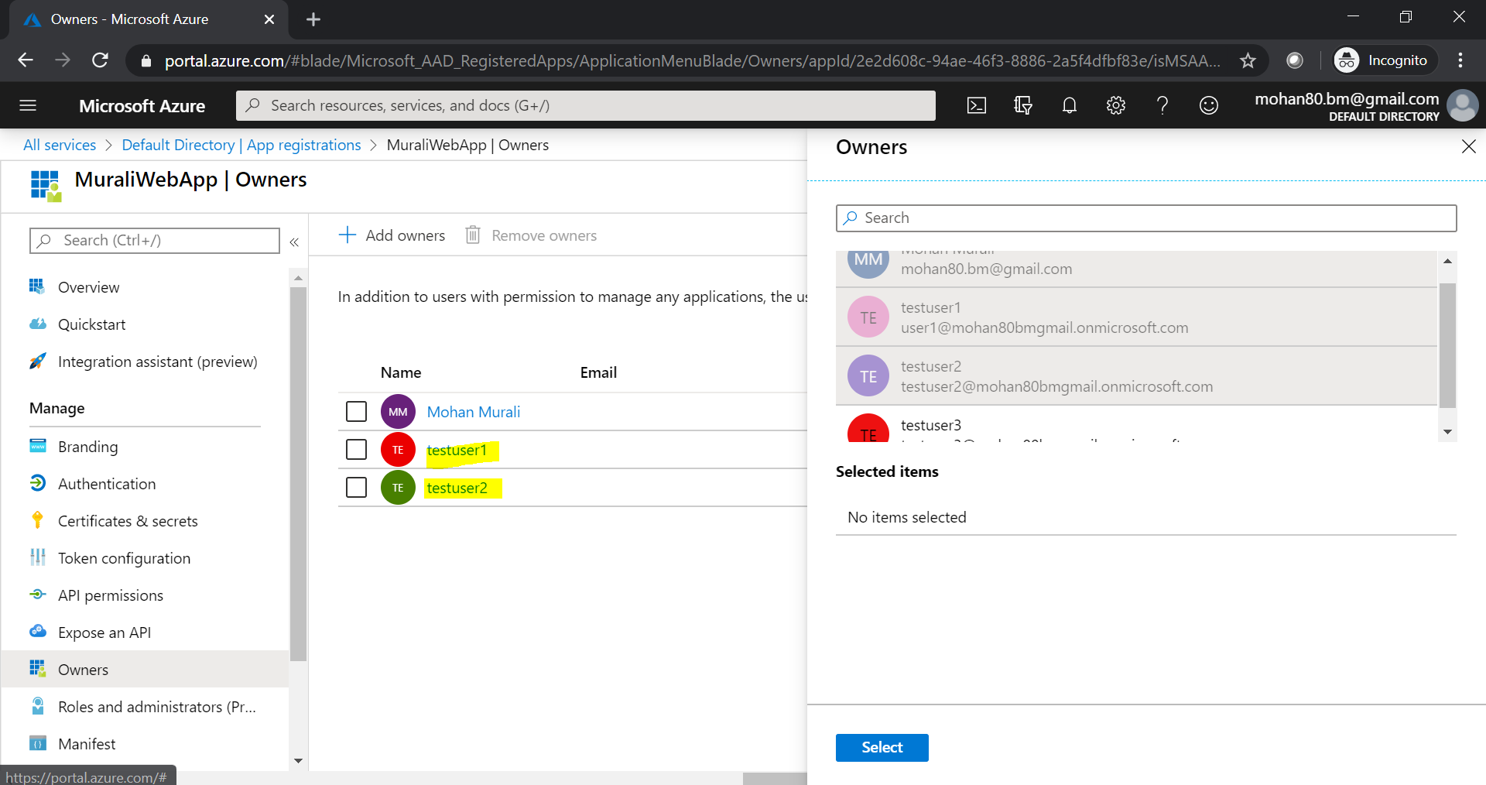

**Enter Azure Sign in Credentials of testuser1.** 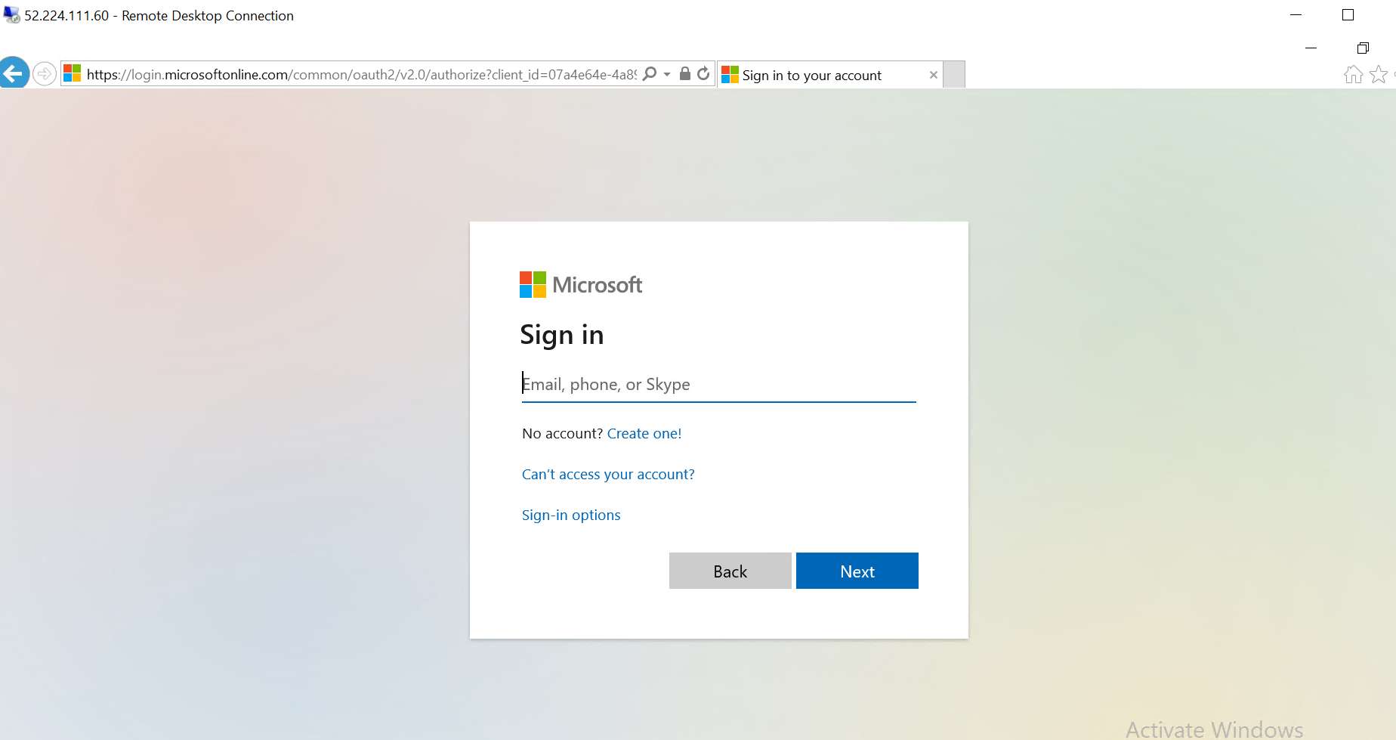

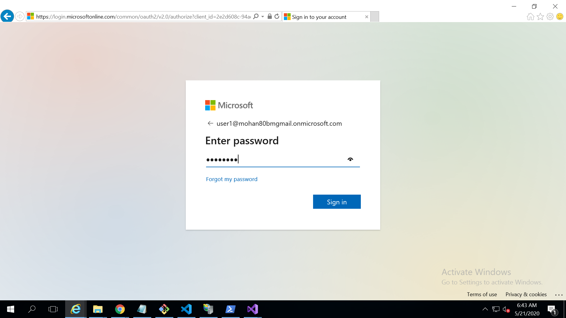

**As I am using user for the first time it is asking for the update password.**

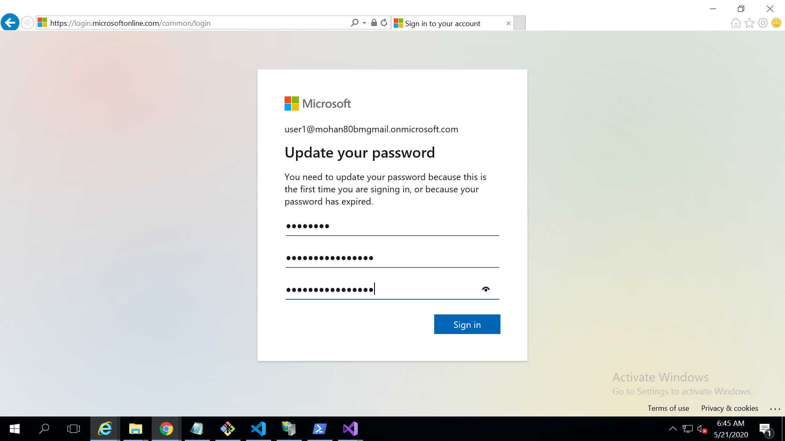

**Once the password is updated it is showing the below screen. It is asking for grant permissions.**

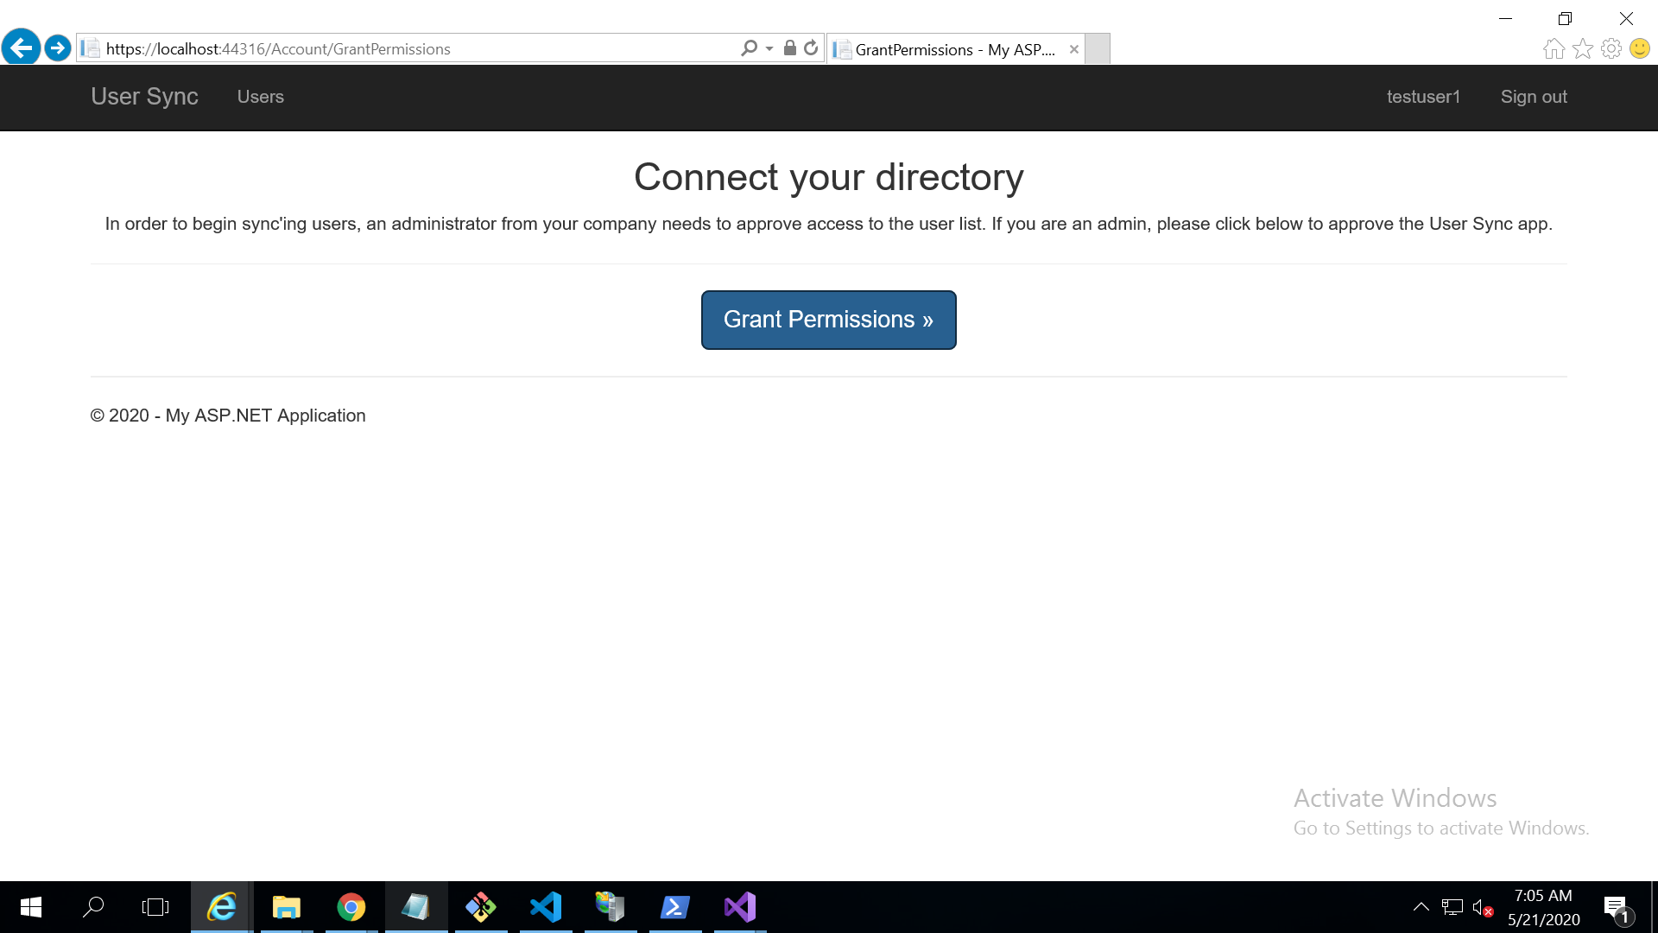

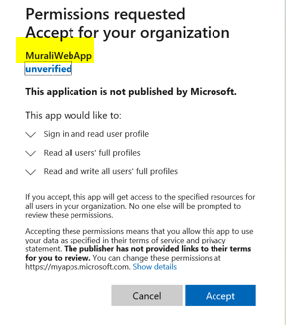

**Click on Accept will navigate to the user page as shown below.**

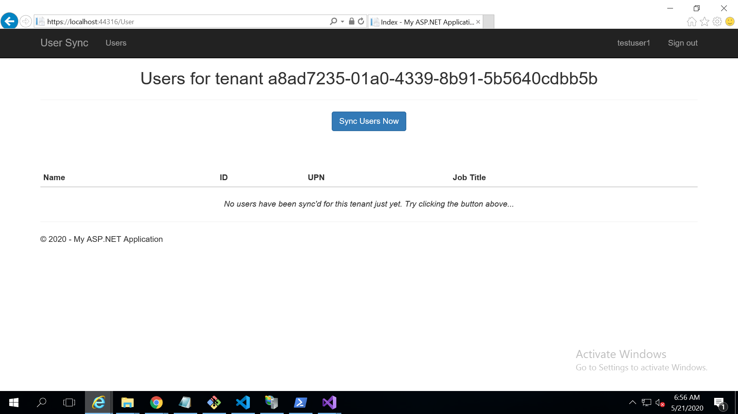

**Click on Sync Users Now button to get the details.**

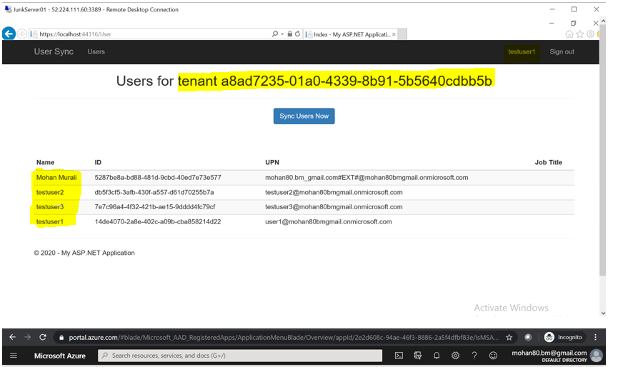

**As we can see in the below screen for tenant ID(for reference) .**

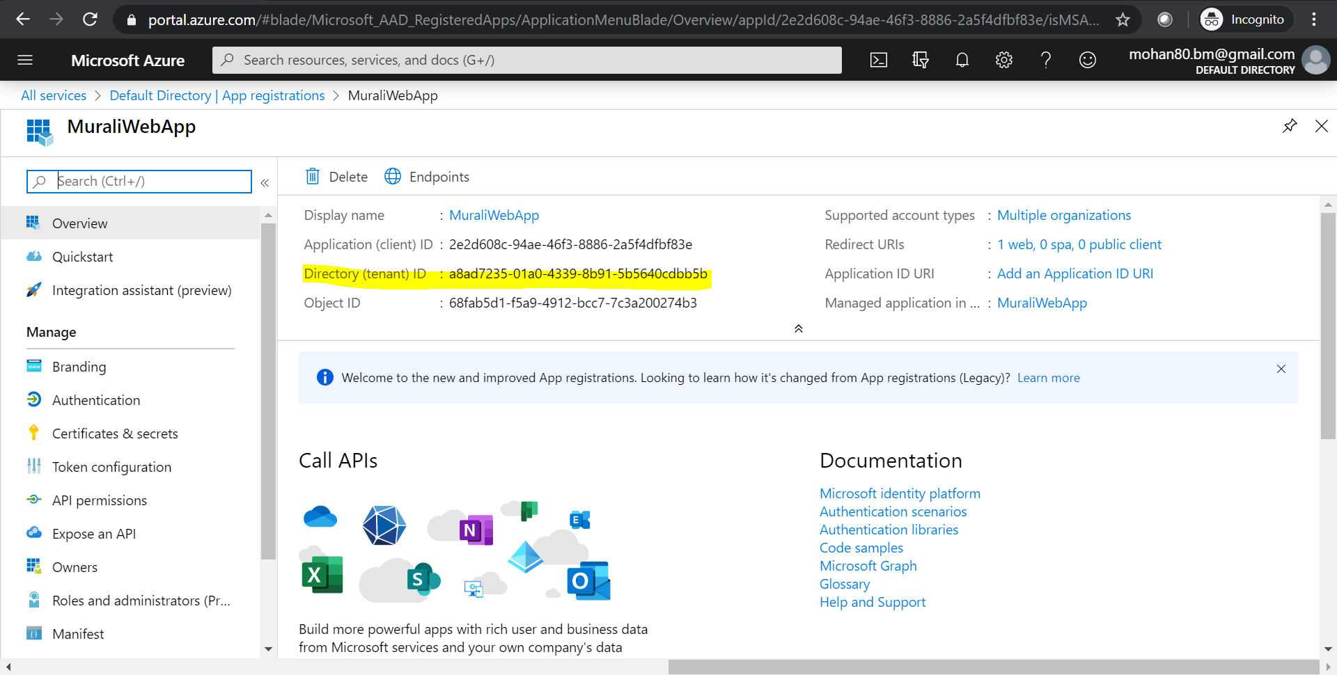

**Testing with another user testuser3 will give the same result.**

